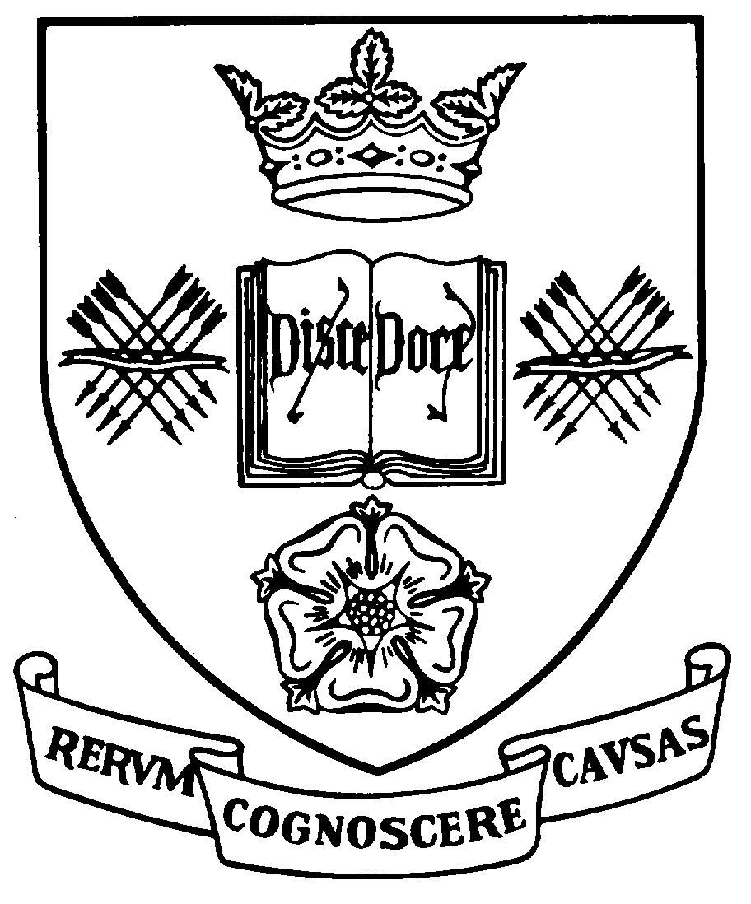
Programme Specification
A statement of the knowledge, understanding and skills that underpin a taught programme of study leading to an award from
The University of Sheffield

1 | Programme Title | English Literature (Creative Writing Pathway)
2 | Programme Code | LITT79 (Full-time), LITT80 (Part-time)
3 | JACS Code | Q320
4 | Level of Study | Postgraduate
5 | Final Qualification | Master of Arts (MA)
6 | Intermediate Qualification | Postgraduate Diploma (PG Dip)  Postgraduate Certificate (PG Cert)
7 | Teaching Institution (if not Sheffield) | Not applicable
8 | Faculty | Arts and Humanities
9 | Department | English Literature
10 | Other Departments involved in teaching the programme | English Language and Linguistics, Russian and Slavonic Studies, History
11 | Modes of Attendance | Full-time or Part-time
12 | Duration of the Programme | 1 year or 2 years
13 | Accrediting Professional or Statutory Body | None
14 | Date of production/revision | July 2014, January 2024
- Background to the programme and subject area
The MA/Diploma/Certificate in English Literature is a flexible taught postgraduate programme which allows for the study of writing from the seventeenth to the twenty-first centuries. Most modules focus on written literatures; some also promote the study of theatre, film or theory. The School of English Literature offers a wide range of designated modules available only to postgraduates. Most are made available to students on this MA/Diploma/Certificate, who then select the four (two in the case of Certificate students) that best suit their own interests: there is no core module. Creative writing pathway students take two modules from the general list of literature modules, and the two creative writing modules, Practical Workshop and Theory of Writing.
MAs, Diplomas and Certificates in English Literature at Sheffield attract students from all over the UK and around the world. Our teaching is ranked as 'excellent' and our research received the rating of 5 in the UK's latest Research Assessment Exercise (2001). Students are taught and supervised by scholars at the forefront of their discipline, and our teaching at postgraduate level is research-led. MA and Diploma students go on to a wide range of career paths, including working in higher education, teaching, management, consulting, writing, and work in arts - especially theatre, film and publishing.
Both Diploma and MA students take four modules, normally two in the Autumn semester and two in the Spring semester. Students who complete a Postgraduate Certificate will have passed two modules in the course of their studies. Each module contains a compulsory but non-assessed 'Research Training Element' that promotes skills of individual data collection and analysis. Students who continue to the MA submit a 15,000-word dissertation, written over the summer and submitted at the end of August. Its theme can either issue out of work that has been done in a subject module or it can be free standing. Creative writing pathway students submit a dissertation which is 20% critical and 80% creative.
For the most recent information about the MA in English Literature, see the Department postgraduate website at http://www.sheffield.ac.uk/english/pgc
- Programme aims
The aims of the programme reflect the general academic aims of the contributing departments and the Mission statement of the University. In particular the aims are:
- To provide a programme of study in English Literature for well-qualified graduate students.
- To offer students a programme of research-led teaching that is qualitatively different from BA-level study by maximising opportunities for independent study and reflective practice.
- To develop and deepen the student’s understanding and analysis of texts presented in English from the Renaissance to the present day.
- To develop a student’s ability to research, prepare and write graduate-level assessments.
- To situate the analysis of English Literature within appropriate contexts.
- To provide students with the training and experience required to structure, manage and deliver substantial written projects, and in particular to highlight issues of project management and work prioritisation.
- To enable students to engage with and critically evaluate published research in their field(s).
- To allow students to engage with the work of, and present work to, their peers.
- To enable students to assess and review research findings presented in a variety of media, and to introduce students to a range of information sources appropriate to their interests and to develop their skills in electronic information retrieval.
- To introduce students to matters of research etiquette and to provide effective training in research methodology and presentation skills.
In addition, the Creative Writing pathway has the following aims:
- enable students to write poetry and/or prose and/or drama to a publishable standard.
- enable students to engage in a disciplined fashion with verbal culture.
- foster a practical engagement with contemporary creative writing, with a view to developing skills in the exercise of writing in different genres, styles and modes of address.
- encourage students to develop practical, imaginative and constructive forms of criticism of the creative writing of their peers.
- enable students to tackle a broad range of writing tasks, eg commissioned features, themed poems and prose pieces, and to be able to address different markets and readerships/audiences.
- enable students effectively to discuss, defend, present and market their own creative writing.
- enable students to contextualize their work within appropriate writing traditions, and to do so with confident critical and technical understanding.
- introduce students to the structure and conventions of the literary marketplace.
17. Programme learning outcomes
Knowledge and Understanding - Upon successful completion of the programme, students will have gained:
K1 | A systematic understanding and advanced knowledge of a range of literature written or presented in English from the Renaissance to the present day.
K2 | An advanced understanding of the relationship between literature and the criticism associated with it.
K3 | A thorough understanding of the relationship between texts and the contexts in which they are created, circulated and received.
K4 | Familiarity with a wide range of relevant secondary criticism, awareness of the ongoing nature of critical enquiry and understanding of how established techniques of research and analysis are used to create and interpret knowledge of English Literature.
K5 | The ability to identify and access resources, archives and information sources germane to the academic project at hand.
The Creative Writing pathway has the following supplementary ‘Knowledge and Understanding’ outcome:
K6 | Write prose/drama/poetry to a publishable standard, with appropriate levels of technical skill, an awareness of audience/readership, effective and imaginative deployment of register, style and genre.

Skills and other attributes - Upon successful completion of the programme, students will have gained:
S1 | The ability to discuss a range of English Literature from the Renaissance to the present day.
S2 | Expertise in the analysis of texts written or presented in English.
S3 | The ability to retrieve data; to use ICT critically; to apply up-to-date research techniques and literary theory to textual interpretation, to identify and engage with problems attendant on the management of sustained projects, in particular the setting of goals, the prioritisation of research activity and the generation of written work.
S4 | The ability to form independent judgements and make comparative evaluations of texts.
S5 | Enhanced communication skills, both written and oral, and the confidence to prepare, present and reflect upon written and oral work, as well as communicate conclusions clearly to specialist (and non-specialist) audiences.
S6 | Those completing the MA will, through work on the dissertation, develop in addition higher level research skills in the retrieval and analysis of primary materials, the dissection of critical positions, and the construction of a powerfully argued thesis.
S7 | Certificate students will have developed the learning outcomes associated with the acquisition of any 60 credits of those available.
S8 | The Creative Writing pathway has the following supplementary ‘Skills’ outcomes:  - work independently with high levels of self-motivation, with the capacity to develop their own writing with specific objectives, and demonstrating the capacity to manage their own workloads, meet challenging deadlines.  - critique and analyze their own and others’ work, with a good sense of cultural context, genre history and style, and to give constructive comments.  - consider themselves as working writers, with a good sense of the exigencies and structures of the marketplace, able properly to present, discuss, and market their own creative writing.  - communicate complex ideas and information with precision and imagination.  - research relevant material, respond intelligently to critical judgments, to reflect on their own writing and creative development.  - effectively work alongside others as part of a team, with good constructive collaboration, and the ability to write with confidence and technical ability as part of a collective enterprise.
18. Teaching, learning and assessment
Development of the learning outcomes is promoted through the following teaching and learning methods:
1. WORKSHOPS AND SEMINARS. Modules are taught through workshops and seminars, usually in small groups of c.4-10 led by writing and research specialists in the area, for 2 hours every week and are designed to develop students’ analytic and writing skills and communicative powers. Seminar and workshops are also fora for debate, and for staff and students to test and explore their ideas. Short pieces of non-assessed written work or oral presentations are often required. A review of module aims and potential outcomes is incorporated into the first seminar. (S1-S5, K1-K5).
2. CONSULTATIONS. Teaching staff offer two hours weekly for individual consultation, and students are encouraged to use this time to discuss their essays, presentations, and general progress. The exact frequency is determined between tutor and student, and regular email contact is encouraged. (K5, S1, S3, S5).
3. INDEPENDENT LEARNING. The programme emphasises student-driven learning, with a particular focus on the development of individual research and reflective reasoning. Each seminar will have assigned reading, and in addition students are expected to explore primary resources and critical debates further. (K 1-5, S 1-5) Students who proceed to the MA and thus undertake the dissertation are expected to range more widely, and to explore in even greater depth their chosen area of study. (K 1-5, S 1-6).
In addition, for MA students:
4. DISSERTATION PLANNING. There is a planning supervision in which a possible ‘field’ is restricted down to an ‘area’ and a working title proposed, suitable for the Dissertation. This occurs in late January or early February. (K4, K5, S3, S6).
5. DISSERTATION SUPERVISION. There are normally three one-to-one sessions, including a criticism session on a part-draft. More frequent meetings can be arranged according to need. (S1-S6, K1-K5).

Opportunities to demonstrate achievement of the learning outcomes are provided through the following assessment methods:
Assessed Work:
1. ASSESSMENT ESSAYS. For MA, Diploma, and Certificate students. At postgraduate level an awareness of how to place intellectual discovery in the context of orthodox academic discourse is expected. The precise weighting depends on the particular forms of assessment associated with an individual module. Students are encouraged to explore new areas of work, and to expand their methodological and disciplinary base. Essays should engage effectively with both primary and secondary materials and show evidence of independent thought. A maximum of 6,000 words is normally required for each module, and this is often presented as one essay of 6000 words or divided between two essays of roughly 3000 words. The Creative Writing courses have assessment demands as follows: 2500-word essay + portfolio of 4,500-5,000 words prose/drama or 20 poems (or equivalent, roughly 400 lines), or mixed portfolios.
2. DISSERTATION. For MA students only. This is a study of between 12,000-15,000 words, supervised by a subject specialist. The creation of the proposal, and completion of the final dissertation offers advanced opportunities for the development of independent thought and the engagement with primary and secondary materials and develops wide-ranging research skills. It draws on all the Knowledge and Skills outcomes developed during the programme. (S1-6; K1-5) The creative writing dissertation, has the following shape: 12,000 words of creative work; 3,000-word critical essay. For poetry, 50 poems, or equivalent (roughly 2000 lines); 3,000 words critical essay. Mixed portfolios welcome. (S7; K6).
Non-Assessed Components:
3. SEMINAR PRESENTATIONS AND REPORTS. Students are usually required to contribute to seminars based on their previous week's reading and research. In addition to normal discussion, this may take the form of a short-written piece presented to the tutor in advance of the class, or an oral report given during the seminar. In this manner we seek to promote continuous feedback on achievement and progress. (S5).
4. RESEARCH EXERCISES. Each module includes a 'Research Training Exercise'. Students must pass this exercise in order to proceed to writing the essay. One of the seminars during the semester is usually devoted to this exercise, which could involve visiting the Special Collections in the Main Library, visiting a collection in another library, or a class-based web and electronic database search; followed by the submission of a prose account of a research task, and evidence of any data unearthed (e.g. a bibliography, interview, catalogue). The exercise is marked (pass/fail) and returned. Presentation is taken into account as part of the training exercise. (K4, K5, S3-5).
19. Reference points
The learning outcomes have been developed to reflect the following points of reference:
The research interests of the department staff and the research strategy of the Department of English Literature and other contributing Departments.
The Mission Statement of the University of Sheffield, as presented in the Corporate Plan.
The Learning and Teaching Strategy of the University of Sheffield.
The Masters’ level qualification descriptor in the QAA Framework for Higher Education Qualifications in England, Wales and Northern Ireland (January 2001).
The AHRB Framework of Skills Training Requirements for Research Students.
The University of Sheffield's School of English Graduate Staff-Student Committee.
The Department of English Literature's Graduate External Examiners.

20. Programme structure and regulations
To achieve the award of MA in English Literature, students must accumulate a total of 180 credits by successfully completing a combination of taught modules, each worth 30 credits and a Dissertation worth 60 credits. These credits can be acquired in 12 full-time months or 24 part-time months. To ensure balanced workload, full-time students normally take 60 credits each semester. For all students the period between the end of the Spring semester and the end of the annual registration period is devoted to work on the Dissertation. For part-time students it is expected that normally 90 credits are taken in each year of study, divided as evenly as possible. The period from the beginning of the Spring semester of the second year of part-time study is normally devoted to work on the Dissertation. Course Directors advise on the construction of a suitable programme.
To achieve the award of Postgraduate Diploma in English Literature, students must accumulate a total of 120 credits by successfully completing a combination of taught modules, each worth 30 credits. These credits can be acquired in 12 full-time months or 24 part-time months. To ensure balanced workload, full-time students normally take 60 credits each semester. For part-time students it is expected that normally 60 credits are taken in each year of study, divided as evenly as possible. Course Directors advise on the construction of a suitable programme.
To achieve the award of Postgraduate Certificate in English Literature, students must accumulate a total of 60 credits by successfully completing a combination of taught modules, each worth 30 credits.
There is no credit-bearing core module on this programme as it is designed to be as flexible as possible and to allow students, in consultation with the Course Convenor, to assemble the module pathway that is most appropriate to their learning interests. However, it includes a 0-credit Pass/Fail module, EGH461 Core Skills in Postgraduate Study, that helps students make the transition to MA study through a series of workshops on topics such as ‘How to be an MA student’, ‘Writing and researching essays’, etc.
The programme is completed for MA students (but not Diploma or Certificate students) by a Dissertation. MA students are encouraged to develop their own dissertation topic. This can either arise out of coursework pursued or can offer the opportunity to develop research interests not directly addressed in the taught programme. Every effort will be made to accommodate student interests, as long as they fall within the range of potential supervisors from the constituent departments. For students intending to continue into doctoral work, the dissertation will normally be in an area related to the proposed doctoral topic. The Dissertation is a substantial scholarly piece of work bridging the undergraduate long essay and the research degree thesis. It is expected that the Dissertation will be aware of the latest findings in its field, and that whilst the research it contains may not be original, the argument it advances will be.
Detailed information about the structure of programmes, regulations concerning assessment and progression and descriptions of individual modules are published in the University Calendar available on-line at http://www.sheffield.ac.uk/calendar/regs.
21. Student development over the course of study
The four taught modules represent the first teaching phase of the MA, all at one level: detailed feedback on assessment is given at the end of the Autumn and the end of the Spring Semester. During the Autumn and Spring Semesters students also take the 0-credit EGH461 Core Skills in Postgraduate Study.
The second phase is represented by the Dissertation.
The overall structure of the programme is designed to support both Diploma and MA students towards the completion of four taught modules, a significant marker of the success of the learning outcomes. For Certificate students, the programme supports the completion of two taught modules. For MA students, the next phase, the Dissertation, is the major indicator of the successful achievement of the learning outcomes. By the time the Dissertation is completed students are expected to have thoroughly mastered the critical organisation of material. It is also expected that the Dissertation should display an ability to use non-standard (i.e. other than printed book) sources, such as electronic, archival, oral history or visual material, and show recognition of the material factors of publication.

22. Criteria for admission to the programme
Our normal entry requirement for postgraduate study is an undergraduate degree of 2.1, or overseas equivalent, in the field of English Literature or a related discipline from a recognised institution. Students from non-traditional backgrounds (particularly those who have studied subjects other than English Literature, or who may have been away from Higher Education for some time) are welcome to apply, as each application is treated on an individual basis. A sample portfolio submission of 2000 words of prose/drama or 8 poems (or equivalent, roughly 150 lines) is necessary for admission to the Creative Writing pathway.
Students whose first language is not English are expected to produce evidence of satisfactory attainment in the English language as used in the academic environment and are required to submit evidence of their language proficiency, typically in the form of an IELTS or TOEFL test. As language skills lie at the heart of study in literature, theatre and cinema, we usually expect IELTS and TOEFL scores to exceed significantly the minimum University recommendations. As a guide, the University's minimum admission standard in English language is 6.5 in IELTS (with 5 in each component) or 600 in TOEFL (with 4.5 in TWE) or 250 in the TOEFL computer test. Successful applicants may be offered the opportunity for language tuition in the University English Language Teaching Centre.
Detailed information regarding admission to the programme is available at http://www.shef.ac.uk/prospective/ and on the Department of English Literature website: http://www.sheffield.ac.uk/english/pgc
23. Additional information

For further information students are directed to the Departmental website at http://www.sheffield.ac.uk/english which gives a full account of the Department and its staff as well as detailed information about the MA in English Literature. Sample Course Documents and Course Schedules are available from the Secretary for Graduate Students (see 22).
This specification represents a concise statement about the main features of the programme and should be considered alongside other sources of information provided by the teaching department(s) and the University. In addition to programme specific information, further information about studying at The University of Sheffield can be accessed via our Student Services web site at http://www.shef.ac.uk/ssid

