Introduction
This document is part of our “First Steps in R” resources. It is assumed that the reader has installed R and RStudio and understands how to type commands in the console. If you would like to recap these topics, the documents and videos are on the MASH website.

What is a Package?
R is a collaborative language, a little like Wikipedia. Anyone can write new functions or create new objects and make them available for other R users in a package. You can think of a package like an app for a smart phone. Which packages you download will depend on what you want to do in R. There are two ways of installing packages, either using menus or in the console window using R commands.

Installing packages from Menus
In the bottom-right window of RStudio click on the “packages” tab. In this tab you can see a list of all the packages which are already installed.

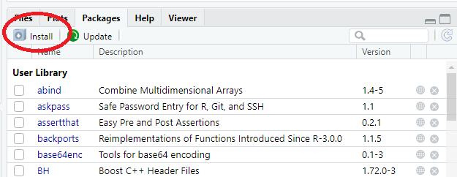
To install a new package that is not in the list, click “Install” in which opens up the “Install Packages” dialogue box and allows you to download packages from the CRAN repository. CRAN stands for “Comprehensive R Archive Network.” This is a website which stores R packages for R users to download. You can think of it as the R version of the App store on a smartphone.

Type the name of the package you want to install. In this case we will install the package “ggplot2”. This is an often-recommended package which contains functions for making elegant graphs and charts.

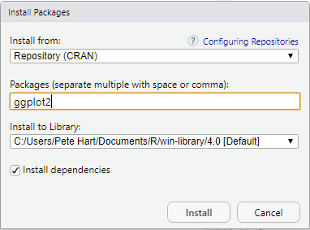

When we click “Install” we will see the progress of the installation in the console. Depending on the package, the installation can take a few minutes. When the installation is finished we will receive a confirmation message in the console.

Our new package should now appear in the list of packages in the “packages” tab.

Installing Packages Using the Console
The command “install.packages()” can be used to perform the same operation as described above. The name of the package to install should be in inverted commas like so:

install.packages(“ggplot2”)
Using Your New Package
Once a package has been installed in R, you will then need to tell R that you want to use it. In the list of packages you will notice that some packages have a tick while most do not. The package we have just installed, ggplot2, does not have a tick. This means that the package has been downloaded (installed) but RStudio is not interacting with it.

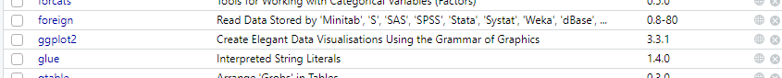

If we want to use the functions or objects from the new package we need to tell R to access it using the “library” command like so:

library(ggplot2)

The functions and objects in the new package are now available to use and a tick has appeared in the list of packages.

Alternatively we can find the package in the list of packages and tick the box using the mouse. You will notice that the library() command appears in the Console window.

