Introduction
This document is part of our “First Steps in R” resources. It is assumed that the reader understands the idea of an object, a function and a package in R. If you would like to recap these topics, the documents and videos are on the MASH website.

Built-in Datasets
When R and RStudio are first installed, several useful packages are installed by default. Two packages in particular contain datasets which are often used for exercises while learning R. The “datasets” package containing 104 datasets is one that is already loaded. This means that all of its datasets are available immediately. To view information on the “datasets” package type the following into the R console:

library(help=”datasets”)

This will give you brief details of the datasets including the name of each and a short description.

The command
data()
will produce a list of the datasets in the “datasets” package.

A second useful package, “MASS”, contains 87 datasets. It is not loaded by default so to access its datasets we must first load the package using the command

library(MASS)

Viewing a Dataset
“mtcars” is a dataset contained in the “datasets” package. We will use this dataset as an example for the rest of this document. Like other datasets in the above packages, it is stored as a data frame in R. Therefore we can view the data by simply typing
mtcars
into the console.

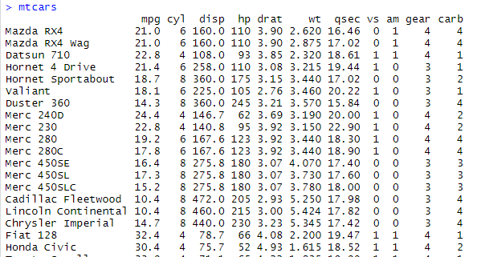

We can find the details of what data is collected and how it is recorded using
?mtcars
The help window then shows us the following:
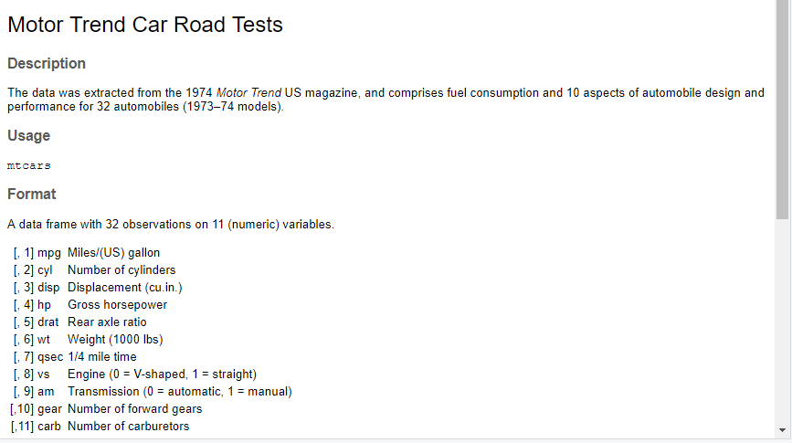

If we want to access one variable from a dataset, we can use “$”. For example

mtcars$cyl

tells R to look at the “mtcars” data frame and then find the variable labelled “cyl”.

Attaching the Dataset
If we are going to work with a dataset a lot we can use the “attach” command like so

attach(mtcars)

Once a dataset is attached, the variables can be accessed without needing to use the “mtcars$” prefix:

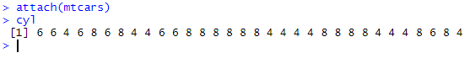
Once you have finished working with the data set, it is good practice to “detach” like so:

detach(mtcars)
Functions for Getting to know a dataset
We can display a full dataset by simply typing the name of the data frame in which it is stored. However, a dataset may be too large to get a feel for the data this way. The following functions are useful for getting to know a dataset:

names()
gives a list of all the column names in the data frame

dim()
gives the number of rows and columns (in that order)
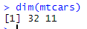
In this example you can see that there are 32 rows and 11 variables in the data frame

nrow() and ncol() can also be used for just the numbers of rows and/or columns

head()
gives the first few rows of the data frame.
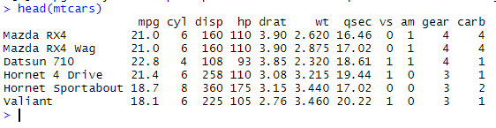

tail() is similar to head() but gives the last few rows.

str()
Stands for “structure”. This gives the number of observations and variables (rows and columns) followed by the name, data type of each column (numerical vector, character vector, logical vector or factor) and the first few entries in each variable:
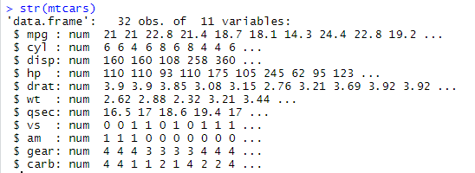
“num” is short for numerical. All the variables in this particular data frame happen to be numerical vectors.
summary()
Gives a summary of each variable in the dataset
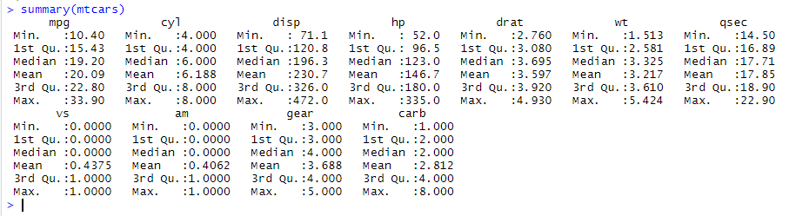
A column which stores a numeric vector gets summarised as above. A column which is stored in R as a factor is summarised with how many times each level appears in the column. To see this try investigating the dataset “esoph” which is part of the dataset package. Hint: type ?esoph to see what data are stored in the dataset then str(esoph) to see which columns are numeric vectors and which are factors. Finally type summary(esoph) to see what the summary of a factor looks like.

Exercise
Use the data() command in the console to view a list of available datasets.
Choose a dataset from the list and find out the following information
- What data are stored in the dataset
- How many sampling units and how many variables there are
- What type of variables the dataset contains (numeric, factor etc)
- The maximum and minimum values of any numeric variables

Initially I chose “InsectSprays”. I typed ?InsectSprays and the following information was displayed in the help window (bottom right):
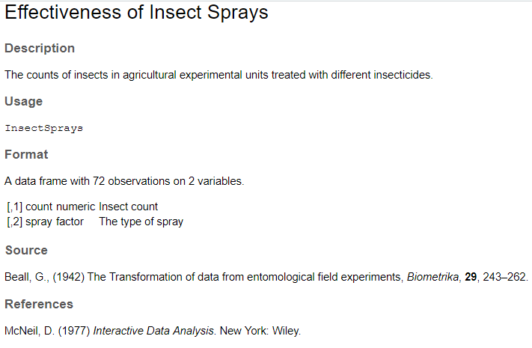

There are two variables in the dataset and 72 observations/sampling units. The first variable is numeric and contains the insect count. The second variable is a factor that codes for the type of insect spray that was used. At this point there is no information on the number of levels of the factor, but the usefulness of using the command ?InsectSprays is that the help window gives you additional information such as the source of the dataset and a description of it.

I then typed str(InsectSprays) to obtain the following info in the Console window, which includes information on the number of level of the factor variable.

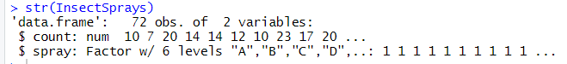

There is only one numeric variable in this dataset so could type summary(InsectSprays$count) to get only the info for this variable:

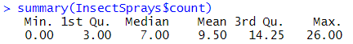

Alternatively could simply type summary(InsectSprays) and get the information for all variables

