Worksheet: Drawing histograms in EXCEL
Example: People with diabetes randomised to either an educational health intervention or care as usual. Key outcomes include quality of life and HbA1c (a measure of how well the diabetes is controlled). Measurements were made at baseline (before the intervention), and 12 months later

In Excel it is possible to create a Histogram using the Data Analysis ToolPak.
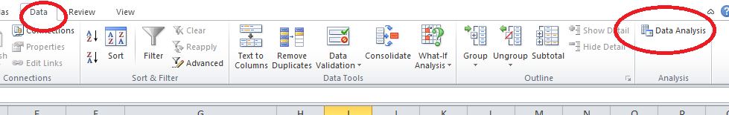

Select Histogram from the Data Analysis dialogue box to open the Histogram dialogue box
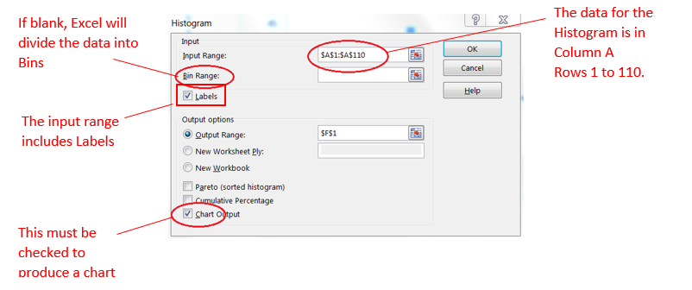

The figure below shows the output. Note that because of the gaps in the bars, this is actually a barchart. A histogram would have no gaps, reflecting the fact that the data are continuous
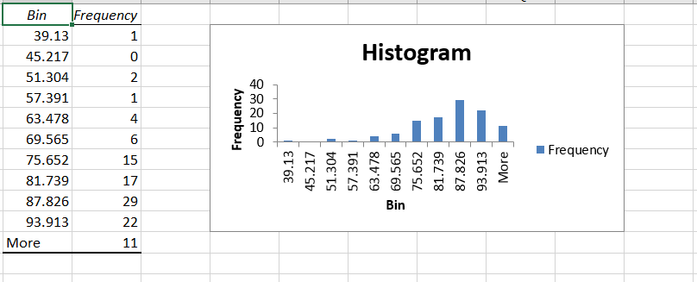
The default chart will need editing to the get the layout correct.

Click on the axis number to open the Format Axis dialog to change the number format and remove the gap between the bars and double click on the axis label to replace ‘Bin’ with a meaningful label
