Worksheet: Paired t-test in EXCEL
Example: Quality of life of people with Type 1 diabetes before an educational intervention and after 12 months. Quality of life is measured from 0 (poorest) to 100 (best)

Data need to be arranged in columns such that the paired observations are in the same row:
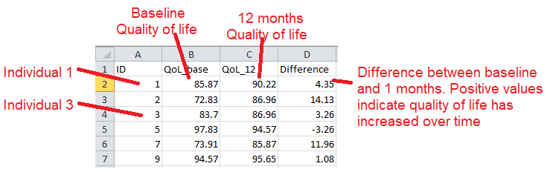

There are two ways to do the paired t-test in EXCEL.
You can either use the T-Test formula:
=T.TEST(A, B, C, D)

Where A= data range for first occasion
B= data range for second occasion
C= 1 if one-sided test
2 if two sided test ***Recommended ***
D= 1 for paired t-test
2 unpaired t-test, equal variances assumed
3 unpaired t-test, equal variances not assumed

For this example there are 109 observations in rows 2 to 110, we want to do a 2 sided test and the data are paired (at baseline and 12 months later) thus the function is:
=T.TEST(B2:B110,C2:C110,2,1)

This gives a single value, the two-sided p-value for a paired t-test = 0.00991723. As this is < 0.05 we say that the result is statistically significant at the 5% level and there is strong evidence to suggest that the population mean difference is not = 0.

Or you can use the data analysis toolpak: 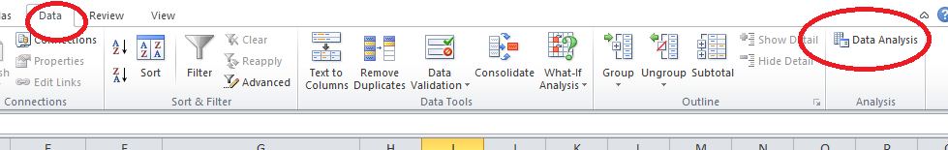

This will open up the Data Analysis dialogue box. Scroll down the list of options until to see t-Test: Paired Two Sample for Means. Select and click OK

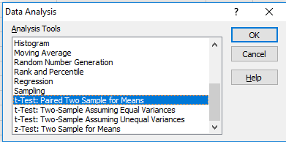

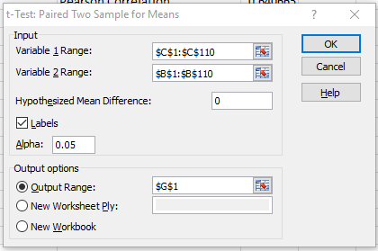
And here’s the output:

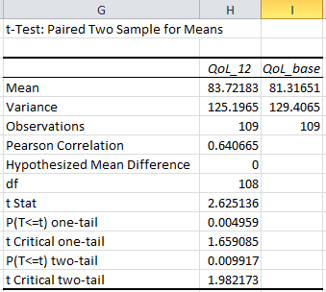

Having obtained a p-value for the difference, it’s useful to know what the mean difference is and what the confidence interval is for this difference. There is no easy way to do this in EXCEL but it can be calculated using a few of the built-in statistics functions.
  - First create a column of the differences between the two time points. You need to decide whether you calculate the difference as {Baseline – 12 months} or {12 months – baseline} as this will affect how you interpret the results

  - Next type in the following formulae:

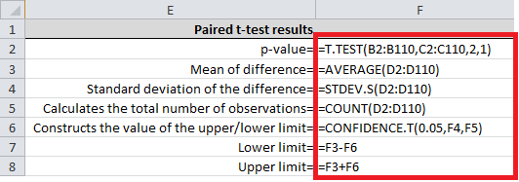

And you will get the following results:
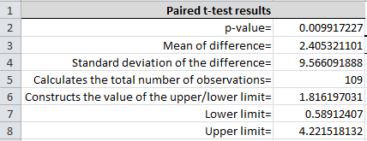

Having obtained the p-value for the difference, calculated the mean difference and its 95% confidence interval, you can now summarise your results:

A group of adults with type 1 diabetes undertook an educational training programme aimed at giving them more freedom and control over what they could eat. A paired t-test was conducted to examine whether there was a change in quality of life from baseline before the programme to 12 months after participation. The result was significant (P<0.01) indicating that there was a significant difference in their quality of life with a positive change of 2.4 (95% confidence interval: 0.59 to 4.22)

