What Does Standard Deviation Measure?
Standard deviation is a measure of how spread out data are. How can we interpret standard deviation? What does it mean if I say one set of data has a standard deviation of 10 and another set of data has a standard deviation of 100? How does this help us picture the data?
You may be familiar with the idea of normally distributed data– often represented by a “bell-shaped” curve.
The two diagrams below represent different sets of data. Both have the same mean (50) but different standard deviations. We can see that a larger standard deviation means the data are more “spread out”
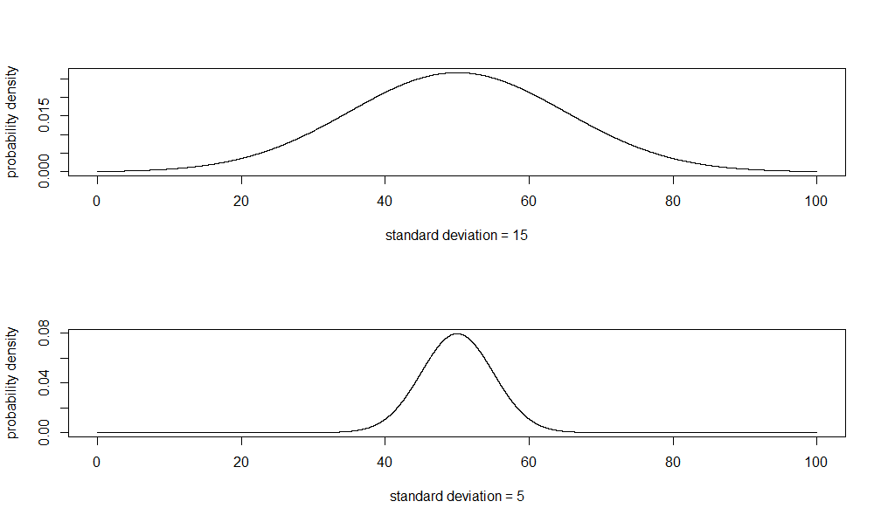
A Practical Rule
Let’s consider a real-life example
A well-used example is height. The height of 10 year-olds in the UK is normally distributed with a mean of roughly 133cm. This means heights near 133cm are common and heights lots taller or smaller are less common. But how unusual is it to be 140cm tall? Or 145cm?
The “68-95-99.7 rule” will help us.
If data are normally distributed (ie. symmetrical):
68% of data are within 1 standard deviation of the mean
95% of data are within 2 standard deviations of the mean
99.7% of data are within 3 standard deviations of the mean
The standard deviation for the height of 10 year-olds is roughly 7cm. So:
68% of 10 year-olds are between 126cm and 140cm (133±7)
95% of 10 year-olds are between 119cm and 147cm (133 ± 2 × 7)
99.7% of 10 year-olds are between 112cm and 154cm (133 ± 3 × 7)

The distribution looks like this as a graph:
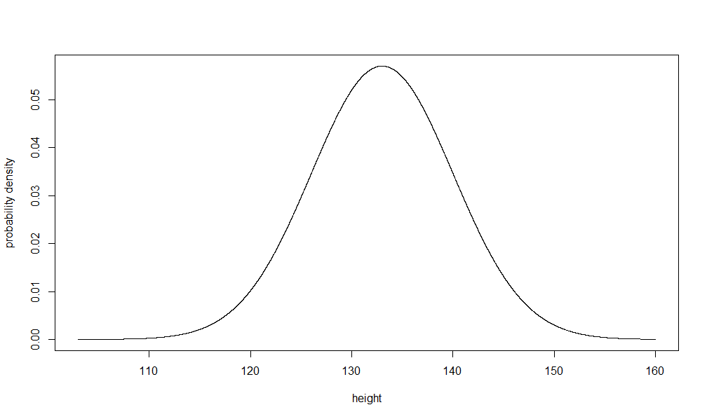
Notation
The mean value (133cm in the above example) is often represented by the Greek letter µ (pronounced “mew.”)
The standard deviation is often represented by the Greek letter σ (pronounced “sigma”)

