Revise With Journosoc: Online Revision sessions by the University of Sheffield Journalism Society

Context: Amidst the uncertainty of the global pandemic, and repatriation of international students, our department announced on April 6 that the remaining in-person exams of National Council for the Training of Journalists were cancelled.
However, on 1st May, we were told that the exams could possibly go ahead remotely, and we should be prepared. This resulted in mass anxiety, with coursemates writing on our group chats, and telling student reps about how their mental health was suffering and they felt unprepared due to strikes and difficulties of online learning.
As the University of Sheffield Journalism Society, we had our first meeting on Zoom after our handovers that week, on the 21st of May.

Decision: We are a departmental society, and discussing the pressing needs that needed to be addressed, we came up with online live zoom Revision Sessions for a content-heavy NCTJ exam that many were particularly worried about as, between strikes and the pandemic, many felt unprepared.
It was the NCTJ Public Affairs exam, on the Power and Society structures of UK, involving a lot of memorisation and analysis of content.
After a unanimous decision by the committee to hold the sessions, we sprang into action immediately, because our exams started on the 8th of June.

Team: Lauren Wilkins as Secretary, Yasmin Waters as Treasurer, Amber Thornton as Welfare and Inclusions Officer, Olivia Ann Schofield as Social Media Officer, Hannah Youds, Emily Pollock and Sam Morris as Social Secretaries, Luke Hansford and Nat Williams as Sports Officers, and me, Sraddha Sabu, as President.
However, as second years, Yasmin, Lauren and Amber, were not taking the exam this year, and some personal commitments for others, the team felt it was ok for some not to be fully involved.
Communication: We communicated regularly on our committee Messenger group. We decided to use our google drive folder as well, and work on the presentations on Google slides. We also personally messaged each other on specific details of tasks.
Our meetings were on Zoom, with shared screen if required.
Issue: Using google sheets for task delegation wasn’t effective at short notice, and messaging was used.

Timeline of Action:

- Deciding the format: As the president, I held a demo meeting to go over how the sessions could work as we had discussed, on the 25th of May.

The format: a visually appealing presentation summarising what we needed to know for the exam, made crib sheets from our lecturer, notes from weekly lectures and our seminars where we discussed contentious issues. We collectively confirmed we would share the screen, explain the slides while inviting discussions for active recall, explore some sample NCTJ exam questions with model answers, and end with a short quiz. Questions were welcome.

I made the first presentation with Hannah’s help , and received extremely constructive feedback from Sam for the demonstration meeting held at short notice before the actual launch.

After finalizing the timing of the sessions to be inclusive for students in different countries with Amber, the sessions were finalized at 4pm BST, around 50 minutes, starting on the 28th of May and ending on the 5th June to give everyone time to prepare for exams. (Some decisions were made at the first and second meeting, others over chat)

- Publicity: Olivia restarted our twitter account, took over our new Instagram account, and updated our facebook page about our new active accounts. She made posters for the Revision sessions in the style of front-page headlines, and after finalizing, posted on Facebook, Twitter and Instagram, Tuesday as announcement.

She posted on the platforms the next day, with a different poster each day, to remind of the first session on Thursday and on the day as well. We posted on Journalism group chats. Issue: Initially we had asked everyone to email us if interested, but we realized that was hard, and created a Facebook event.

Olivia posted on our socials, updated our stories and created the event each day of sessions.

- Sessions Timeline:

- The first session was held on Thursday the 28th of May on the British Constitution and Monarchy by me, with Olivia and Hannah for support. Olivia updated our instagram story with a picture.
- The zoom link was sent on the event page 30 minutes before, and the second zoom link sent when required as well.
- Issue: Initially 16 topics, and we could cover 8-10 at maximum. Started off with the first two topics, but realized that it wasn’t helpful to cover in order as some didn’t need significant explanation. Therefore, with advice, chose harder topics.
- Issue: Red flag raised by Olivia and Hannah that it’d be too stressful to hold them everyday, and I decided that we’d take the weekend off.
- On Sunday, I posted on our chat about delegation, and the week ahead, where we would hold classes everyday.

Date | Session | Slides
1st | Sraddha | Hannah and Sraddha
2nd | Yasmin | Sam and Hannah
3rd | Sraddha | Olivia and Sraddha
4th | Freddie Coates (volunteer attendee) | Freddie Coates
5th | Sraddha | Sraddha and Hannah

- As Secretary, Lauren helped take minutes of meeting, and managed emails throughout.
- After the sessions ended on Friday the 5th, we posted our presentations in a drive on all our social media platforms for everyone to access for revision.

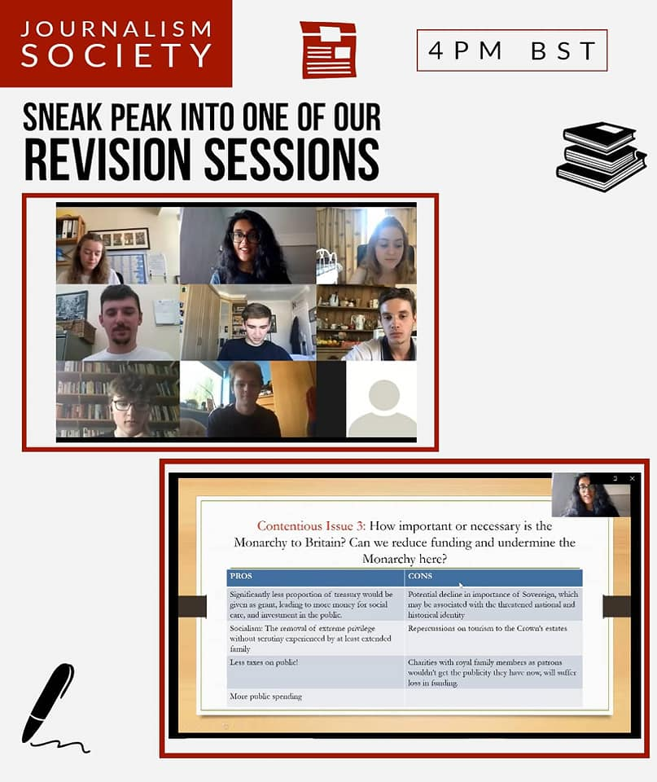

Outcome:
- A total of 11 people attended sessions, 3 attended 5 of sessions, 1 attended 6 of the 7 sessions. Received messages about the slides being helpful, and sent out feedback forms for further comment to improve.
- They said the sessions were helpful for exams, but the results are yet to come.
It was challenging to run, considering we had our final deadlines between the sessions, and exams to prepare for, not to mention personal challenges due to the pandemic. We tried our best under the circumstances.

What we would do differently:
- More group chat publicity, for the MA chat and second-years as well.
- Use a picture with the name of the topic being covered as well on the event page.
- Personally ask coursemates to attend as well.

