DEM SIMULATION OF WET PARTICLES IN A HIGH SHEAR MIXER CONSIDERING LIQUID BRIDGE FORCE
Kimiaki Washino1, Hong Sing Tan2, Michael J. Hounslow1 & Agba D. Salman1
1 Department of Chemical and Biological Engineering, University of Sheffield, Newcastle Street, Sheffield, S1 3JD, UK
2 P&G Technical Centres Ltd, Whitley Road, Longbenton, Newcastle upon Tyne, NE12 9TS, UK
Email: example@sheffield.ac.uk

In many powder handling processes in industry, e.g. wet granulation and coating, liquid is often mixed with the powder in order to increase the cohesiveness and stickiness of the particles. This can change the dynamics of the powder flow significantly, and therefore, can influence the quality of the final products [1].
In this work, the behaviour of dry and wet particles in a high shear mixer was simulated using Discrete Element Method (DEM). For the simulation of wet particles, the pendular liquid bridge force was taken into consideration between a pair of particles. The velocity of the particles obtained by the simulation was compared with experimental results using Particle Image Velocimetry (PIV) in order to check the accuracy and limitation of the simulation model. It was found that the existence of the liquid significantly affected the particle behaviour, and the surface velocities in the simulation and experiment showed a similar fluctuation pattern. The effect of the moisture content and the liquid properties were also examined in the simulation.
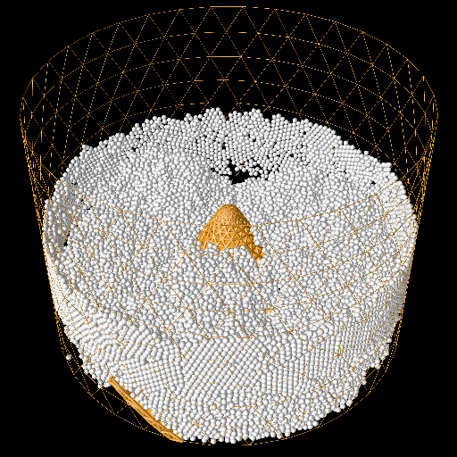
Wet particle flow in a high shear mixer
[1] C.A. Biggs, C.A. Sanders, A.C. Scott, A.W. Willemse, A.C. Hoffman, T. Instone, A.D. Salman, M.J. Hounslow, Coupling granule properties and granulation rates in high shear granulation, Powder Technology, 130 (2003) 162-168.

