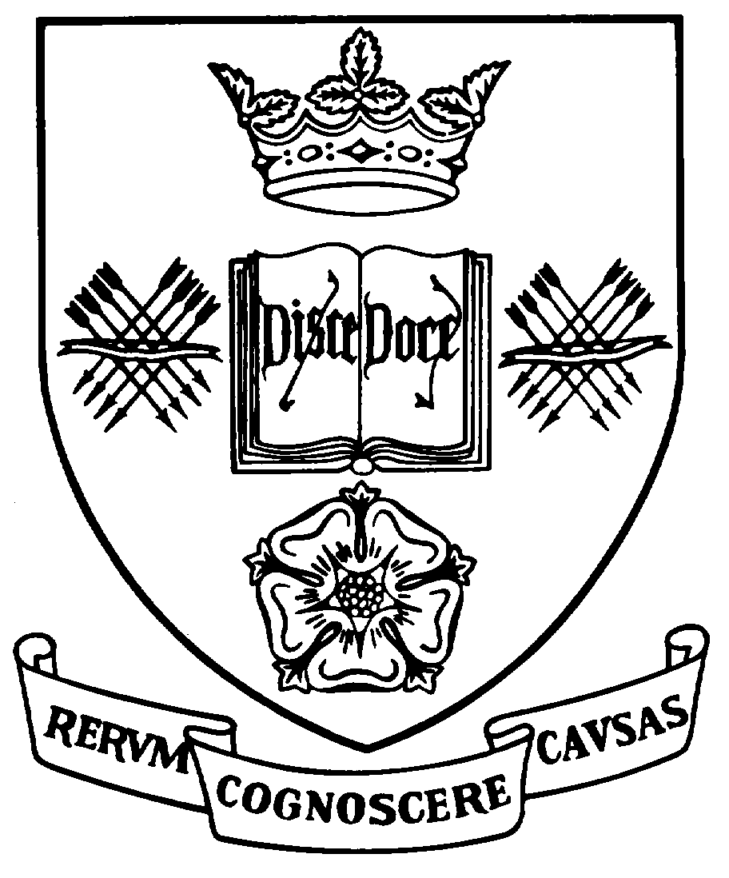
Programme Specification
A statement of the knowledge, understanding and skills that underpin a taught programme of study leading to an award from
The University of Sheffield
1 | Programme Title | Classical and Historical Archaeology
2 | Programme Code | AAPU23
3 | JACS Code | V470
4 | Level of Study | Undergraduate
5a | Final Qualification | Bachelor of Arts with Honours (BA Hons)
5b | QAA FHEQ Level | 6
6 | Intermediate Qualifications | None
7 | Teaching Institution (if not Sheffield) | Not applicable
8 | Faculty | Arts and Humanities
9 | Department | Archaeology
10 | Other Departments involved in teaching the programme | None
11 | Mode of Attendance | Part-time
12 | Duration of the Programme | 6 years
13 | Accrediting Professional or Statutory Body | Not applicable
14 | Date of production/revision | April 2019
15. Background to the programme and subject area
Archaeology is the study of the past through material culture – the objects, monuments, landscapes, texts etc. that human beings have created in the course of the last five million years. The study of Archaeology provides students with a unique insight into humanity’s place in history and in nature, with an appreciation of human creativity, and with an awareness of the diversity and difference of human populations in the past. In this way a degree in Archaeology contributes to the forging of the knowledgeable and tolerant citizen of the 21st century. In addition, it constitutes one of the principal bases on which the burgeoning ‘heritage industry’ is constructed, and so contributes to the economic well-being not only of its graduates but of the country as a whole.
The Department of Archaeology at the University of Sheffield is an acknowledged centre of excellence for teaching and archaeological research. The large number of full-time academic staff, and their complementary research specializations, methodologically, chronologically and geographically, enable us to cover the Classical and historical past of Europe in depth and, unusually, to integrate ‘sciences’ and ‘humanities’ approaches in an imaginative programme of teaching and research.
Within this broad context, our BA in Classical and Historical Archaeology examines the place of the Classical World in the development of Europe, the Mediterranean, and Western Asia, the emergence of the Islamic World and its relations with Medieval Europe, and the material transformations that define the emergence of the Early Modern World. An underlying theme throughout the programme will be the complex and often antagonistic relationship between those communities that emerged from the Western and Eastern components of the Roman Empire.
A degree in Classical and Historical Archaeology provides students with knowledge and understanding of the past, and with the opportunity to acquire the transferable skills valued by employers within and beyond the ‘heritage industry’. These range from the IT skills required for the manipulation of archaeological data sets, through the interpretative skills necessary to write history from them, to the ability and confidence to present arguments clearly in both written and oral form. The Department places emphasis on fieldwork, which enables students to acquire archaeological and other transferable skills, while experiencing the thrill of discovery and appreciating that they are making history.
Archaeology is an established profession that is central to Britain’s ‘creative economy’. It makes a major contribution not only to the social, intellectual and economic well-being of its graduates but also that of the country as a whole (with the heritage sector contributing £21 billion annually to the UK economy). A substantial proportion of our graduates choose careers in archaeology, with some continuing their studies at postgraduate level, and many of our former graduates now hold senior positions in academia and in public and private organisations within the heritage sector. Others have achieved success in a wide range of professional vocations in education, business administration and management, broadcast media and in other fields of employment.
16. Programme aims
Degree programmes offered by the Department of Archaeology have the following general aims:
- Encourage and support learning and teaching in a collegiate environment that is led and stimulated by the research and scholarship of the department’s staff.
- Foster in students an enthusiastic, self-motivated, and reflective approach to their learning.
- Provide a forward-looking and coherent curriculum that is actively moulded by the interests, needs and goals of individual students, and founded on a blend of teaching and learning methods.
- Provide diverse and fair assessments and informative feedback that actively promote learning and reflect the learning outcomes of our programmes.
- Encourage and support students in developing their employability and suitability for academic and professional careers.
- Provide a broad platform of knowledge and understanding in archaeology according with the areas defined by the QAA Subject Benchmark Statement for Archaeology (2007).
- Provide opportunities to acquire subject-specific knowledge and skills within the archaeology of the classical and early historical past of Europe and adjacent regions.
- Foster in students an awareness of the relevance of archaeology and heritage in the contemporary world, in part through an active participation in professional practice and community engagement projects.
- Encourage and support students in the development of a wide range of intellectual, analytical and personal skills that are relevant to their future careers within and beyond archaeology, according with the abilities defined by the Sheffield Graduate.
17. Programme learning outcomes
Knowledge and understanding – upon successful completion of the programme students will have:
K1 | Acquired an understanding of the basic concepts, historiography and the contemporary theoretical debates that inform the study of the Classical and early historical past.
K2 | Acquired a knowledge of the major chronological periods of the Classical and early historical past, and a deeper understanding of selected areas and periods within this broad framework.
K3 | Acquired a familiarity with the evidence used by archaeologists, an understanding of how this evidence is formed, and an appreciation of the fragile nature of the resource.
K4 | Acquired an understanding and practical experience in a wide range of archaeological methods, including field, laboratory and collections based techniques of recording, analysing and interpreting archaeological data.
K5 | Developed an appreciation of different strategies for integrating and interpreting archaeological evidence and constructing narratives of the past.
K6 | Developed an appreciation of the institutional, social, cultural, economic, ethical and political contexts of archaeological research and heritage conservation, and of the professional practice of archaeology and heritage conservation in the UK.
K7 | Developed an understanding of the value of heritage in defining the diversity of living communities, an appreciation of the cultural and political relevance of the past, and an awareness that heritage is a contested and powerful cultural domain.

Skills and other attributes - upon successful completion of the programme students will have:
S1 | Developed a range of skills in acquiring, using and critically evaluating information from a variety of sources, including material, textual and contextual evidence.
S2 | Developed the ability to produce cogent, structured and innovative arguments, supported by evidence and demonstrating a critical awareness of relevant academic ideas and debates.
S3 | Developed the ability to communicate effectively with peers and a range of public and professional audiences.
S4 | Practised core techniques of observation, identification, descriptive recording, analysis and interpretation of archaeological materials during fieldwork, collections-based and laboratory studies.
S5 | Acquired the ability to apply analytical techniques, including statistical methods, and interpret different kinds of archaeological data as a means of establishing an understanding of historical processes.
S6 | Acquired the skills to design, research and present a sustained piece of independent archaeological investigation.
S7 | Developed a flexible and professional attitude towards teamwork, demonstrating respect for others and an appreciation of diversity and cultural difference.
S8 | Developed an ability to recognise and reflect on personal abilities, experience, strengths and weaknesses, and to plan and develop aspirations for future careers.
18. Teaching, learning and assessment
Development of the learning outcomes is promoted through the following teaching and learning methods:
The teaching, learning and assessment strategy of the Department is founded on the principles of coherence of provision, flexibility of choice and progression in the delivery, acquisition and testing of knowledge. It is designed to ensure a move from extensive to increasingly intensive modes from Levels 1 to 3.
Lectures are used to impart essential knowledge at all levels of the curriculum, where the knowledge promoted progresses from general syntheses of current understanding and methods of analysis at Level 1 towards a more research and problem orientated delivery at Level 3. Interactive, large-group classes allow students to develop and evaluate their comprehension of knowledge and concepts.
Seminars are used throughout the programme to deepen students’ understanding and comprehension of knowledge and concepts introduced in lectures, and to develop their skills and abilities in the following areas: acquiring, using and critically evaluating information from a variety of sources; applying different strategies for interpreting archaeological evidence; producing cogent arguments, supported by evidence; demonstrating a critical awareness of relevant academic ideas; communicating effectively with peers and responding constructively to the presentation of alternative views.
Practical Classes take place in a range of settings: laboratories, historic landscapes, museums, and archaeological excavations. The classes introduce students to the evidence used by archaeologists and develop their understanding of how this evidence is formed. They allow students to practise core techniques of observation, identification and classification, descriptive recording, analysis and interpretation of archaeological materials, and to apply analytical techniques, including statistical methods, and interpret different kinds of archaeological data. The group-based tasks during practical classes enable students to develop a flexible and professional attitude towards teamwork.
Tutorials provide opportunities for students to discuss their academic progress with unit and personal tutors. Group feedback tutorials are used throughout the programme to provide specific guidance on both formative and summative assignments, and to help students recognise and reflect on their abilities, achievements and experience. Individual supervision tutorials are employed at Level 3 in support of the dissertation, during the course of which tutors monitor students’ progress in meeting their self-defined milestones in their research projects. Students also meet their personal tutors on four occasions in each academic year to review and reflect upon their academic progress and to plan and discuss their aspirations for their future careers.
Placements form a part of the learning strategy in the optional Level 3 unit ‘Work Place Learning’. The placements are organised independently by students, with tutorial support from the placement supervisor. Students work with research projects and professional organisations to acquire advanced subject-specific knowledge and skills; to develop a reflective and self-motivated approach to learning; an ability to recognise and reflect on personal abilities, experience, strengths and weaknesses; and to plan and develop aspirations for their future career.
Independent Study is essential to the successful completion of the programme. Students are expected to spend the majority of their learning hours in all units undertaking guided reading that is related to their taught classes, as well as completing their assignments, preparing for examinations and (at Level 3) in carrying out their independent dissertation research.

Opportunities to demonstrate achievement of the learning outcomes are provided through the following assessment methods:
The department aims to provide diverse, fair and accessible assessments and feedback that actively and effectively promote learning and provide an accurate and reliable measure of the learning outcomes of our degree programmes. Formative assessment is integral to our assessment strategy at all Levels. It is used to monitor students’ progress and to provide them with the rapid feedback they need in order to evaluate their own learning and to reflect upon the knowledge and understanding that they have acquired. Summative assessment is used to promote learning, to gauge depth of knowledge and understanding and to monitor students’ progress. The structure of our teaching allows us to give students, on completion of each unit, feedback on their summative assignments. This provides them with the means to evaluate their progress, to make informed choices about the structure and direction of their programme, and to reflect upon the knowledge and understanding they have acquired.
Essays assess students’ familiarity with and understanding of the concepts, debates and material evidence that inform the study of the human past, and their skills in acquiring, using and critically evaluating information, and producing coherent arguments supported by evidence and demonstrating a critical awareness of relevant academic debates. Short essays (up to 1000 words) are used in conjunction with resource evaluation exercises at Level 1, with longer essays employed within units at levels 2 (typically 1000 words formative and 2000 words summative) and 3 (1500 formative and 3000 summative).
Unseen examinations are used to assess the breadth of students’ familiarity with and understanding of the concepts, debates and material evidence that inform the study of the human past, and their skills in producing cogent arguments, supported by evidence and demonstrating a critical awareness of relevant academic arguments. Most unseen examinations at Level 1 use multiple choice questions, while most unseen examinations at Level 2 require short answers responding to visual material or primary textual sources.
Portfolios and Lab-books are used at all levels to assess students’ understanding of archaeological methods, and their skills in descriptive recording, analysis and interpretation of archaeological materials during fieldwork, collections-based and laboratory-based studies.
Reports are used at all levels to assess students’ ability to apply analytical techniques, including statistical methods, and interpret different kinds of archaeological data as a means of establishing an understanding of historical processes. Reports submitted in the core units at Levels 1 and 2 are based on group work, and so assess students’ flexible and professional attitude towards teamwork, and their ability to present the results of an archaeological research project.
Reflective writing forms a minor component of assessments at all levels. It assesses students’ ability to recognise and reflect on personal abilities, experience, strengths and weaknesses, and to plan and develop aspirations for future careers.
The Dissertation is an extended piece of writing, up to 10,000 words in length, which assesses the students’ ability to design, research and present a sustained piece of independent archaeological investigation. The dissertation unit at Level 3 includes a dissertation research design and an oral presentation, which are assessed in order to provide formative feedback on their progress.
Oral presentations, posters and exhibitions are used at all levels to assess students’ ability to communicate effectively with peers and a range of public and professional audiences.
Over the course of the programme, the balance between the different modes of assessment changes as the units taken become more specialised and research-led, and as students become more proficient in generic and subject-specific skills. At Level 1, the balance for most units is 50% on coursework written throughout the term, and 50% on the end-of-term unseen exam. At Level 2, there is a shift towards assessing depth of knowledge and understanding with coursework constituting 60%, and examinations (designed to assess ‘breadth’) 40% of the marks. The more specialised units, normally flowing directly from the research interests of staff, offered at Level 3 are assessed by coursework. These, along with the dissertation, provide students with an opportunity to demonstrate the achievement of the programme learning outcomes.
19. Reference points
The learning outcomes have been developed to reflect the following points of reference:
Subject Benchmark Statements
http://www.qaa.ac.uk/AssuringStandardsAndQuality/subject-guidance/Pages/Subject-benchmark-statements.aspx
Framework for Higher Education Qualifications (2008)
http://www.qaa.ac.uk/Publications/InformationAndGuidance/Pages/The-framework-for-higher-education-qualifications-in-England-Wales-and-Northern-Ireland.aspx
University Strategic Plan
http://www.sheffield.ac.uk/strategicplan
Learning and Teaching Strategy (2011-16)
http://www.shef.ac.uk/lets/staff/lts
The teaching ethos of the Department of Archaeology as articulated through its Teaching Committee and the annual Away Day held to reflect upon Departmental practice in teaching and research.
The research interests of Departmental staff and the research strategy of the Department of Archaeology.
20. Programme structure and regulations
At Level 1 students take 80 credits of core units which provide them with an overview of the concepts and historiography of archaeology, together with an introduction to the archaeology of the Classical past and of the role of Greco-Roman civilisation in shaping modern western culture. A further 40 credits are chosen from an unrestricted selection including Archaeology modules and unrestricted F4 units. Professional development is a non-credited requirement composed of attendance at careers week activities in semester one and a fieldwork requirement of two week field course (or appropriate work experience) at the end of the second semester. Students are strongly encouraged to take advantage of a choice of Departmental further training projects held in the Summer and perhaps Easter vacations to contribute to the cumulative 6 week work experience requirement by the end of semester 1, level 3. Students are expected to demonstrate a broad knowledge of the role of archaeology in the study of human prehistory and early history and of the relevance of the past to the present.
At Level 2 students take two compulsory 20-credit modules: one designed to enhance their understanding of key conceptual issues in the recent history of archaeology as a discipline and in its relevance to contemporary society; and one exploring the interplay between archaeology and text in the study of the human past. Students take a further 60 credits from a range of modules most of which are focussed on a particular period and area of European historic archaeology and integrate a range of humanities and scientific approaches. Students’ remaining 20 credits are taken from unrestricted modules within and beyond Archaeology. Professional development is a non-credited requirement composed of attendance at careers week activities in semester one and a fieldwork/work experience requirement at the end of the second semester. Students are strongly encouraged to take advantage of a choice of Departmental further training projects held in the Summer and perhaps Easter vacations to contribute to the cumulative 6 week work experience requirement by the end of semester 1, level 3. Students are required to demonstrate an understanding of a broad corpus of archaeological evidence relevant to the analysis of specific issues relating to the European Classical and early historical past.
At Level 3 (from 2016-17), students will take a 40-credit dissertation in Archaeology, a 20-credit core module on a particular archaeological theme of contemporary relevance, 40 credits from a range of special research-led options (20 of which may be Science options), and unrestricted modules to the value of 20 credits. Professional development is a non-credited requirement composed of attendance at careers week activities in semester one. By the end of the Level 3, students will have developed the ability to manage their own learning, review scholarly sources of primary information, and will thus have achieved the ability to undertake original analysis directed at specific research themes.
The Department covers the cost of the Level 1 compulsory field training. Students can apply for some funds towards subsistence costs while carrying out independent fieldwork/work experience.
Detailed information about the structure of programmes, regulations concerning assessment and progression and descriptions of individual modules are published in the University Calendar available on-line at http://www.sheffield.ac.uk/calendar/.

21. Student development over the course of study
By the end of Level 1 students will have:
- Acquired an understanding of the concepts and historiography that inform the study of the human past, and a knowledge of Classical and early historical archaeology.
- Acquired a familiarity with the evidence used by archaeologists, an understanding of how this evidence is formed and practical experience in a range of archaeological methods of recording, analysing and interpreting archaeological data.
- Developed an introductory understanding of the value of heritage in defining the diversity of living communities, and an appreciation of the cultural and political relevance of the past.
- Developed basic skills in acquiring, using and critically evaluating information from a variety of sources, including material, textual and digital evidence.
- Developed the ability to communicate effectively for a range of public and professional audiences, and to produce academic arguments, supported by evidence and demonstrating an awareness of relevant academic ideas and debates.
- Practised core techniques of observation, identification, descriptive recording and interpretation of archaeological materials during fieldwork, collections-based and laboratory studies.
- Acquired introductory familiarity with the process of designing, researching and presenting a piece of archaeological investigation as part of a team.
- Developed a flexible and professional attitude towards teamwork, demonstrating respect for others and an appreciation of diversity and cultural difference.
In addition, by the end of Level 2 students will have:
- Acquired an understanding of the contemporary theoretical debates that inform the study of the human past, together with an understanding of selected periods of Classical and early historical archaeology.
- Acquired a deeper familiarity with the evidence used by archaeologists, an understanding of how this evidence is formed, and an appreciation of the fragile nature of the resource.
- Acquired further understanding and practical experience in field, laboratory and collections based techniques of recording, analysing and interpreting archaeological data.
- Developed an understanding of the value of heritage in defining the diversity of living communities, an appreciation of the cultural and political relevance of the past, and an awareness that heritage is a contested and powerful cultural domain.
- Developed the ability to communicate effectively with peers and a range of public and professional audiences, and the ability to produce cogent, structured arguments, supported by evidence and demonstrating a critical awareness of relevant academic ideas and debates.
In addition, by the end of Level 3 students will have:
- Acquired a deep knowledge and understanding of selected themes and periods within Classical and early historical archaeology.
- Acquired an advanced understanding and practical experience in selected archaeological methods of recording, analysing and interpreting archaeological data, and developed an appreciation of different strategies for integrating and interpreting archaeological evidence and constructing narratives of the past.
- Developed the ability to produce cogent, structured and creative arguments, supported by evidence and demonstrating a critical awareness of relevant academic ideas and debates.
- Acquired the skills to design, research and present a sustained piece of independent archaeological investigation.
Students are required to monitor their own progress over the three years of the programme by the preparation of a Personal Development Portfolio.
22. Criteria for admission to the programme
Detailed information regarding admission to the programme is available in the University’s On-Line Prospectus at http://www.shef.ac.uk/prospective/
23. Additional information
For further information students are directed to the Departmental web pages at http://www.shef.ac.uk/archaeology
This specification represents a concise statement about the main features of the programme and should be considered alongside other sources of information provided by the teaching department(s) and the University. In addition to programme specific information, further information about studying at The University of Sheffield can be accessed via our Student Services web site at www.shef.ac.uk/ssid.

