
Programme Specification
A statement of the knowledge, understanding and skills that underpin a taught programme of study leading to an award from
The University of Sheffield

1 | Programme Title | Musculoskeletal Health and Ageing
2 | Programme Code | HMCT05
3 | JACS Code | B190
4 | Level of Study | Postgraduate
5a | Final Qualification | Master in Research
5b | QAA FHEQ Level | Level 7
6a | Intermediate Qualification(s) | None
6b | QAA FHEQ Level | Level 7
7 | Teaching Institution (if not Sheffield) | University of Liverpool and Newcastle
8 | Faculty | Medicine, Dentistry and Health
9 | Department | Human Metabolism
10 | Other Departments involved in teaching the programme | Oncology
11 | Mode(s) of Attendance | Full-time
12 | Duration of the Programme | 1 year
13 | Accrediting Professional or Statutory Body | Not applicable
14 | Date of production/revision | November 2019, April 2020
15. Background to the programme and subject area
As part of the Centre for Integrated research into Musculoskeletal Ageing (CIMA) funded by Medical Research Council (MRC) and Versus Arthritis, CIMA postgraduate students will receive multidisciplinary research training aimed at giving an integrated view of the musculoskeletal system as a whole in the context of ageing, with topics ranging from basic science to clinical aspects, from in vitro to in vivo models, the latest advances in the assessment of the musculoskeletal system and lifestyle interventions. Most of the training will be ‘hands on’ in the laboratory on a project of choice. Students will have access to state of the art research facilities across the three institutions in Sheffield, Liverpool and Newcastle. All research projects will be collaborative among CIMA members. Although primarily based at one of the three institutions, it will involve exchange visits and placements in at least one of the other sites. The training has a strong intersectorial component to ensure the skills developed by the students reflect those needed by employers whether in the academic or private sector. Each student will have the possibility to interact with the funders and their work of advocacy and public engagement, with industrial partners.
16. Programme aims
The aims of the programme are to supply researchers:
- With an integrated knowledge of the healthy musculoskeletal system as a whole and the changes it undergoes with age;
- With the ability to appraise and use appropriate model systems to study the musculoskeletal (MSK) system in health and as a result of ageing, the latest assessment technologies and interventions leading to healthier ageing;
- With an optimal range of complementary skills(including flexibility, networking, intersectorial knowledge, self-management and understanding of career development strategies) such that they are capable of interacting across disciplines and sectors and are of lifelong benefit to academic, industrial and public sector employers.

17. Programme learning outcomes
Knowledge and understanding:
Candidate for MRes will be able to:
K1 | Discuss mechanisms of bone, muscle, cartilage and tendon maintenance and how they are affected by ageing.
K2 | Evaluate ageing using systems approaches.
K3 | Critically appraise in vitro and in vivo models to study the MSK system and mechanisms of ageing.
K4 | Evaluate potential interventions to slow the ageing process and best method of assessment (experimental and clinical).
K5 | Perform a range of experimental techniques and methodologies relevant to the MSK ageing discipline, including data analysis and the use of statistics.

Skills and other attributes:
S1 | Flexible approach to work, ability to work in multidisciplinary environment and with multiple teams, ability to network.
S2 | Scientific and lay communication, including written and oral and information technology skills.
S3 | Scientific integrity and accountability, ethics and confidentiality.
S4 | Understanding of the principle of Commercialisation of research and acquisition of funding.
S5 | Self and Scientific project management, personal effectiveness.
S6 | Career development and commitment to professional development.
18. Teaching, learning and assessment
Development of the learning outcomes is promoted through the following teaching and learning methods:
 | Learning and Teaching methods
 | E-learning (online lectures ) | Seminars (online and face-to-face) | Tutorials (online and face-to-face) | Work placement / exchange visit | Doctoral Development Programme | Workshops | Individual and group meetings | Independent study
K1 | X | X | X | X |  |  | X | X
K2 | X |  |  |  |  |  |  | X
K3 | X |  | X | X |  |  |  | X
K4 | X | X |  |  |  |  | X | X
K5 |  |  | X | X
S1 |  | X |  | X |  |  | X | X
S2 |  |  | X | X | X | X
S3 |  |  | X |  | X | X |  | X
S4 |  |  | X |  | X | X
S5 |  |  |  | X | X | X |  | X
S6 |  |  | X |  | X | X

Opportunities to demonstrate achievement of the learning outcomes are provided through the following assessment methods:
 | Formative Assessment Methods |  |  | Summative Assessment Methods
 | Problem solving / MCQs | Data analysis (online and laboratory) | Training needs analysis | Written exam (including MCQs & SAQs) | Presentations | e-portfolio / Self-assessment  (online) | Thesis / Research project
K1 | X |  | X | X | X | X | X
K2 | X |  | X |  | X
K3 | X | X | X | X | X | X | X
K4 | X | X | X | X |  | X
K5 |  | X | X | X | X | X | X
S1 |  |  | X |  |  | X | X
S2 |  |  | X | X | X | X | X
S3 |  | X | X |  | X | X | X
S4 |  |  | X |  |  | X
S5 |  |  | X |  |  | X | X
S6 |  |  | X |  |  | X
Sixty credits will be awarded from assessing the taught component which is delivered by e-learning. The assessment will be online and a combination of written examinations (i.e. MCQs, short answers, problem solving) and presentations to their peers in equal parts. During the course formative assessment will be given in the form of activities such as problem solving and data analysis or questions in relation to a given scientific paper to demonstrate their critical ability. These will be given online and answers will be available in a separate window when the answer is short. In contrast for activities where critical thinking is required feedback will be delivered by the unit leader and/or their peers through online discussions.
During the research project (at the start and 4 months into the project) the student will carry out a training needs analysis with the supervisors and the academic tutor (plus the industrial mentor if the student has requested one) and based on this will identify training activities (from a wide ranges of workshops, seminars, DDP and units available within CIMA) . The expected training activities should be equivalent approximately to 200 hours of study time and will be assessed through an e-portfolio, where the student will report the aims of the training activity, what has learned through it and what changes they intend to undertake in their day to day working practise to implement what they have learnt. The supervisors and tutor will have the opportunity to comment on their self-reflection. Part of the project is also a placement of at least 3 weeks in another laboratory. This will be assessed in a similar way through the e-portfolio. The research project will be assessed through a written thesis and an oral presentation. The e-portfolio will be evaluated with the thesis at the end of the project unit. The number of credits for this part will be 120. The mark will be weighted 70% by the quality of the thesis, 10% by the oral presentation and 20% by the e-portfolio. The quality of the e-portfolio will be assessed based on the quality of the training needs analysis, particularly quality of the evidence given to justify the level achieved in a given skill, activities undertaken and quality of the reflection after the activities. The thesis and the e-portfolio will be marked by an independent assessor and by the supervisors. The student will be able to show the e-portfolio to any prospective employer.
The pass mark is 50%, with possibility of one re-sit with the mark capped at 50%. For the award of distinction the student will require to obtain a mark of 70% or above in the research project, for the award of merit the student will require to obtain a mark of 60% or above in the research project.

19. Reference points
The learning outcomes have been developed to reflect the following points of reference:
- The University Learning, Teaching and Assessment Strategy https://www.sheffield.ac.uk/staff/learning-teaching/our-approach/strategy2016-21/contact
- Departmental Learning, Teaching and Assessment Strategies.
- The University’s plan for the future http://www.shef.ac.uk/ourplan/what-we-stand-for/our-vision.
- Departmental activities such as research.
- Feedback from external examiners.
- Liaison with employers if it can be evidenced that these routinely inform programme development.
- Requirements of professional or statutory bodies for accredited programmes.
The programme has been externally peer reviewed as part of the CIMA application to MRC and Arthritis Research UK and was praised for its innovative aspects. It has been discussed with the Head of Department of Human Metabolism, academic staffs within CIMA (Including Newcastle and Liverpool),. It has a high content in research and complementary skills development. It is multidisciplinary and intersectorial with possibility of networking with industrial partner, with funders, and placements in different laboratories within CIMA.
It has been designed taking into consideration benchmark statements from Biosciences Honours level qualification and added value using the Masters level framework qualification.
The design has taken into account a market research held among industrial employers on the skill gap of postgraduate researchers and what universities can do to fill that gap and on a piece of research carried out by L Lee and I Bellantuono on skills important for academic outputs (published in Int. J. Researcher Dev. 2010, 1: 84-96).
Moreover, a review of the UK government’s policy in this area has demonstrated that it is one of the government’s aim to increase the number of people aged 50+ in employment by over 1 million, so that 80% of people of working age are employed. If these aims were achieved, the ratio of workers to non-workers would be the same in 2050 as it is now, despite the increasing age of the population. According to HSE review of the literature on ageing and work-related musculoskeletal disorders (2010) between the ages of 51 and 62 years, the prevalence of musculoskeletal disorders may increase as much as 15% among workers, with more pronounced increases occurring in physically demanding occupations. This, in turn, leads to increasing costs for sick leave and health care and a further increase in number is expected over 65 years of age. The need to target the area of musculoskeletal disorders to keep more people over 65 in work is high on the government agenda as highlighted by the response to the government’s response to the Sickness Absence Review (2013). This requires professionals with a broad understanding of the musculoskeletal system, how it ages and how we can devise new cost-effective intervention. The need for capacity building in this area is reflected by the fact that this area is a priority across all research councils.
It will be continually appraised for quality through feedback from students, unit leaders, external examiners, employers, funders, CIMA external advisory board.

20. Programme structure and regulations
Provide an overview of the structure of the programme
A graphic representation of the programme is below. There will be 4 units delivered by e-learning (total 60 credits) to provide the initial background on ageing, the musculoskeletal (MSK) system, methodologies to study the MSK apparatus and the state of the art on intervention. These modules will be delivered in a way the student will start forming the ability to critically evaluate information. The students will then start the main research project and will attend seminars, tutorials or courses depending on the training needs identified in a flexible way. This will be self-assessed through the e-portfolio and discussed with the supervisors and tutors. The majority of the skills will be put into practise during the research project unit. During this time the students will be given the possibility to present their work to at least one CIMA meeting and to industrial partners, they will visit another laboratory within CIMA for at least 3 weeks. They will be encouraged to visit the funders (AGE UK) for a one day visit to learn about process of funding, their work on advocacy and public engagement. It is expected they will take part to at least one event organised by age UK in engaging the public after that. The research project will be assessed by submission of a thesis. The complementary activity through the e-portfolio.
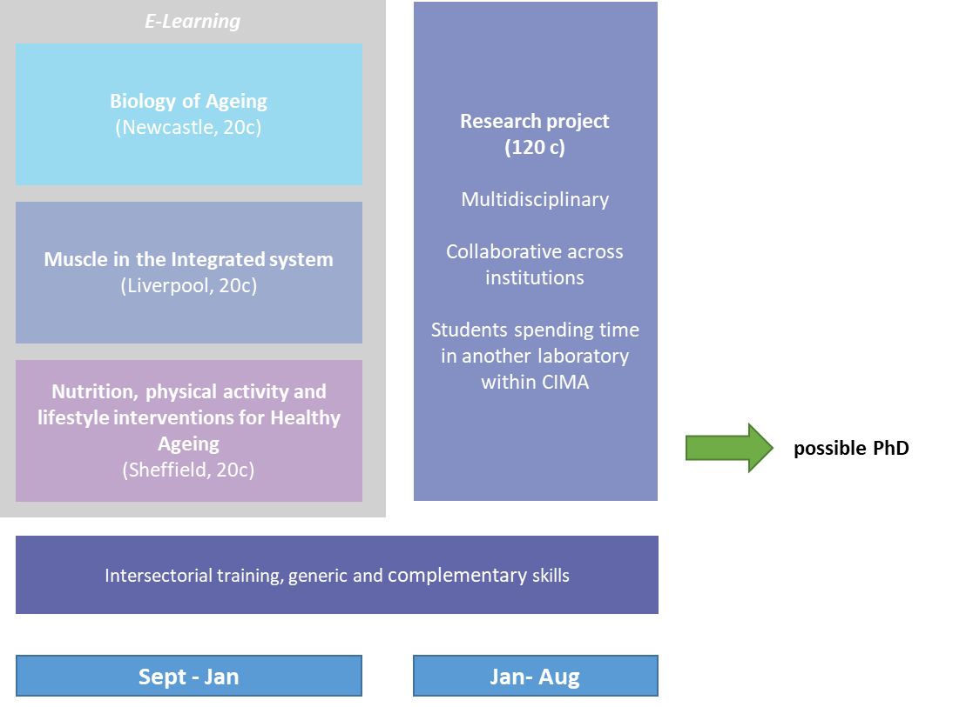
Detailed information about the structure of programmes, regulations concerning assessment and progression and descriptions of individual modules are published in the University Calendar available on-line at http://www.sheffield.ac.uk/calendar/regs.html.
21. Student development over the course of study
In the initial 4 units the student will acquire knowledge on the healthy MSK system and about ageing, methodologies to study it and the available interventions focused towards healthier ageing. During this period the Units will progressively introduce the students to critically evaluate data and information, to present to their peers using a variety of communication means. With the start of the research project the students will put into practise some of what they have learnt in the taught component, learning to plan their own work, critically appraise it and putting it in the context of the literature already available. They will gain experience in data analysis and statistics. All of these will be reported and assessed through their thesis. All projects will be collaborative and therefore the students will learn to work as part of teams, be flexible and able to communicate with a variety of people. Through the training needs analysis the student will be encouraged to self-manage his own learning, more similarly to a working situation. Flexibility and ability to gain quickly the missing knowledge has been highlighted as important from employers outside academia. Particular attention will be given to area of commercialization, gaining funding and public engagement and advocacy, career development. These areas have been recognised as important to develop successful researchers according to our study on skills. Workshops in those areas are already available within the Faculty of Medicine, Dentistry and Health through the “Think Ahead” programme. The students will have the opportunity to network with future employers, particularly industrial partners and other academics by presenting their work to at least one CIMA meeting and attending events organised by InKForge. This is a programme for postgraduate researchers to develop their knowledge of working with industry. The students will be helped in this process by their supervisors and tutor who will act as a sounding board. Students will keep a record of their learning experience through the e-portfolio who they will be able to present to any future employer.
22. Criteria for admission to the programme
Detailed information regarding admission to programmes is available from the University’s On-Line Prospectus at http://www.shef.ac.uk/courses/.
A good honours degree (first or upper second) in a biomedical-related subject. Overall IELTS grade of 6.5 with a minimum of 6.5 in each component.
23. Additional information
This specification represents a concise statement about the main features of the programme and should be considered alongside other sources of information provided by the teaching department(s) and the University. In addition to programme specific information, further information about studying at The University of Sheffield can be accessed via our Student Services web site at http://www.shef.ac.uk/ssid.
This programme has a cost of £3000 to cover research expenses (£500 of which is to cover travelling and accommodation costs during the 3 weeks placement in another laboratory within CIMA).
http://www.shef.ac.uk/humanmetabolism/prospectivepg
http://www.cimauk.org/

