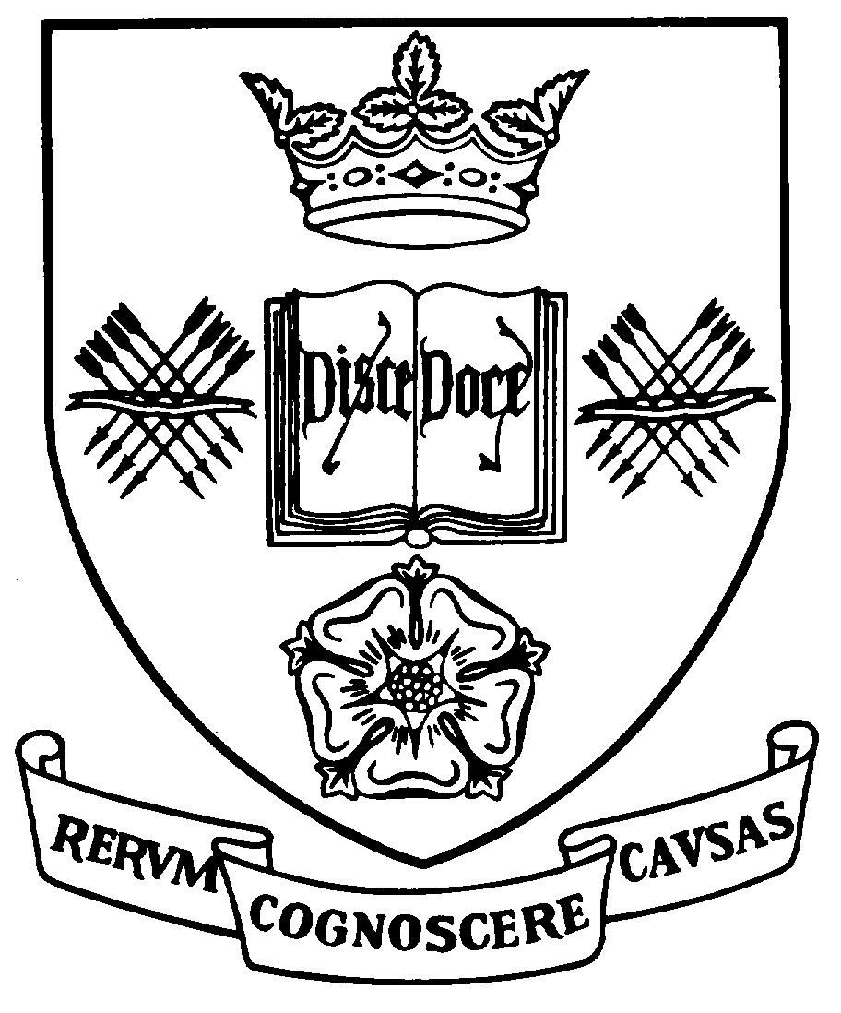
Programme Specification

A statement of the knowledge, understanding and skills that underpin a taught programme of study leading to an award from
The University of Sheffield
1 | Programme Title | Modern Languages and Cultures
2 | Programme Code | MDLT43
3 | JACS Code | R000, T371
4 | Level of Study | Postgraduate
5a | Final Qualification | Master of Arts (MA)
5b | QAA FHEQ Level | Masters
6 | Intermediate Qualification | Postgraduate Diploma (PG Dip), Postgraduate Certificate (PG Cert)
7 | Teaching Institution (if not Sheffield) | Not applicable
8 | Faculty | Arts and Humanities
9 | Department | School of Languages and Cultures
10 | Other Departments involved in teaching the programme | None
11 | Modes of Attendance | Full-time or Part-time
12 | Duration of the Programme | 1 year or 2 years
13 | Accrediting Professional or Statutory Body | None
14 | Date of production/revision | August 2018
- Background to the programme and subject area
The MA in Modern Languages and Cultures (hereafter MAMLC) offers students who have successfully completed a degree in a relevant area (and obtained a minimum 2:1 or equivalent) an opportunity to undertake higher-level work and obtain a specialist qualification, focusing on a single discipline or engaging in interdisciplinary or comparative studies.
Structured, flexible, and informed by nationally and internationally recognised expertise within the School of Languages and Cultures, the MA is designed to meet the needs of students with a background in any area of specialism in Germanic, French, Spanish, Latin American, Catalan, or Russian and Slavonic Studies where staff research and teaching expertise exists in the School. The MA combines a dissertation, core Research Methods in Modern Languages and Cultures module, Directed Reading, specialist academic modules, and generic skills training. Its broad and flexible range of options are designed to enable students to develop specific areas of interest to a high level, pursuing either a single or multiple specialism(s).
PG Diploma will be available for students who take 120 credits (not including the Dissertation module).
PG Certificate will be available for students who take 60 credits from the two core modules “Topics in Modern Languages & Cultures (1 and 2)”.
For further details see: https://www.sheffield.ac.uk/postgraduate/taught/courses/2019/modern-languages-and-cultures-ma
- Programme aims
Programmes offered by the School of Languages and Cultures have the following general aims consonant with the Mission Statement of the University of Sheffield:
The Masters Degree, Postgraduate Diploma and Postgraduate Certificate all aim
- To provide high quality teaching at undergraduate and postgraduate levels that reflects the range and vitality of Modern Languages and Cultures;
- To provide a stimulating and effective environment for the study of Modern Languages and Cultures;
- Drawing on the research expertise and scholarship of staff, to involve students in new thinking and approaches in Modern Languages and Cultures;
- To provide an environment that is intellectually challenging but supportive and flexible;
- To foster the development of intellectual qualities, linguistic and cultural skills and other competences that will enable students to benefit fully from these opportunities;
- To encourage and prepare students to put their knowledge, understanding and skills to good use on leaving university;
- To sustain a research culture that is stimulating, productive and open, and that promotes the acquisition of intercultural awareness and informed, tolerant and professional attitudes to the languages and cultures studied.
The Masters Degree and the Postgraduate Diploma specifically aim:
- To provide opportunities for high-level work to graduates with a background in Languages and Cultures who wish to work within and across disciplines;
- To offer students a programme that is qualitatively different from BA-level study by maximising opportunities for independent enquiry, reflective practice, and work on more challenging material.
The Masters Degree specifically aims:
- To prepare students with potential for further research, by combining academic study, a specialist dissertation, and a substantial research training element;
- To focus on generic research and learning skills, including the critical evaluation of material, problem solving, high-level oral and written communication, time management, and key strategies and conventions for publishing research;
- Through the dissertation, to foster the development of intellectual qualities and organisational skills essential for higher-level research;
- By these means to ensure that the student is well-placed to prepare a cogent, fresh and rigorous MPhil/ PhD proposal and to obtain financial support for further study.
The Masters Degree and the Postgraduate Diploma specifically aim:
- To provide a higher-level qualification for graduates seeking to develop their intellectual potential and enhance their intellectual and professional profile;
- To offer a broad and flexible range of options, including directed reading modules, to enable students to develop specific areas of interest to a higher level and research them in greater depth than is possible in BA-level study;
- The dissertation undertaken by all students on the Masters Degree is designed to deepen further subject knowledge, to provide a broader range of opportunities to apply relevant research methodologies to selected primary and secondary materials, and to hone critical evaluation and language skills.

17. Programme learning outcomes

Knowledge and understanding
Students achieving the Masters Degree or the Postgraduate Diploma will have developed:
K1 | An understanding of research methods and techniques and their effective application within and (where relevant) outside of Modern Languages and Cultures.
K2 | An appropriately critical understanding of relevant primary and secondary sources, advances in the field of study, and the contexts in which study and research take place.
K3 | Enhanced intercultural awareness and/or knowledge of the target language(s) sufficient for their productive and receptive use in the field of study.
In addition, students achieving the Masters Degree, through the completion of a dissertation, will have:
K4 | A deeper knowledge and understanding of the specialist subject area, developed through independent work and of relevant research methodologies and their application.
Students achieving the award of the Masters Degree will have:
K5 | Considered their interest and potential in pursuing further research.
K6 | Produced a substantial piece of research that can serve as preparation or orientation for an MPhil/ PhD thesis and, where appropriate, will have received guidance in producing a cogent and focused application for funding.

Skills and other attributes
Students achieving the Masters Degree, Postgraduate Diploma or the Postgraduate Certificate will have developed:
S1 | The ability to think independently and critically.
S2 | A creative, discerning, open-minded, and self-disciplined approach to study and research.
S3 | Effective oral and written communication skills.
S4 | Key transferable lifelong-learning skills such as setting goals, time management, working collaboratively, negotiation and presentational skills, reflective practice, and IT skills, all of which will be of value in a range of professions.
In addition, students achieving the award of the Masters Degree will have developed:
S5 | Higher-level skills in the acquisition, use, and critical evaluation of subject-related information and methodologies.
S6 | Further transferable research and learning skills applicable within and beyond Modern Languages and Cultures, including: information and data gathering and management, identifying and solving problems, the capacity and confidence to evaluate source material, to construct and sustain logical argument on the basis of this material and present it in a suitable oral and written form.
18. Teaching, learning and assessment
Development of the learning outcomes is promoted through the following teaching and learning methods:
- Seminars, which may be staff or student led, are used throughout the programme. They provide opportunities for students to work through, discuss and debate, analyse, and respond to information. Advanced language classes (where relevant) are normally through the medium of the target language. Seminars will contribute to the development of linguistic and subject-specific knowledge (K2, K3) and the development of key skills (S1, S3-S5). Seminars will also foster small-group dialogue and more detailed discussion of discipline-specific material, enhancing knowledge and understanding of the field and contexts of study and research (K2, K3) and developing key critical and analytical skills (S1–S6).
- Workshops explore generic aspects of research methods and techniques (K1) and provide opportunities for the acquisition and practice of core skills (S4, S6).
- Independent study is a crucial element of the MA. It encourages the development of intellectual autonomy, reflective reasoning, self-discipline, and information acquisition and management skills (K4-K6, S1, S2, S4-S6).

Opportunities to demonstrate achievement of the learning outcomes are provided through the following assessment methods:
All students will encounter some of the following forms of assessment, depending on the combination of option modules chosen:
- Extended essays or individual projects test subject knowledge and provide opportunities to apply appropriate research techniques independently in a specific field of study (K1, K2). At the same time they promote the development of: information and data management, organisational and problem-solving skills; self-discipline and critical analysis; the ability to construct a logical argument; effective writing skills; enhanced understanding and (where applicable) production of the target language (S1-S6); In addition, collective projects foster collaboration and negotiation skills (S4).
- Individual or small-group oral presentations enable students to enhance and apply research techniques and organisational and analytical skills, collaboratively or independently, while developing their oral fluency and confidence (K1, K2, S1-S6).
- For students taking advanced language modules, weekly formative written exercises (including translation from and into English, summaries, preparation of essays/articles/opinion pieces/reviews in the target language), are all designed to monitor student progress, to address development of linguistic skills, to enhance productive and receptive knowledge and to reinforce comprehension and critical skills. Cultural and linguistic knowledge and understanding, critical and time-management skills, and autonomous learning are at the heart of these modules (K3, S1, S3, S4, S6).
In addition Master Degree students complete:
- A dissertation: (12-16000 words) which requires them to demonstrate: subject knowledge, informed and critical application of relevant research methodologies; independent, critical and contextualised understanding of relevant primary and secondary sources; sound knowledge of the target language; the development of transferable skills (K1-3, S1-4).
All Masters Degree students are assessed in Research Methods:
- The core Research Methods module is assessed by either a) the drafting, revision, and copy editing for publication of a PhD proposal, b) a proposal for addressing a topic using a range of research methods (plus justification of choice), or c) in-depth literature review(s). These are designed to test subject knowledge and/or the ability to evaluate the relevance appropriate sources and research methods.
19. Reference points
The learning outcomes have been developed to reflect the following points of reference:
The research interests of School staff and the research strategy of the School of Languages & Cultures.
https://www.sheffield.ac.uk/slc
Framework for Higher Education Qualifications
http://www.qaa.ac.uk/
University Strategic Plan
http://www.sheffield.ac.uk/strategicplan
Learning and Teaching Strategy
https://www.sheffield.ac.uk/staff/learning-teaching/our-approach/strategy2016-21
20. Programme structure and regulations
Students register specifically for the Masters, the Postgraduate Diploma or the Certificate at the outset of their studies. In the interests of flexibility, however, movement between them is normally permitted where students are demonstrably suited to the intellectual demands of the change of programme and able to meet the relevant criteria for admission and successful completion.
To achieve the award of Masters students must accumulate a total of 180 credits, by successfully completing a combination of modules each worth 15 or 30 credits plus a dissertation worth 60 credits. These credits can be completed over 12 months (full-time study) or 24 months (part-time study). To ensure a balanced workload over the year, full-time students are normally expected to take 60 credits in each semester, although student choice and the availability of modules in a given year may produce some slight variation in this pattern. For all Masters students, the period between the end of the Spring semester and the end of the period of registration is devoted largely to the dissertation. In the case of part-time students, the normal expectation is that 90 credits will be taken in each year of study, divided as evenly as possible (subject to student choice and module availability between semesters). The period from the beginning of the Spring semester of the second year of study and the end of the second year of study will normally be devoted entirely to the writing of the dissertation.
The Masters Degree and the Diploma are structured around a Research Methods core module which enables students to deepen their knowledge of key methodologies within and (where necessary for their work) outside of their disciplines; in addition the Research Seminar Module in the spring semester gives students the opportunity to organise, host and present at a research event.
The PG Diploma will be available for students who take 120 credits (not including the Dissertation module)
The PG Certificate will be available for students who take 60 credits from the two core modules “Topics in Modern Languages & Cultures (1 and 2)” enabling students to engage with key debates and discussions in the field(s).
In certain optional modules graduate students are taught alongside final year undergraduates. Assessment of the enhanced, graduate, version of these modules addresses the learning outcomes specific to the School’s Masters and Diploma programmes; it requires intensive and extensive study, of independent research, and engagement with the expertise of staff within the School.
Credits are accumulated as follows:
- MDL*** F7 Dissertation 60 Credits Graduate Year
- MDL*** F7 Research Methods in Modern Languages & Cultures 15 Credits Autumn
- MDL*** F7 Topics in Modern Languages & Cultures 1 30 Credits Autumn
- MDL*** F7 Topics in Modern Languages & Cultures 2 30 Credits Spring
- MDL*** F7 Research Seminars 15 Credits Spring
- 30 credits of approved F7 options
Detailed information about the structure of programmes, regulations concerning assessment and progression and descriptions of individual modules are published in the University Calendar available online at https://www.sheffield.ac.uk/calendar
21. Student development over the course of study
In the Masters and in the Postgraduate Diploma, research training and option modules contribute to students’ progression and the achievement of learning outcomes by developing their ability to think critically and independently, by enhancing specialist subject knowledge, and by honing their communication and other transferable skills. Modules will allow students, in consultation with staff, to build pathways of study that focus on their special interests and support their growing intellectual autonomy.
The Masters is structured so as to lead logically to the writing up of the dissertation. Essential training in research techniques and methodologies is delivered in the Autumn semester and provides the grounding for independent research.
The Postgraduate Certificate offers flexibility for student to focus on one or more related topics at the forefront of Modern Languages and Cultures, according to their interests.
22. Criteria for admission to the programme
The Department normally asks for first or upper-second class honours, or the international equivalent, in a first degree in any branch of Modern Languages and Cultures. Exceptionally, we may also consider applications from graduates of other disciplines with strong Hispanic interests and relevant language skills. International students will need to demonstrate a good level of spoken and written English. The minimum required is equivalent to a TOEFL iBT 95, or an IELTS score of 7.0 (with a minimum of 6.5 in each component). The background of all candidates should have prepared them to function effectively in an academic setting and to produce clear, independently reasoned, well-structured written work and oral arguments.
Application should be made in the first instance to https://www.sheffield.ac.uk/postgraduate/taught/courses/2019/modern-languages-and-cultures-ma

23. Additional information
For further information students are directed to the Departmental web pages at https://www.sheffield.ac.uk/slc
These pages contain full information on programmes of study.
This specification represents a concise statement about the main features of the programme and should be considered alongside other sources of information provided by the teaching department(s) and the University. In addition to programme specific information, further information about studying at The University of Sheffield can be accessed via our Student Services web site at http://www.shef.ac.uk/ssid.

