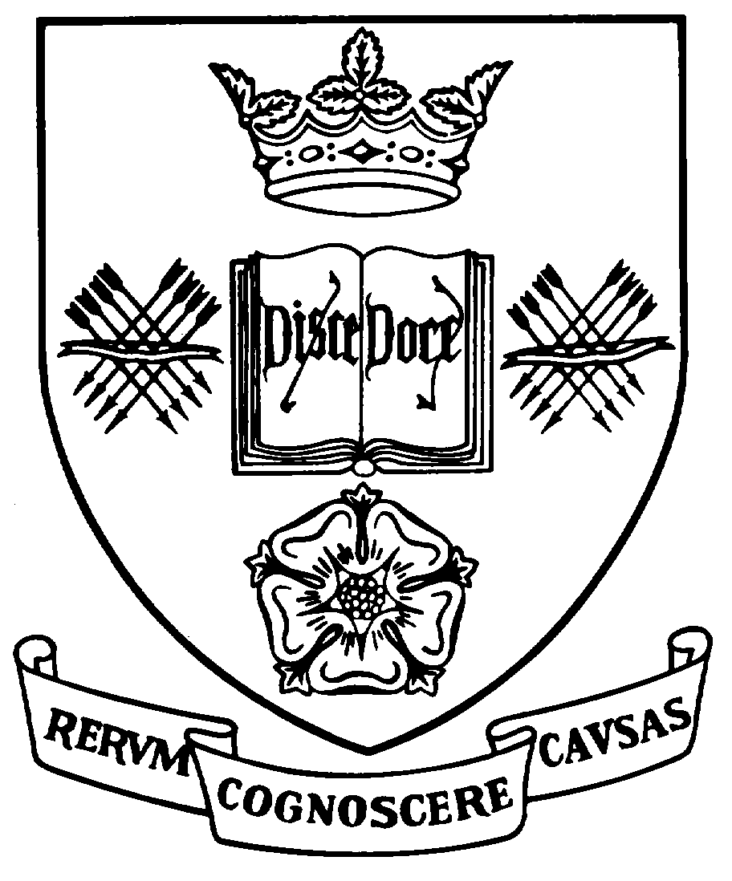

Programme Specification

A statement of the knowledge, understanding and skills that underpin a taught programme of study leading to an award from

The University of Sheffield

This programme specification covers the curriculum in Russian or Slavonic Studies for the following dual honours degree programmes and should be read in conjunction with the relevant programme specification for the second subject:
1. Programme Title |  | 2. Programme Code | 3. JACS Code
Archaeology and Slavonic Studies |  | AAPU08 | V400
Linguistics and Russian |  | ELLU06 | Q100
English and Russian |  | ELLU08 | Q300
French and Russian |  | FREU08 | R100
German and Russian |  | GERU07 | R200
History and Russian |  | HSTU02 | V100
Journalism and Russian |  | JNLU05 | P500
Russian and Economics |  | RUSU02 | R700
Russian and Politics |  | RUSU03 | R700
Russian and Business Management |  | RUSU04 | R700
Russian and Hispanic Studies |  | RUSU05 | R400
Russian and Philosophy |  | RUSU14 | R700
Russian and Music |  | RUSU16 | R700
4 | Level of Study | Undergraduate
5a | Final Qualification | Bachelor of Arts (BA Hons)
5b | QAA FHEQ Level | Honours
6 | Intermediate Qualifications | None
7 | Teaching Institution (if not Sheffield) | Not applicable
8 | Faculty | Arts and Humanities
9 | Co-ordinating Department | Russian and Slavonic Studies
10 | Other Departments involved in teaching in the subject | None
11 | Mode of Attendance | Full-time
12 | Duration of the Programmes | Four years, including two semesters spent abroad between study at Levels 2 and 3 of the programme.
13 | Accrediting Professional or Statutory Body | None
14 | Date of production/revision | December 2002
- Background to the programmes and subject area
The importance of Russia in strategic, political, economic and cultural terms has altered but has not diminished in the post-Soviet period, and those who have knowledge of its language and life are likely to find themselves increasingly in demand as the country modernises and opens up. The study of Russian at Sheffield as part of a dual honours programme provides a rich and rewarding field of inquiry offering the study of Russian language, culture, history and institutions alongside the knowledge and skills acquired through study of another subject area. These multifaceted programmes also promote the development of intellectual, practical and transferable skills.
The acquisition of advanced linguistic skills in Russian, allied to the broad range of interpersonal skills and intercultural competence associated with the study of a modern language, enriches the study of the other dual subject and leads to enhanced employability. The Department of Russian and Slavonic Studies has a strong record of graduate employment, and graduates have entered diverse professions such as the Foreign and Commonwealth Office, GCHQ, banking and commerce, marketing and advertising, teaching (including University lecturing) and research, journalism, translation and interpreting. Many graduates have found employment in Russia.
Dual honours graduates in Russian will also have benefited from the experience of study and residence in Russia (and, in the case of duals with another modern language, in another European country) during their third year, and from the option to acquire during the programme practical and theoretical knowledge of Czech and/or Polish. The availability of other Slavonic languages is a distinctive feature of the programme, along with its flexible structure and the wide range of options offered, which permit students to customise their programmes of study to a significant extent. Teaching is informed by the research activities of the staff, which were awarded the highest grade of 5*A (denoting research of international excellence) in the 2001 national Research Assessment Exercise, so that students are able to study at the cutting edge of the discipline. There are particular research specialisms in the areas of Russian and Slavonic linguistics, nineteenth- and twentieth-century Russian culture, intellectual history, and critical theory.
Further information is available at the departmental web site: http://www.shef.ac.uk/russian/
- Subject aims
Programmes offered by the Department of Russian and Slavonic Studies have the following general aims consonant with the Mission Statement of the University of Sheffield:
- To provide high quality teaching at undergraduate and postgraduate levels that is informed and invigorated by the research and scholarship of its staff and alert to the benefits of student-centred learning that fosters the development of transferable analytical and communicative skills;
- To provide the acquisition of practical language skills alongside awareness and understanding of the appropriate cultural context;
- To sustain a culture of research and teaching that is able to foster the free pursuit of knowledge, the impartial analysis of values, and the acquisition of intercultural awareness and informed, tolerant and professional attitudes to the languages and countries studied;
- To respond to the diversity of student interests by allowing both the combination of the subject of study with subjects offered by other providers and a level of student choice within each programme of study appropriate to that programme;
- To widen access to its programmes of study to the extent permitted by the intellectual and linguistic aptitudes which the programmes demand;
- To enable students to maximise their potential in all aspects of their course;
- To assess students over a range of knowledge, understanding and skills, and to identify and support academic excellence.
17. Subject learning outcomes
Knowledge and understanding:
K1 | Sound knowledge and critical understanding of the structures and usage of Contemporary Standard Russian
K2 | Sound knowledge and critical understanding of key aspects of Russian culture and society, acquired through study of the cultural products of that society (e.g. literature, visual arts and cinema, social and political thought)
K3 | Sound knowledge and practical and critical understanding of the methodologies used to analyse language and culture
K4 | Sound knowledge and critical understanding of aspects of Russian history, politics and institutions (depending upon options selected)
K5 | Sound knowledge and critical understanding of aspects of Russian and Slavonic linguistics (depending upon options selected)
K6 | Knowledge of other Slavonic languages appropriate to the level of study undertaken (depending upon options selected)
K7 | Practical knowledge of contemporary Russian life through experience of the period abroad

Skills and other attributes:
S1 | A high level of competence in the productive skills of writing and speaking Contemporary Standard Russian
S2 | A high level of competence in the receptive skills of understanding the written and spoken forms of Contemporary Standard Russian
S3 | A high level of intercultural awareness, derived from setting awareness of one’s own culture against the study of Russian language and culture and from the experience of the period abroad, and leading to tolerant, professional and informed attitudes to the language and culture studied
S4 | Skills in acquiring, using, and critically evaluating information about language and culture gained from a variety of sources, including teachers, native speakers, newspapers, broadcasts, books and works of reference, and electronic sources
S5 | Familiarity with the essential primary and secondary source material appropriate to the programme of study, alongside a regard for the impartial analysis of values expressed therein
S6 | The ability to carry out individual study and research, and to participate in group activities such as seminars
S7 | Familiarity with bibliographic and research skills, including such IT skills as word-processing, e-mail and use of the internet
S8 | Further transferable skills, valuable for employment, including information gathering, the development of individual resourcefulness, analytical thinking, the ability to identify problems and ways of resolving them, the critical appreciation of source material, the ability to construct and sustain logical argument on the basis of such material, and the ability to present such argument clearly in both oral and written forms
18. Teaching, learning and assessment
Development of the learning outcomes is promoted through the following teaching and learning methods:
- Induction procedures at Level 1, but available also to students from higher Levels, are designed to orientate the student and help develop the basic bibliographic and study skills, including subject-specific IT skills, such as word-processing in Cyrillic, e-mail, and Russian internet resources described in S7 above. These induction procedures include orientation classes, introduction to Russian resources available via the departmental web-site, the local intra-net and the world wide web, and the provision of departmental and Level-specific Student Handbooks.
- Lectures are used infrequently, and mainly at Level 1, in order to impart essential knowledge relating to K1-K6 above.
- Seminars, which may be either staff-led or student-led, are used throughout the programme for both language classes and modules devoted to culture, history, politics and institutions. Their use is extensive beyond Level 1 and is designed to reinforce information imparted through lectures by allowing students to work through, analyse, understand and respond to that information. Seminars devoted to target-language acquisition may take the form of classes devoted to reading or listening comprehension, written and spoken language production, translation both from and into the target language, or the teaching of formal grammar backed up by exercises and drills. In all cases the aim is to expose students to as much authentic material in the target language as possible, both written and spoken. Language seminars may therefore be conducted partly in the target language. Seminars devoted to cultural studies are generally taught in English, but they may also make use of authentic target language materials in the form of texts that serve as a basis for group discussion or student presentation. Seminars thus contribute both to the achievement of knowledge and understanding (K1-K6) and to the development of key skills (S1-S6, S8).
- Tutorials are smaller-group versions of the seminar, and they serve the same purposes and learning outcomes. The term applies to small-group classes with a native speaker – an important authentic language resource – designed to reinforce skills S1-S3. The word tutorial is also used to describe meetings arranged between a tutor and an individual student in order to clarify a particular problem experienced by that student in the understanding of material or in the process of preparation for a seminar or an assessment.
- Independent study is essential to the successful completion of the programme. New students are introduced to study skills through information in the Student Handbook and through practical experience in Level 1 modules. The amount of independent study broadly expected for each module is clearly set out in the course information, although it is recognised that this will vary from student to student. Independent study is generally geared towards the assimilation and further clarification of material gleaned from lectures, preparation for seminars, preparation for written assessments, and the broader development of knowledge of the field of study. Independent study thus contributes to the development of all the programme learning outcomes, but is especially important in refining skills S4-S8.
- The period of residence abroad (two semesters during the third year of the programme, one in Russia and one in another appropriate country if the dual is with another modern language) is an essential part of the learning experience. Students normally attend formal programmes of study in institutions of higher education, living either in hostels or with Russian families, and this provides unrivalled opportunities for creative contact with native speakers, for the sustained exercise and development of both productive and receptive linguistic skills to a level appropriate to embark upon final year study (S1, S2), for the development of practical intercultural awareness to set alongside the theoretical awareness derived from the study of culture (S3), and for the development of personal resourcefulness and adaptability likely to enhance employability (S8).

Opportunities to demonstrate achievement of the learning outcomes are provided through the following assessment methods:
Regular formative assessment – usually in the form of periodic tests or weekly exercises designed to reinforce knowledge and skills such as vocabulary acquisition, language production (written and spoken), language comprehension (written and spoken), translation to and from the target language – is used at all Levels to monitor carefully the student’s progression through the core language programme and to pick up and rectify areas of potential weakness in linguistic competence (K1, S1, S2).
Summative assessment of target language knowledge and skills uses a variety of methods, but common to all Levels is the testing of a student’s ability to demonstrate productive and receptive skills in both formal written examinations and one-to-one oral examinations. In addition, progression through the programme sees increasing emphasis placed upon assessment methods designed to reflect and test increasing autonomy in student learning (S4). Such methods include projects in the target language designed to test progress during the period abroad, oral presentations, and ‘takeaway’ examinations with access to dictionaries, reference works and other information sources. The balance between unseen examination and other assessment methods in Levels 2 and 3 of the core language programme is approximately 50/50.
Assessment of modules in related thematic subjects (culture, history, etc.) uses appropriate combinations of the following:
- written examinations designed to test subject knowledge (K2-6);
- essay writing and project work designed to test subject knowledge, increasing autonomy in student learning, and the development of transferable skills (K2-6, S3-8);
- oral presentations designed to test organisational and communicative skills (S6, S8).
Progression through the programme sees the emphasis shift away from written examinations towards the other forms of assessment. At Level 1 the written examination accounts for between 60% and 66% of the assessment of ‘thematic’ modules, whereas by Level 3 assessment is almost entirely by independent coursework and oral presentation. The assessment of core culture modules at Levels 2 and 3 is also designed in such a way as to encourage the reading of texts in Russian.
The importance attached to the period abroad placement is reflected in the fact that assessment of that period is formalised through project work and contributes to final degree classification.
19. Reference points
The learning outcomes have been developed to reflect the following points of reference:
The research interests of departmental staff and the research strategy of the Department of Russian and Slavonic Studies;
Subject Benchmark Statements
http://www.qaa.ac.uk/AssuringStandardsAndQuality/subject-guidance/Pages/Subject-benchmark-statements.aspx
Framework for Higher Education Qualifications (2008)
http://www.qaa.ac.uk/Publications/InformationAndGuidance/Pages/The-framework-for-higher-education-qualifications-in-England-Wales-and-Northern-Ireland.aspx
University Strategic Plan
http://www.sheffield.ac.uk/strategicplan
Learning and Teaching Strategy (2011-16)
http://www.shef.ac.uk/lets/strategy/lts11_16

20. Programme structures and regulations
Dual degrees offered by the Department of Russian and Slavonic Studies take the form of ‘parallel’ programmes with half the total credit taken in each subject. The two subjects are taught independently, but the combination allows the two to complement, inform and illuminate each other.
The Russian element of each dual degree programme offers two major pathways: Course A, for those students entering with an A-level qualification or equivalent in Russian, and Course B, for beginners or those whose knowledge of Russian is insufficient to allow them to follow Course A. The Russian language core of these two pathways is differentiated at all Levels below Level 3, with Course A and Course B students receiving language tuition appropriate to each pathway at both Level 1 and Level 2, so that neither group of students is disadvantaged or in inappropriate competition with the other. By Level 3, as a result of the different language pathways and the experience of the period abroad, Course A and Course B are at broadly the same standard and take the same core language modules in Russian.
Both Course A and Course B are structured on the twin principles of coherence and student choice:
Coherence is achieved through a spine of progressively developing core modules. In addition to core language tuition, both Course A and Course B contain a compulsory module in Russian thematic studies at each Level, in order to ensure sufficient exposure to key aspects of Russian society, literature and other cultural products (K2).
Student choice is served through the availability at Levels 2 and 3 of a wide range of optional modules in Russian thematic studies, linguistics, and other Slavonic languages, designed to encourage students to construct a degree programme in accordance with their developing interests and skills. Students take optional modules from the Russian programme to the value of 20 credits at each of Levels 2 and 3. Further optional modules may be available in the other half of the dual programme.
Two semesters of the third year of both Course A and Course B are spent on a placement abroad. Where the dual combination is with another modern language (French, German, or Spanish), the placement is shared between the countries concerned. In all other Russian dual combinations, the placement is entirely in Russia.
Please refer to the Programme Regulations, General University Regulations and the On-line Directory of Modules for detailed information about the structure of programmes, regulations concerning assessment and progression and descriptions of individual modules.
21. Student development over the course of study in the subject
Level 1 (Course A) develops and consolidates skills acquired at A-level in the reception and production of written and spoken Russian and translation from and into Russian, provides opportunities for vocabulary building, and enhances understanding of Russian grammar and syntax. A core module in Russian culture introduces students to the methodologies required for the study of cultural products and develops critical and analytical skills, as well as skills in oral and written presentation. Opportunities exist to take further modules in related thematic or language studies.
Level 1 (Course B) provides a beginners’ course in Russian designed to introduce the major structures of the language, to build vocabulary, and to develop elementary skills in the reception and production of both written and spoken Russian. The core Russian language component of Course B carries twice the credit weighting of that of Course A, and involves more contact hours, so as to begin the process of convergence between the two pathways. A core module in Russian culture introduces students to the methodologies required for the study of cultural products and develops critical and analytical skills, as well as skills in oral and written presentation. Opportunities exist to take further modules in related thematic or language studies.
Level 2 promotes, in ways appropriate to each pathway, developing mastery of and sophistication in productive and receptive language skills, including grammatical understanding, vocabulary building, translation, reading and writing skills, aural comprehension, and oral expression. While Level 2 post-beginners and Level 2 post-A-level students continue to follow separate core language programmes, both groups take a core module in nineteenth-century Russian culture designed to introduce key aspects of Russian history, intellectual history and literature, and provide opportunities for the development of reading skills in the target language. Optional modules available at this Level permit students to deepen and broaden their interests in more specialised areas of Russian linguistics, culture and society, or to develop knowledge of another Slavonic language. Core and optional modules at this Level employ teaching and assessment methods, such as seminars, essay-writing and student presentations, that are designed to encourage and test the further development of analytical, problem-solving and transferable skills such as those set out in Section 17 (S4-S8) above. In all areas of teaching and assessment at Level 2 emphasis is placed on increasing autonomy in student learning, as seminars and essay work demand more in the way of independent preparation and presentation (S6).
The Period Abroad placement, between Levels 2 and 3, further consolidates all language skills, promotes intercultural awareness and understanding, and develops self-reliance and confidence in the use of the target language. As a result of the intensive immersion it offers in both the reception and production of Russian, it contributes significantly to the process of convergence of the Course A and Course B pathways begun in the provision of separate language tuition at Levels 1 and 2.
Level 3 exploits and develops increased confidence and sophistication in students’ language skills following the period abroad and demands advanced ability in the reception and production of written and spoken Russian, and in translation from and into Russian. There is also a core module in twentieth-century Russian culture, permitting the further development of analytical, problem-solving and Russian reading skills. Further opportunities to deepen existing knowledge and skills, or to acquire new ones, are offered by further optional modules in linguistics, culture, society, or the study of another Slavonic language. An emphasis on take-away language assessment, alongside formal examinations, further promotes student-centred learning, as does the increased importance attached to essays, oral presentations, and project work in the assessment of related thematic modules. Essays and other project work at Level 3 are longer than those expected at Level 2, and they demand more in the way of critical engagement with the topic, while student presentations at this level emphasise individual, rather than group, preparation and presentation.
The Russian dual honours degree programmes recognise that there are occasions when the concepts of Level and progression are more appropriately associated with the individual student rather than the programme. For example, subject to programme regulations and/or the approval of the Head of Department, it might be entirely appropriate to the progression, knowledge acquisition and skills development of a student beyond Level 1 for that student to take a beginners’ module in another foreign language. Equally, a Level 2 student may wish to develop knowledge and skills associated with a thematic module that is also available at Level 3. In all such cases, the key consideration is that the module should contribute appropriately to the academic progression of the student.
Exit awards are not available before the completion of this programme.
22. Criteria for admission to the programme
Detailed information regarding admission to the programme is available in the University’s On-Line Prospectus at http://www.shef.ac.uk/prospective/
Entry on to the programme beyond Level 1 is normally subject to satisfactory completion of a period of study equivalent to Level 1 and is at the discretion of the departments involved in teaching the programme. Application should be made in the first instance to the departmental Admissions Tutor at russian-slavonic@sheffield.ac.uk (Tel. 0114 2227400)
23. Additional information
For further information students are directed to the Departmental web pages at http://www.shef.ac.uk/russian/. These contain full information on the programmes of study offered by the Department and provide access to student handbooks.
This specification represents a concise statement about the main features of the programme and should be considered alongside other sources of information provided by the teaching department(s) and the University. In addition to programme specific information, further information about studying at The University of Sheffield can be accessed via our Student Services web site at www.shef.ac.uk/ssid.

