How to create an URMS for the Student Ethics form

To fill this in, you will need:
- Student’s name
- Title of project
- Start/End date of project,
- Student’s registration number
- Whether the student is PGR, PGT or UGT

- Enter URMS, click ‘Create new project’
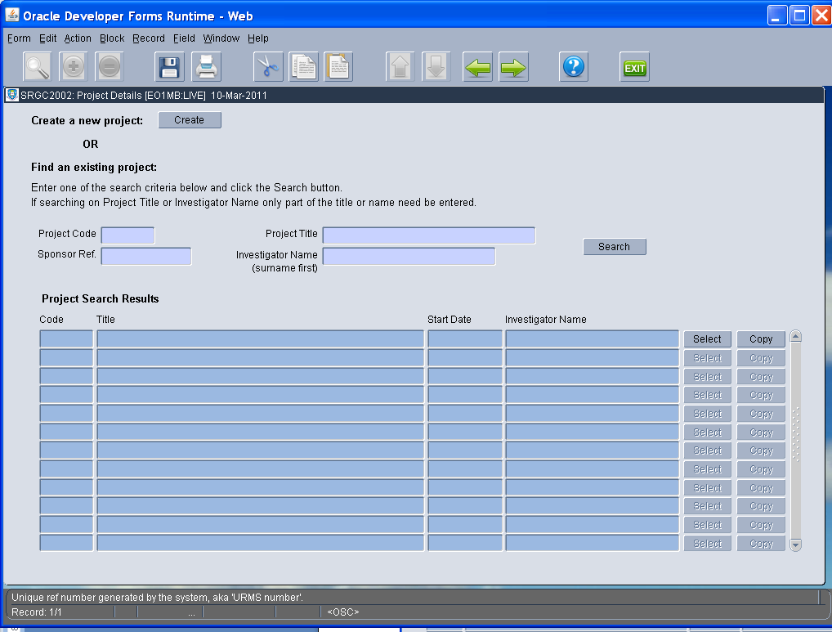

- Select ‘Student Governance’ from drop down menu.
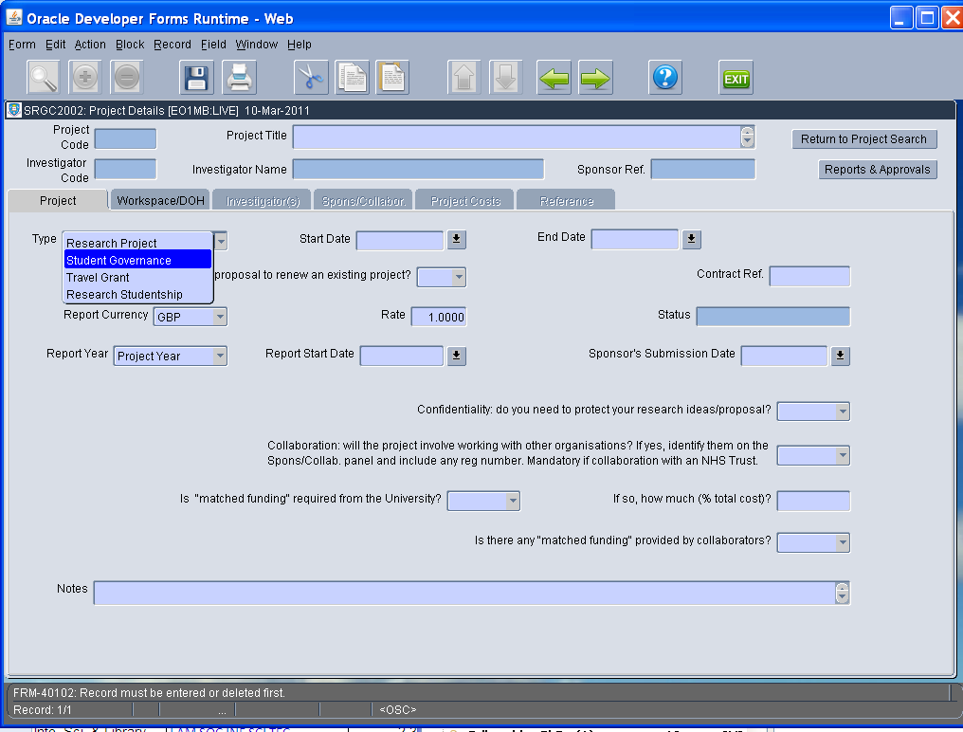

- Fill in fields:
- Project Title, put Student’s name, module if appropriate, and title of project
- Start and End date, put the start and end dates of the project/module.
- Other fields may be left blank – but in case the system changes in the future, it is safer to use the drop down menu and choose ‘No’.
- Before moving to the next tab you will be prompted to ‘Save’ – click floppy disc icon at the top of the page.
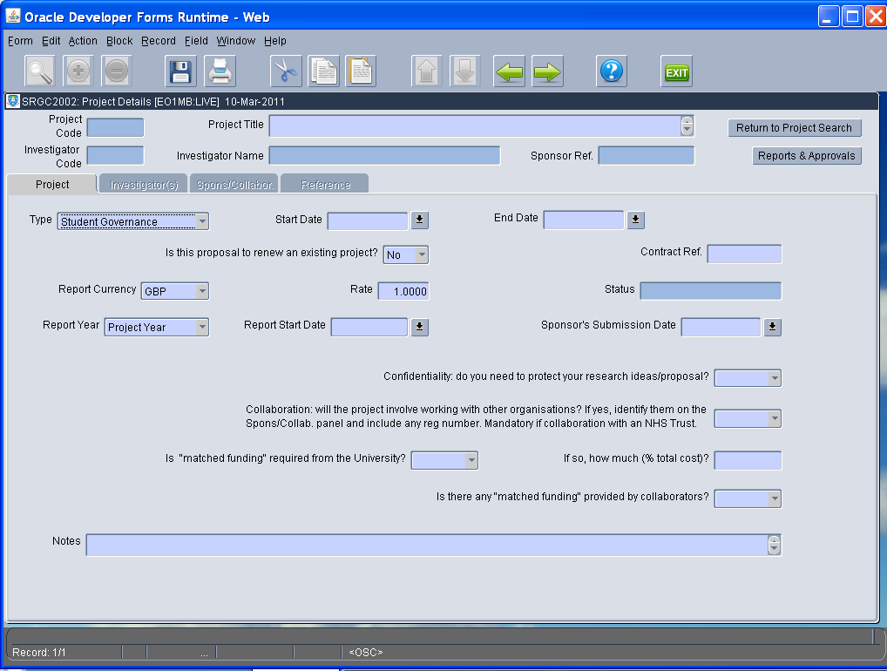

- Move to Investigator tab.
- Type your surname in the Investigator field, then use the drop down arrow to confirm your name, highlight it and click
- Value: 100%, Primary Investigator: Yes
- (The Investigator Code, Primary Dept and Faculty will auto-fill once you have confirmed your name).
- You will be prompted to ‘Save’ – click floppy disc icon at top of page.
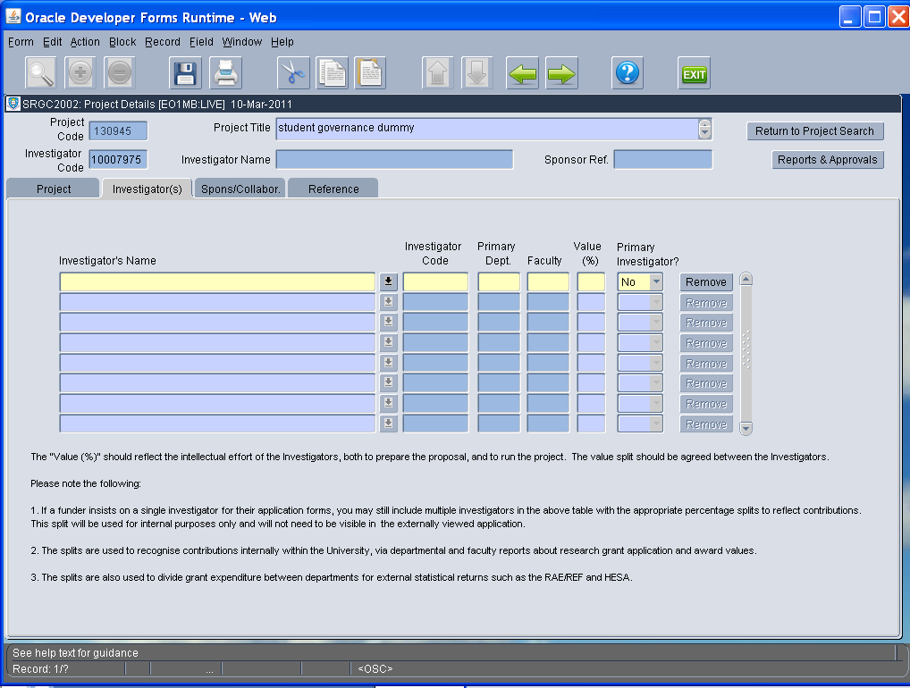

- Move to Sponsor/Collabor. tab.
- click ‘Add a Sponsor or Collaborator to this Project’

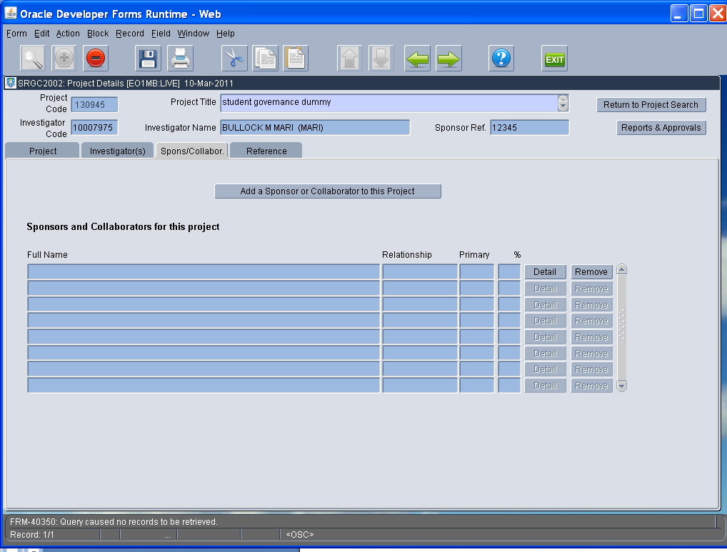

- The University of Sheffield will be pre-entered.
- Put the student’s registration number in the Sponsor Ref.
- Click the drop down menu at Programme Name (see next screen shot)

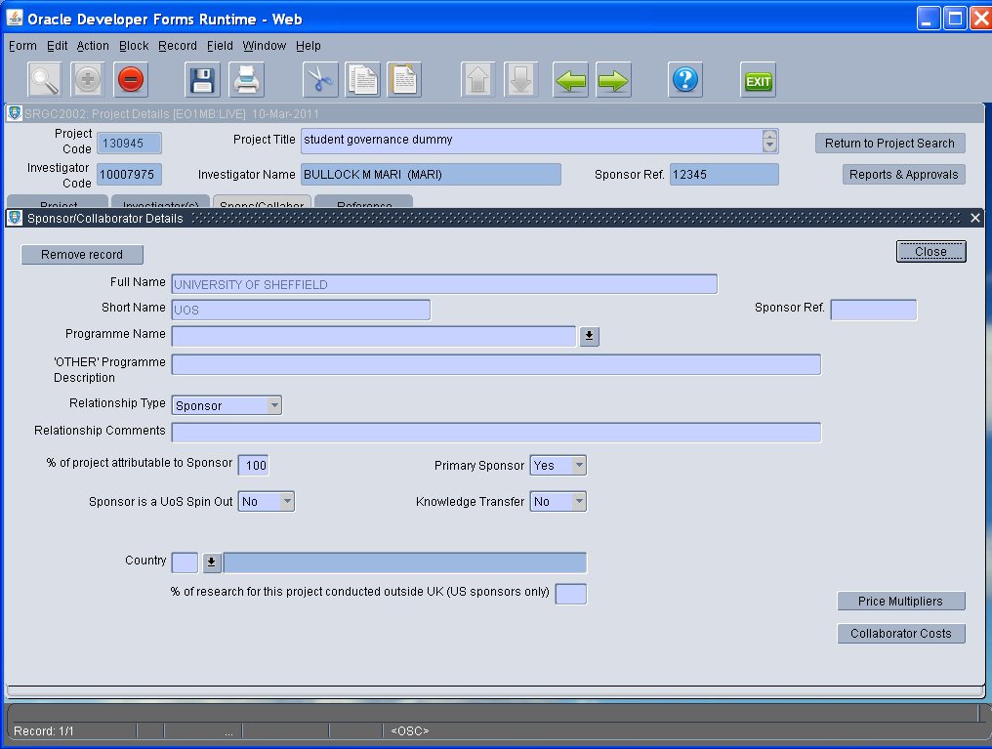

- Scroll down the list of ‘Programme Names’ and click on the correct description out of
Student Research Project - PGR
Student Research Project – PGT
Student Research Project – UGT

- Click ‘Close’.

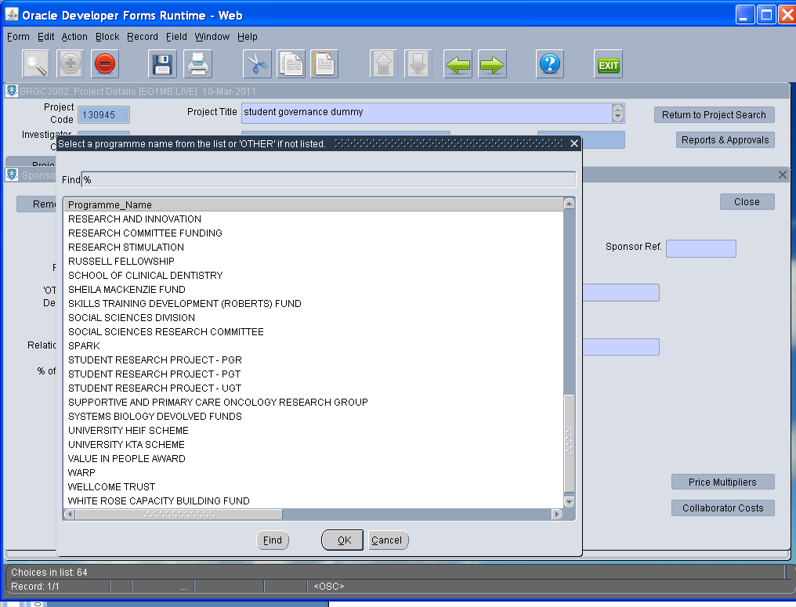

- A pop up regarding Price Multipiers will appear – ignore it, and click OK.
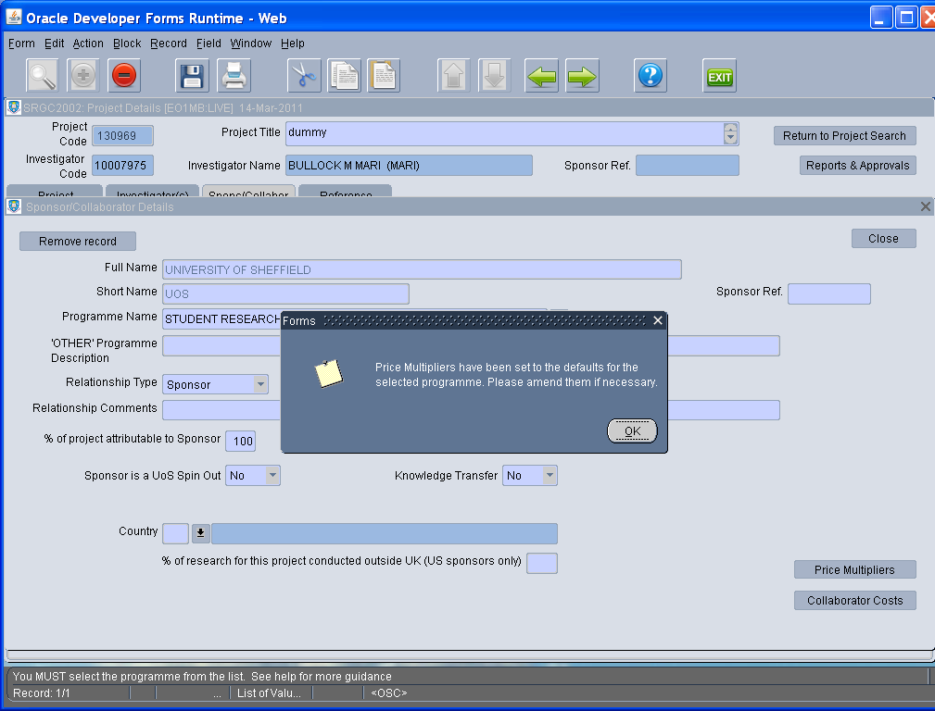

- Take a note of the Project code (the ‘URMS number’)
- Exit system
- Email/Phone Mari Bullock (m.bullock@shef.ac.uk or extension 20714) and ask for the project to be approved.
- Put the URMS number on your ethics form (you don’t have to wait for the approval process).

