PGR Applicant Guide to the Online Ethics Review System
Log in to the system at: ethics.ris.sheffield.ac.uk

Online Ethics Application screen
You will see a dashboard screen like the one shown below. From here you can manage all features of the ethics review system that you are involved with. To begin a new application select the ‘New Application’ button. To return to a previous application (submitted or incomplete), select ‘My Applications’.
Log out here

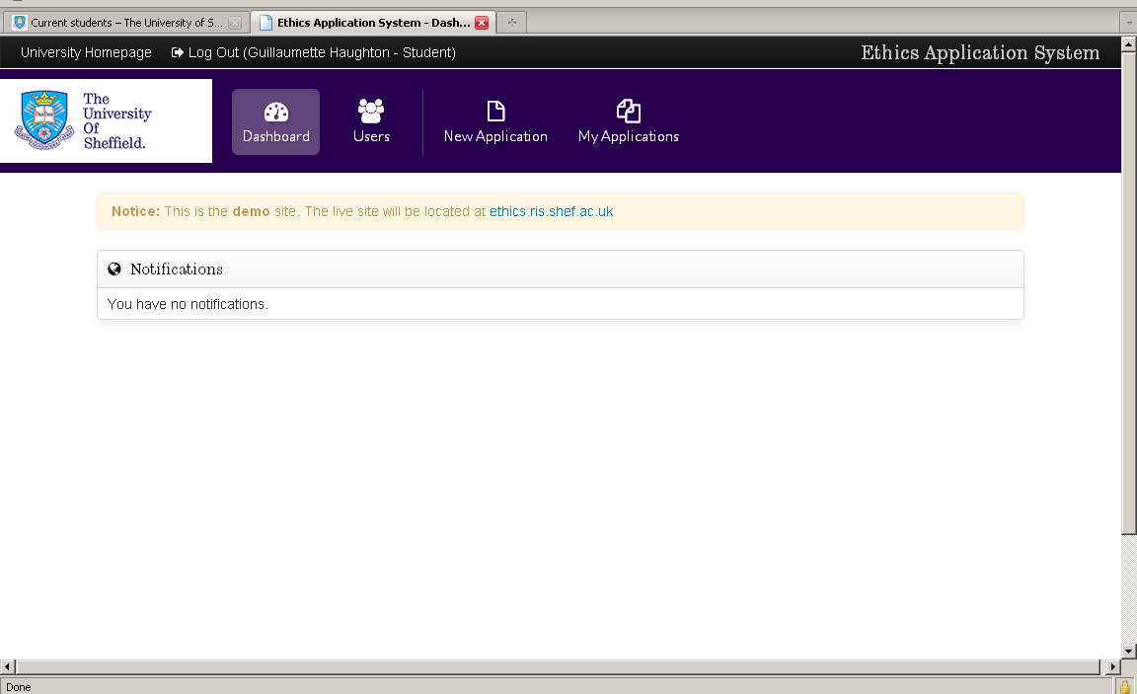
Notifications – this tells you the most recent activity within your Ethics account
New Application
My Applications

When you select a new application, you will see this page:
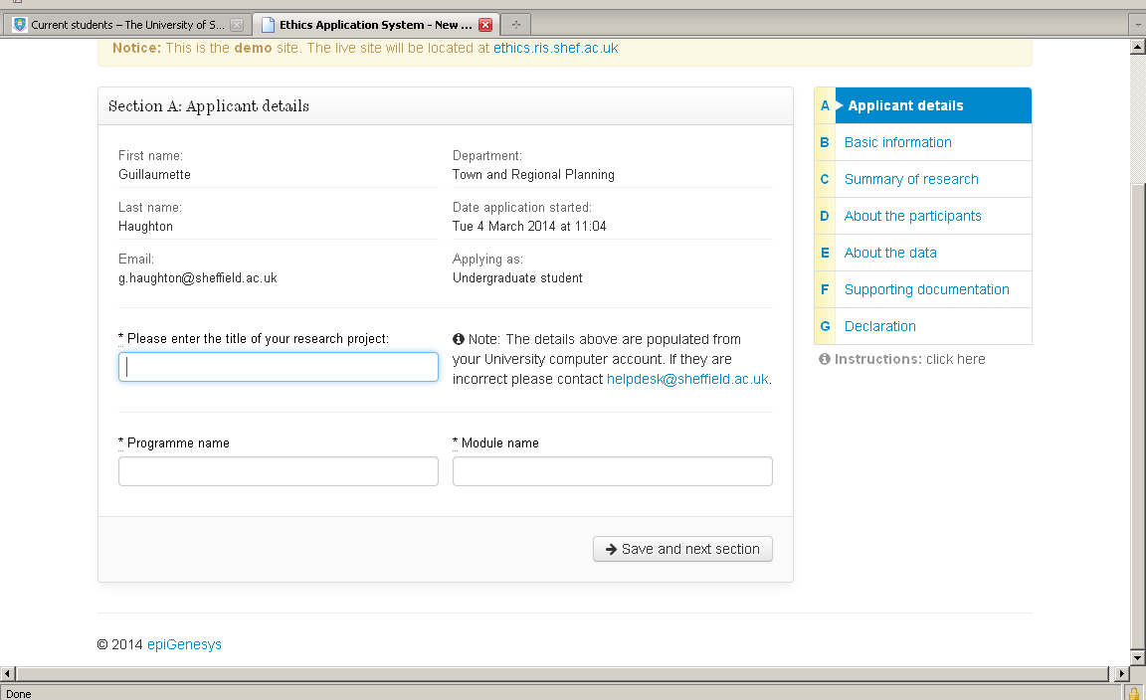
Fill in the programme and module name in these boxes.
You will see a summary of your application here. The colour of the letters changes as each section is marked as complete.
When you complete a section, click on save and next section to move on, or use the summary bar to move between sections.

You will see pop-ups at points through the application to draw your attention to certain information; make sure you pay attention to this as it may be important to your application.
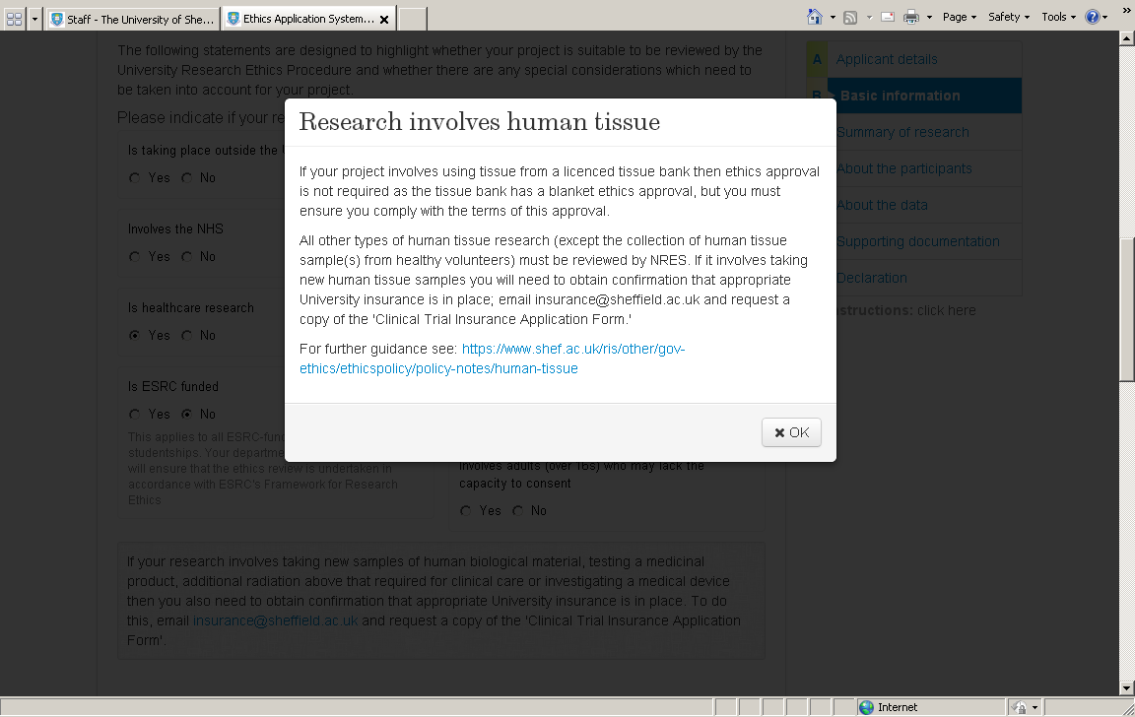
Hyperlinks will open in a new browser to give more details on particular issues if you require clarification

Under ‘Suitability’ you will be asked a series of yes/no questions to confirm your research project is suitable for ethical review by the University of Sheffield. If your research project cannot be ethically reviewed by the University of Sheffield, you may need to gain ethical approval elsewhere.

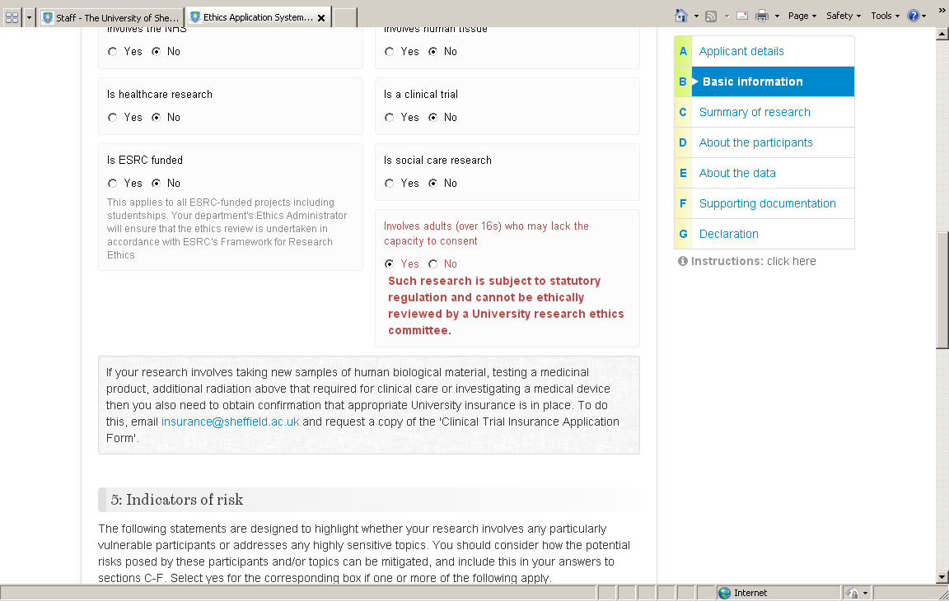
This research project would need to be ethically reviewed elsewhere. If you are unsure how to proceed there is guidance on the University website: http://www.shef.ac.uk/ris/other/gov-ethics/ethicspolicy

You must complete all of the information required in each section, and you will be unable to submit your application until it is complete. You can navigate between screens without completing the full screen. If you make changes the system will ask if you want to save changes before leaving the screen you are working on. You will not be able to select ‘save and next section’ at the bottom of each screen without fully completing the page. If you close the browser at any time, or your computer crashes, your work may be lost if you have not saved.

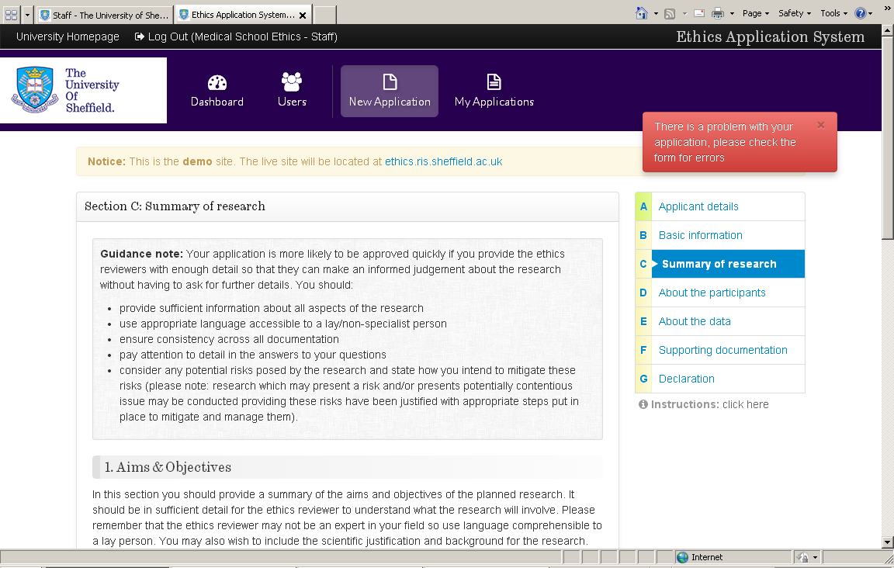
If you attempt to save a screen and move on to the next screen without completing all of the information required you will see this message. The missing parts will be highlighted in red.

If you intend to use a consent form or information sheet you will be asked to attach these documents to your application. You can attach any type of document as appropriate (e.g. Word, Excel, PDF, etc)
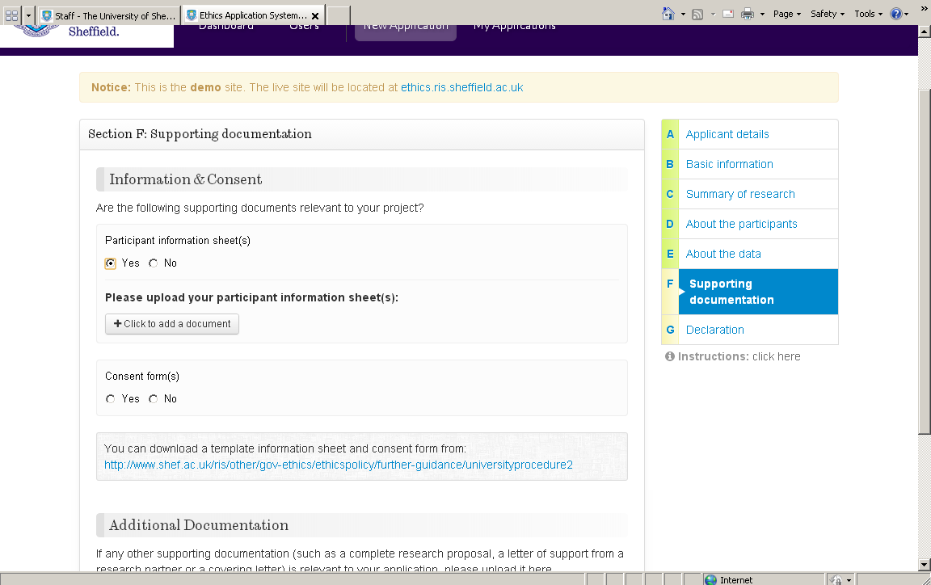
Attach a document here
You can also upload any other relevant documentation, or hyperlinks to online surveys for example.

You can save and return to your application as many times as you wish, and continue to make alterations to it up to the point that you submit your application.

Once you have completed your application, you will be asked to sign a declaration before it is submitted.
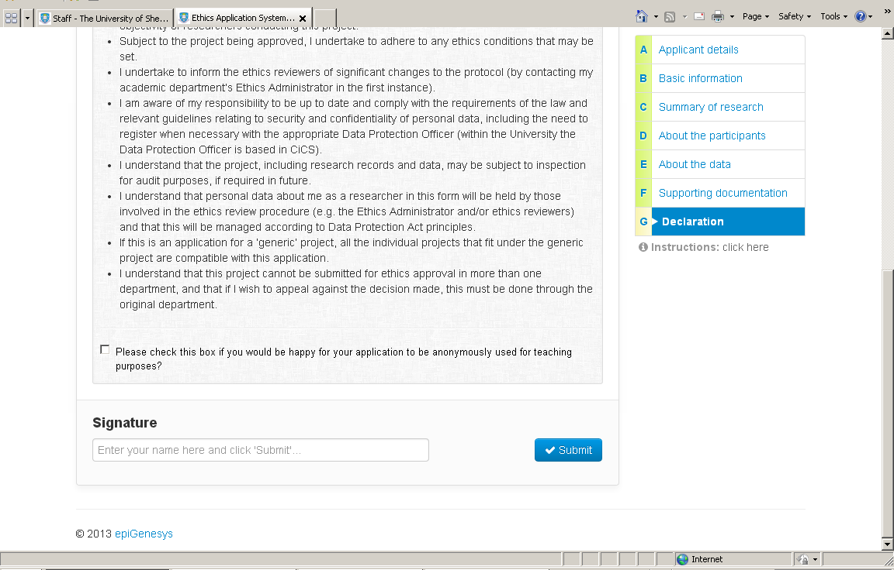
Type your name here before clicking submit.

Once your application has been submitted you will see this screen:
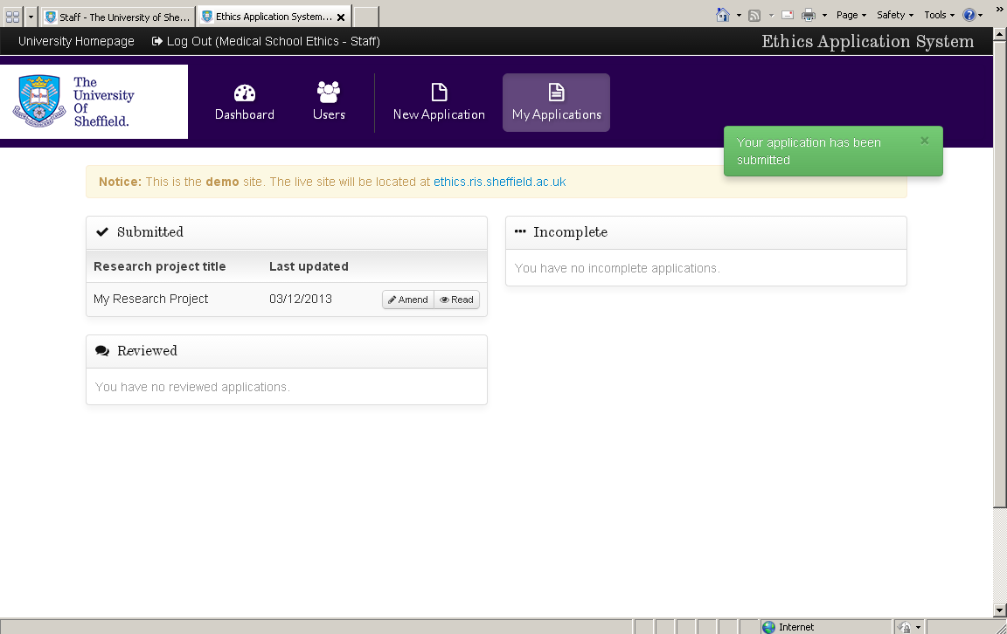
This box flashes up to confirm your application has been submitted
You can read your application at any time.
You can continue to amend your application until it has been reviewed.

Your application will be sent to your supervisor, who will check you have covered everything they think necessary. If they are happy with your application, it will be then sent to the Ethics Administrator for your Department. If your supervisor feels your application needs more work, they will return it to you, and you will need to make the necessary changes and submit it for your supervisor to review again.

Once your application has been submitted to the Departmental Ethics Administrator you will need to wait for approximately ten working days (check your department guidance for clearer indication) whilst your Ethics Administrator assigns three reviewers and your application is reviewed.

You will receive updates on the progress of your application in your notifications bar
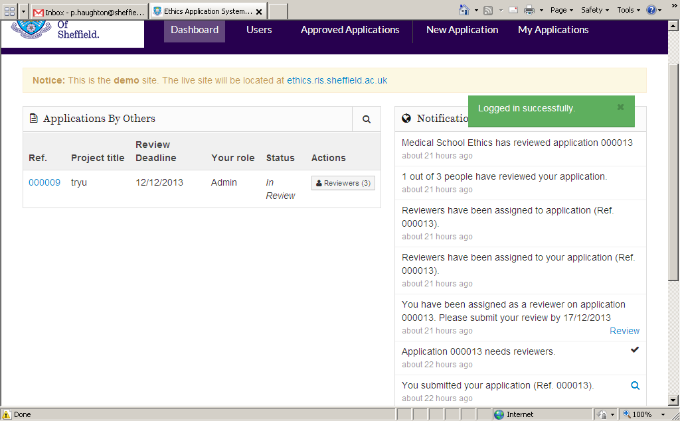

Once your application has been reviewed
You will receive notification from your Ethics Administrator that your project has been reviewed.

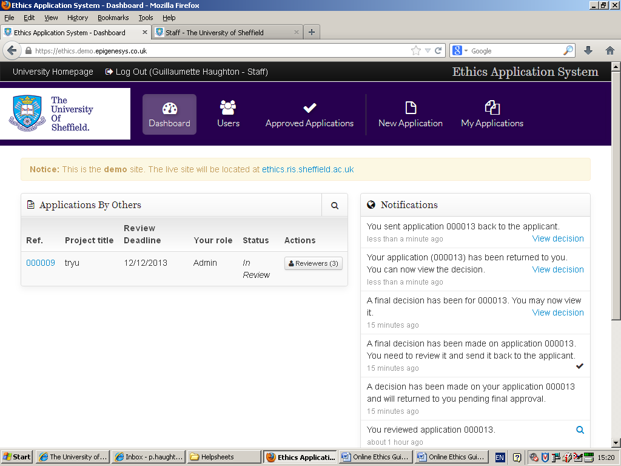

You can then view the final decision on your application.
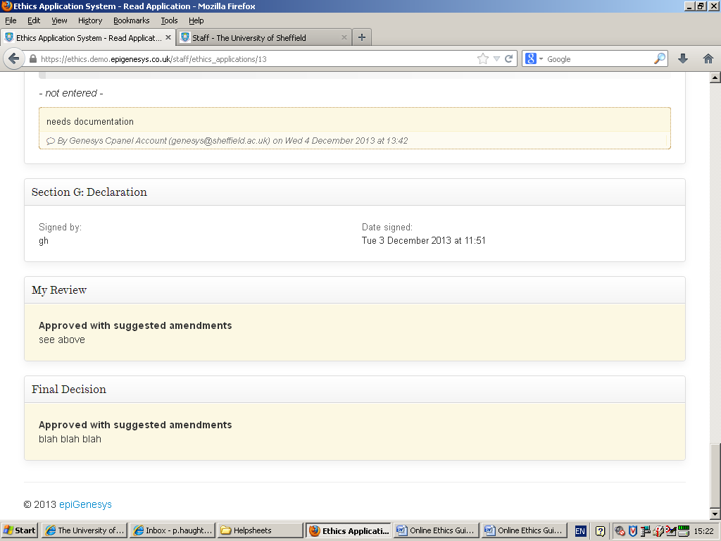
If your application has been approved or approved with suggested amendments, you can proceed with your research. A letter of approval will be available to you.

If your application requires compulsory changes, you will need to make changes to your application according to the comments given by the reviewers. You can then resubmit your application, and will receive notification of the final decision when it has been reassessed by the reviewers.

If your application has not been approved, you are unable to proceed with your research. You may wish to rethink your research plans and submit a new application. If you are dissatisfied with the decision made, you can follow the appeal process, which can be found in the Ethics Policy and Procedure: http://www.sheffield.ac.uk/ris/other/gov-ethics/ethicspolicy/general-principles

If you need any assistance, please contact p.haughton@sheffield.ac.uk. If you have an urgent technical issue with the system, please contact support@epigenesys.co.uk.

