Supervisor Guide to the Online Ethics Review System
Log in to the system at: ethics.ris.sheffield.ac.uk

Online Ethics Review screen
You will see a dashboard screen like the one shown below. From here you can manage all features of the ethics review system that you are involved with. To begin a new application select the ‘New Application’ button. To return to a previous application (submitted or incomplete), select ‘My Applications’.
Log out here

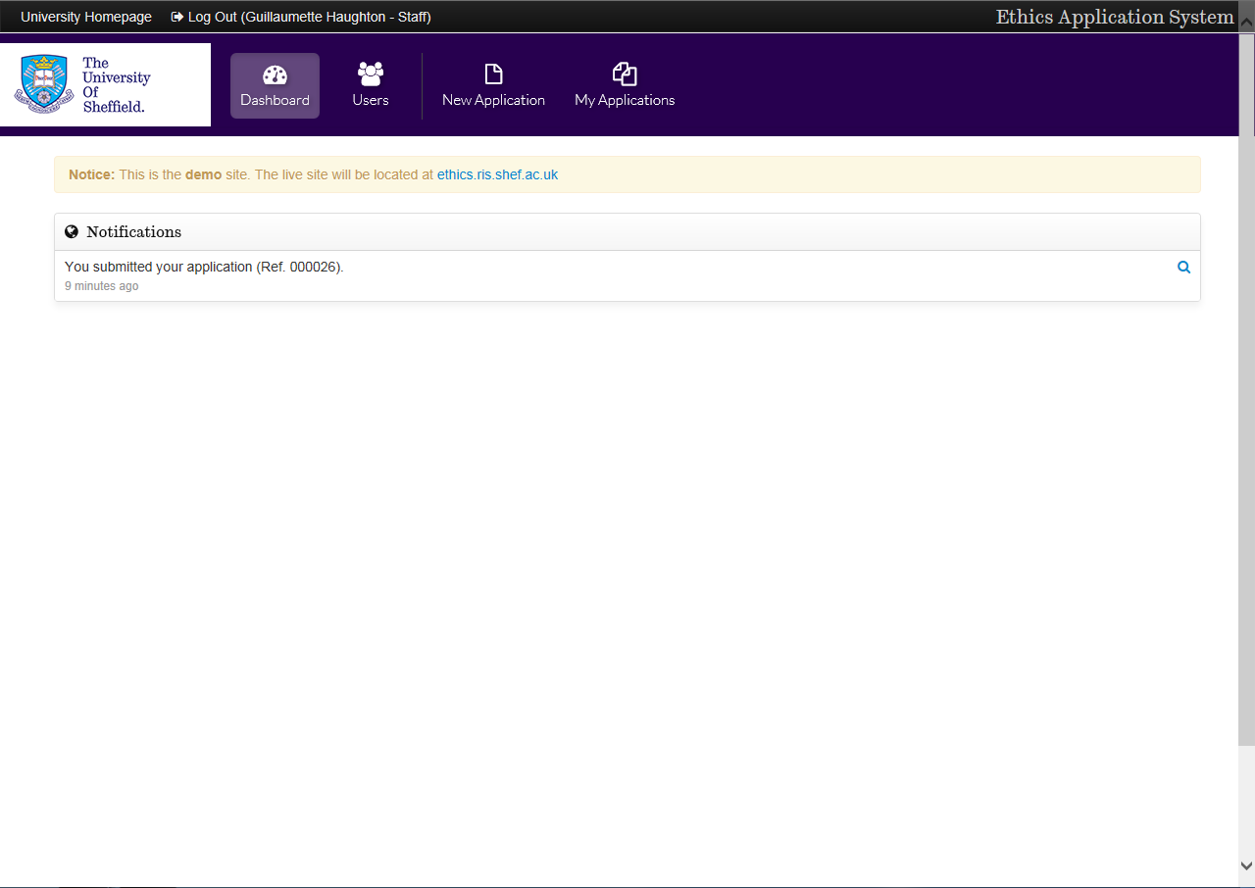
Notifications – this tells you the most recent activity within your Ethics account
New Application
My Applications

When one of your students has submitted an application, you will receive an email notification, and when you log into the online ethics system you will see this page:
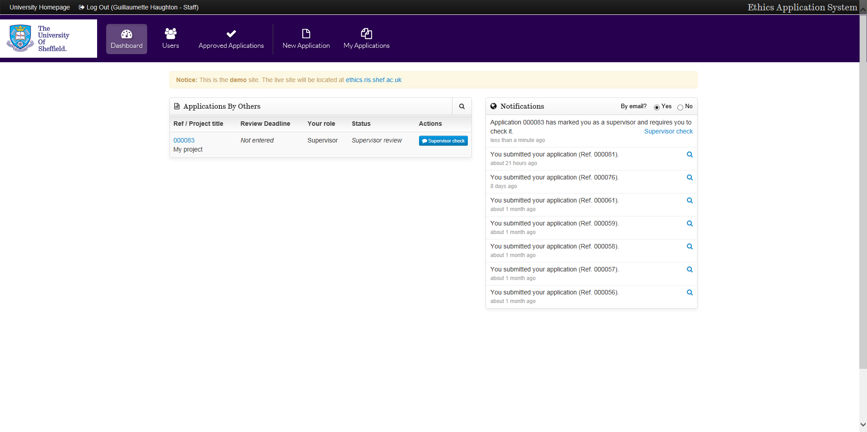
You will see the application in your notifications, and will be asked to perform a supervisor check

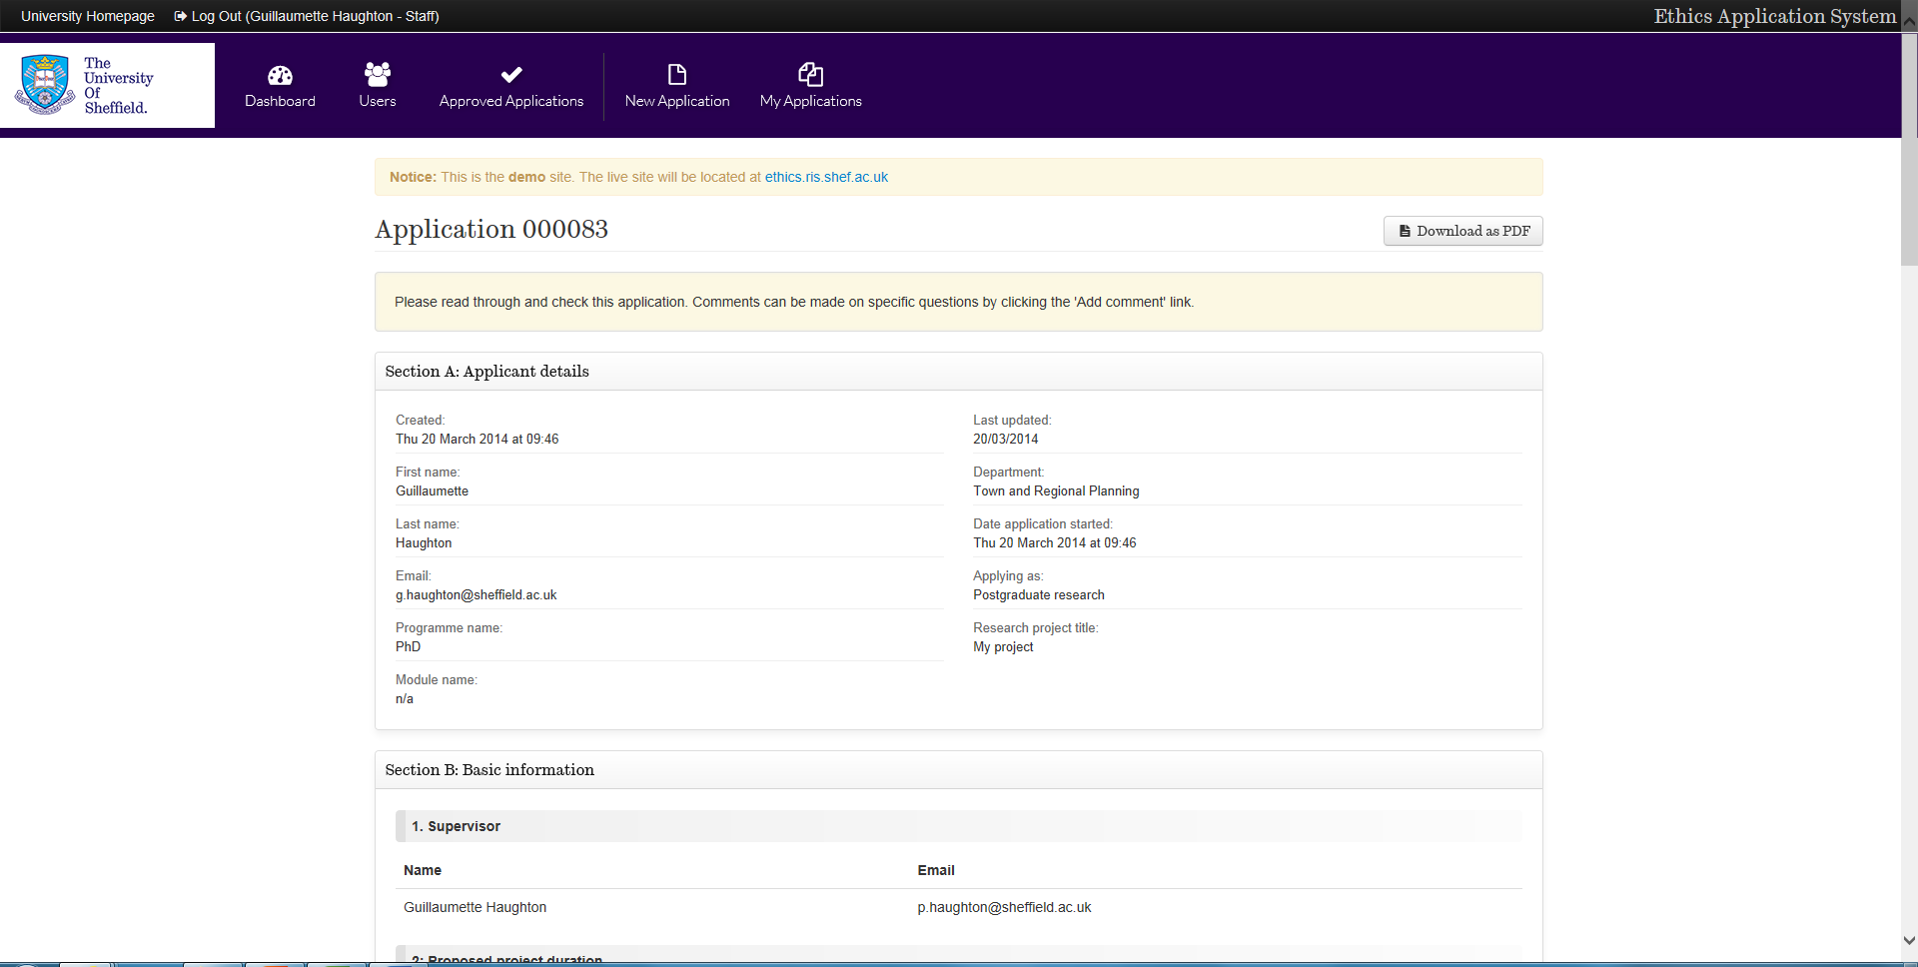
You can download the application as a PDF to read at your convenience

You then need to check the application to ensure the student has met all of the necessary criteria. All text boxes should contain information (rather than n/a), and the student should fully address the issues. If you feel the student has failed to address the question at any point on the application, you are able to add comments.

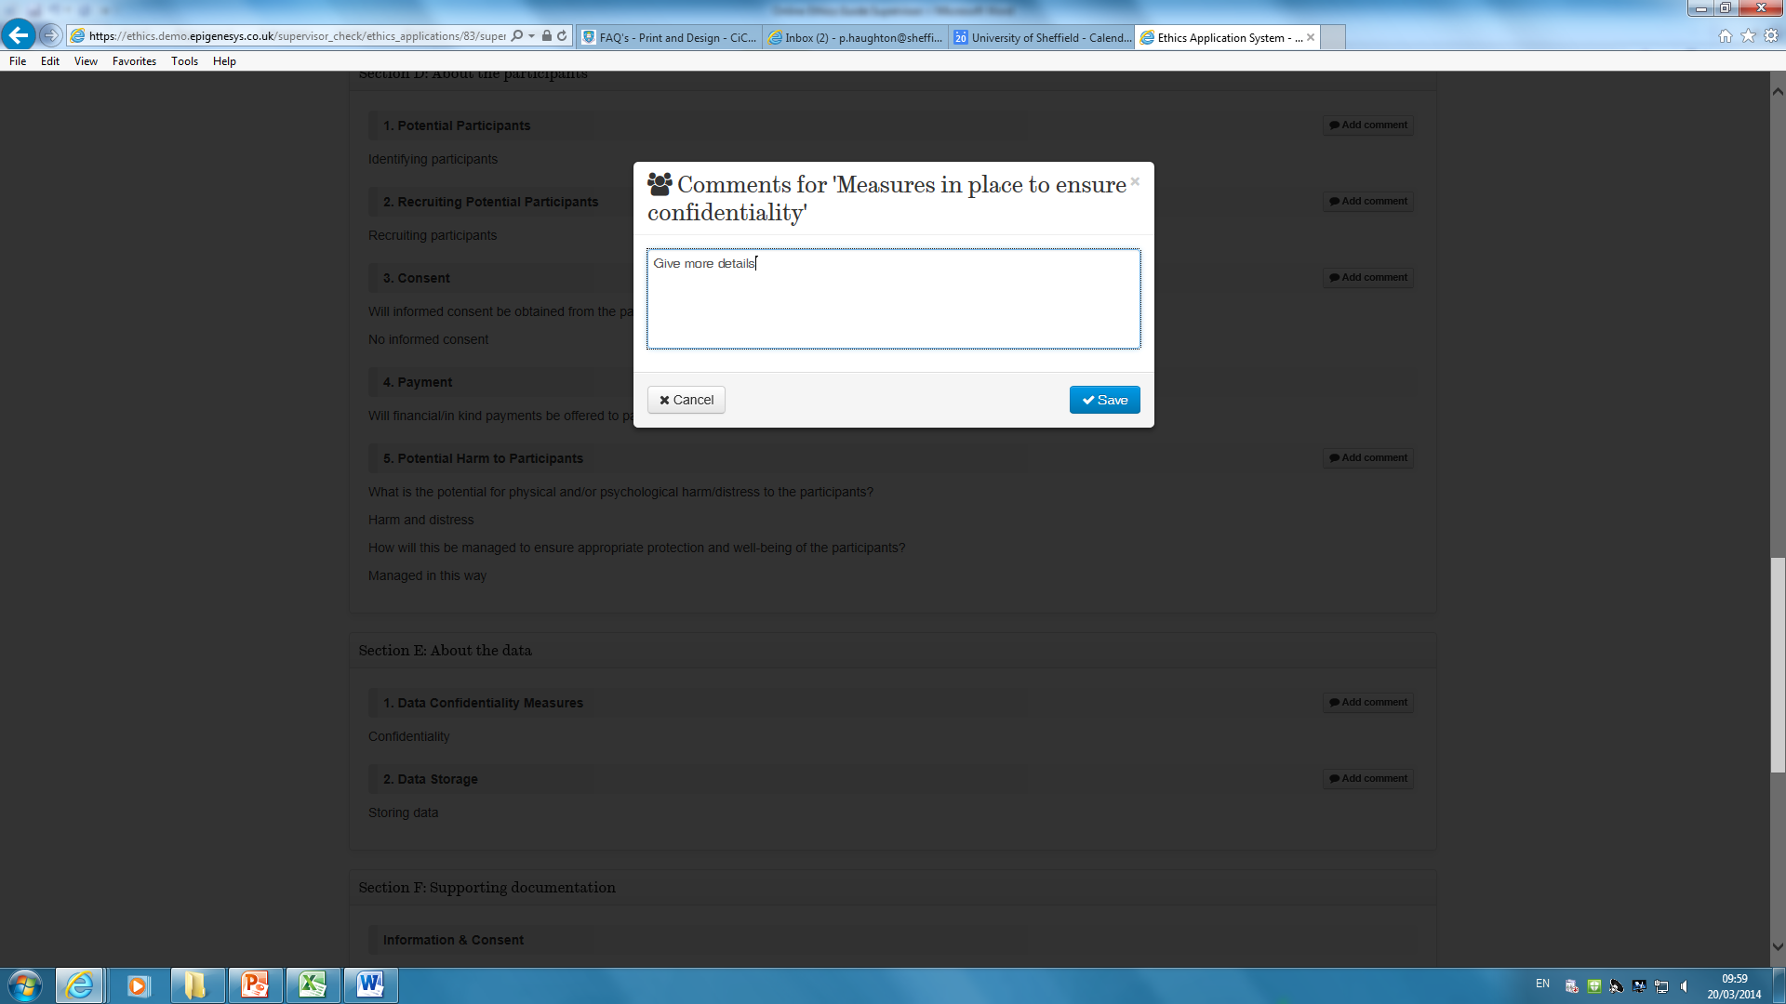
A text box opens for you to type comments
At the end of the application you will be asked if the student needs to make revisions to the application. If you select ‘yes’, the application will be returned to the student to make these revisions, after which you will check the application again.
If you select ‘no’ the application will move to the next stage of the ethics review process.
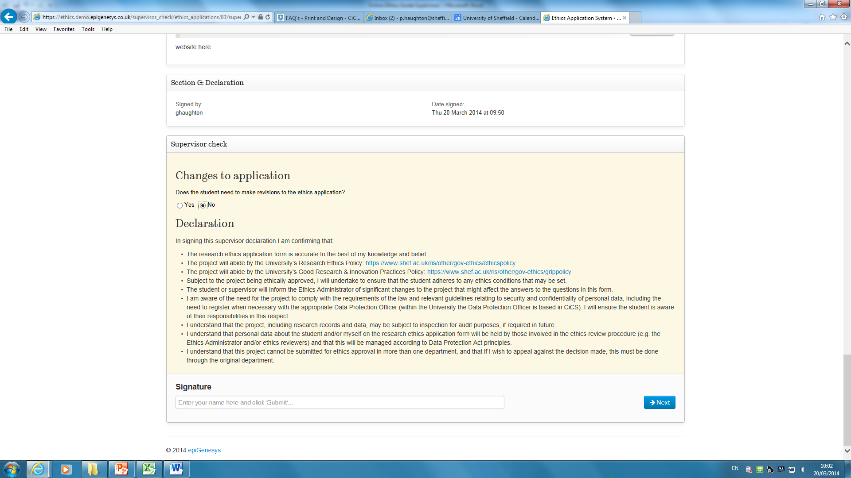
You are required to sign a declaration to say you are satisfied with the application as the supervisor.
PGR Applications
If the application is a PGR application, it will then be sent to the ethics administrator to assign three independent reviewers.
PGT/UG Applications
If the application is from a PGT or UG student, you will be asked to assess the risk of the project as low or high risk. Check with your department if you are unsure how your department operates the high/low risk application process.

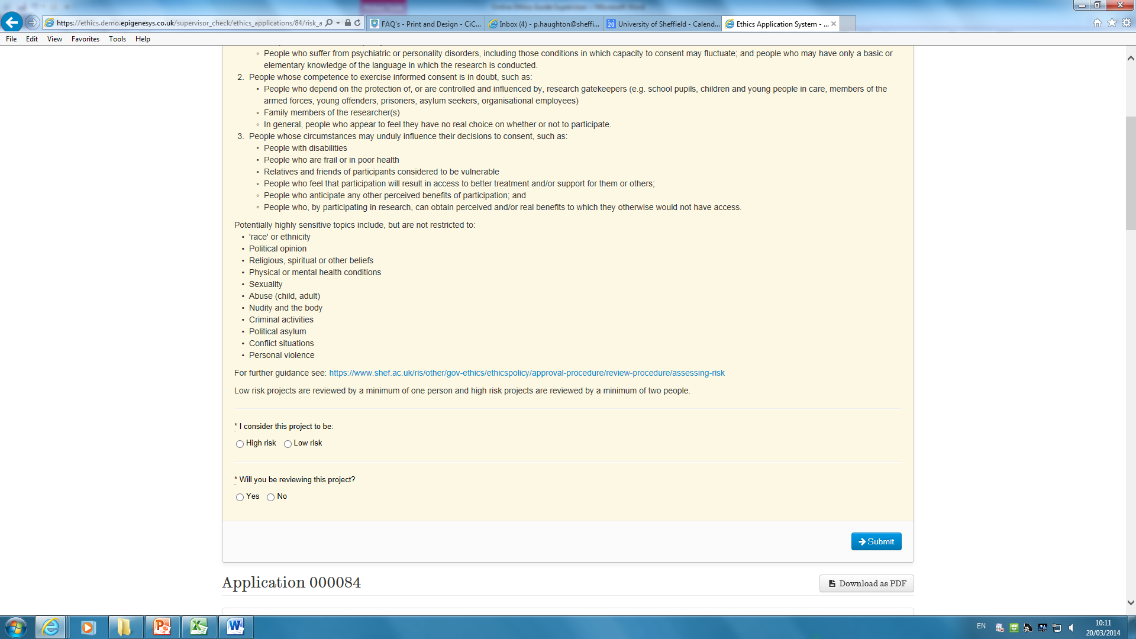
Are you reviewing the project?
Select high or low risk as appropriate
You will be asked if you are reviewing the project. Check with your department if you are unsure of departmental protocol.
If the project is low risk you will be able to review the project immediately, and the project will be returned to the student as soon as it has been checked by the ethics administrator.
If the project is high risk you will be able to review the project once the ethics administrator has assigned a second reviewer for the project.

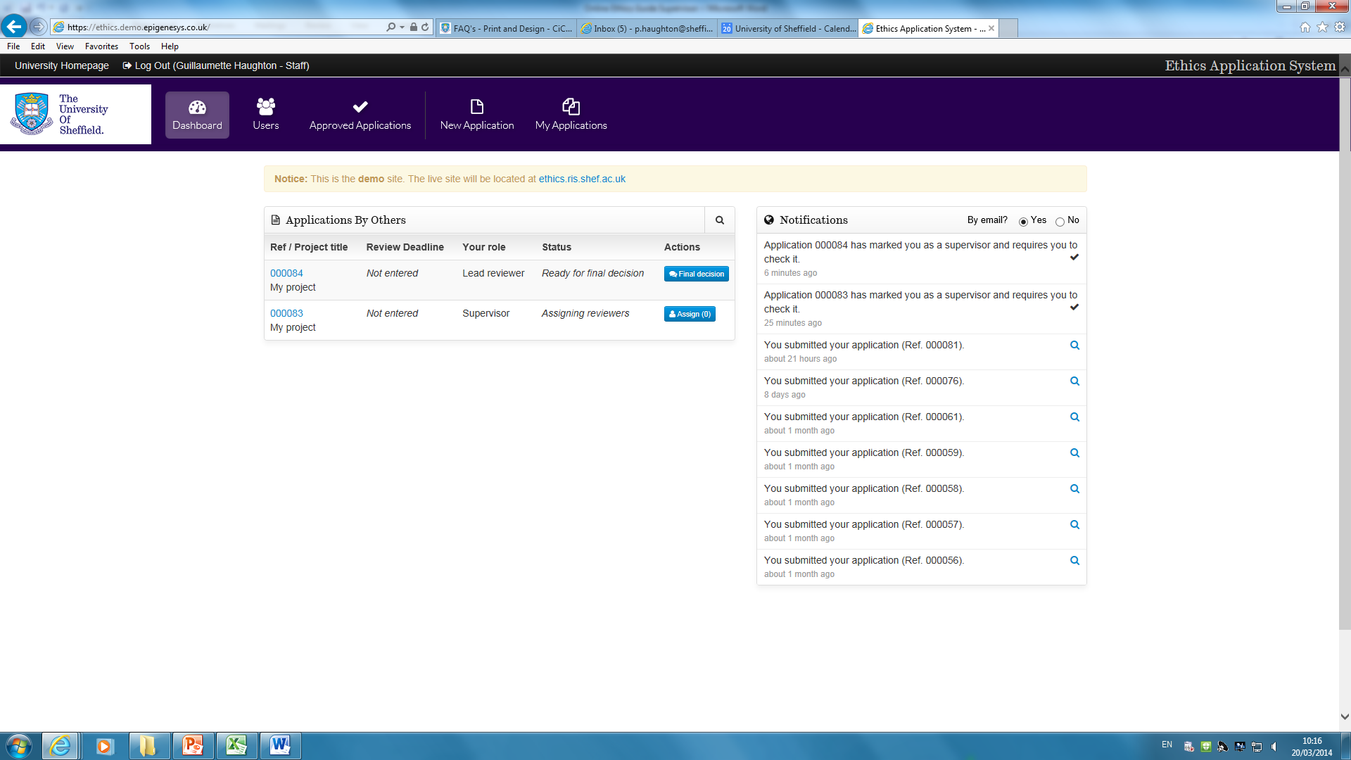
Once you have given a final decision on the project, it is checked by the ethics administrator and returned to the student.

If you need any assistance, please contact p.haughton@sheffield.ac.uk. If you have an urgent technical issue with the system, please contact support@epigenesys.co.uk.

