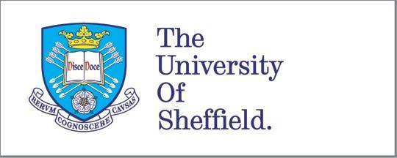

Job Title: | Leverhulme Early Career Fellow
Contract Type: | Fixed-term with a start date between 1 September 2021 and 1 May 2022 for a period of 36 months.
Faculty: | Faculty of Arts and Humanities
Department: | Candidates are welcome to submit applications to hold this post in any of the schools or departments within the Faculty of Arts and Humanities
Salary: | Grade 7.1 £31,866 per annum
Closing Date: | 4th December 2020

Summary:

The Faculty of Arts and Humanities at the University of Sheffield comprises four departments and three schools: Archaeology, History, Philosophy, Music, the School of East Asian Studies, the School of English and the School of Languages and Cultures. We critically reflect on all aspects of human society and culture (past, present, and future) and on the process of reflection itself. We investigate cultures and languages near and far, their ideas, texts, artefacts and landscapes. We aim to create the cultural capital of the future. Working individually and collaboratively, we continually develop innovative methods of enquiry within and across disciplines. Our openness to enquiry and independence in asking and answering questions, enables further understanding, allows us to work creatively and enhances our disciplines.

The Faculty of Arts and Humanities will support up to seven applicants for the current round of Leverhulme Early Career Fellowships, in one or more of the following fields: Archaeology, East Asian Studies, English, History, Philosophy, Music, and Modern Languages and Cultures. Applicants with a proven track record of research and high quality research proposals will be selected for support on the basis of their fit with both the Leverhulme Trust's expectations and Departmental and Faculty strategic priorities.

Leverhulme Fellows will undertake a significant piece of publishable work during their tenure and conduct a programme of high quality research in line with the Leverhulme project proposal.

These are fixed-term appointments for a 36-month duration. The Fellowship must commence between 1 September 2021 and 1 May 2022. Appointments are dependent on the successful award of the Leverhulme Fellowship.

If you are interested in applying, you must first check that you meet the Leverhulme Trust's eligibility criteria. These can be found here.

To apply, contact the relevant Departmental Director of Research and Innovation for the School/Department of choice, see information here. This includes further information about the Leverhulme Early Career Fellowship process.

For other Early-career Fellowship opportunities at Sheffield visit:
http://www.sheffield.ac.uk/faculty/arts-and-humanities/research-innovation/early-career-fellowships

We’re one of the best not-for-profit organisations to work for in the UK. The University’s Total Reward Package includes a competitive salary, a generous Pension Scheme and annual leave entitlement, as well as access to a range of learning and development courses to support your personal and professional development.

We build teams of people from different heritages and lifestyles from across the world, whose talent and contributions complement each other to greatest effect. We believe diversity in all its forms delivers greater impact through research, teaching and student experience.

Follow @sheffielduni and @ShefUniJobs on Twitter for more information about what makes the University of Sheffield a remarkable place to work.

