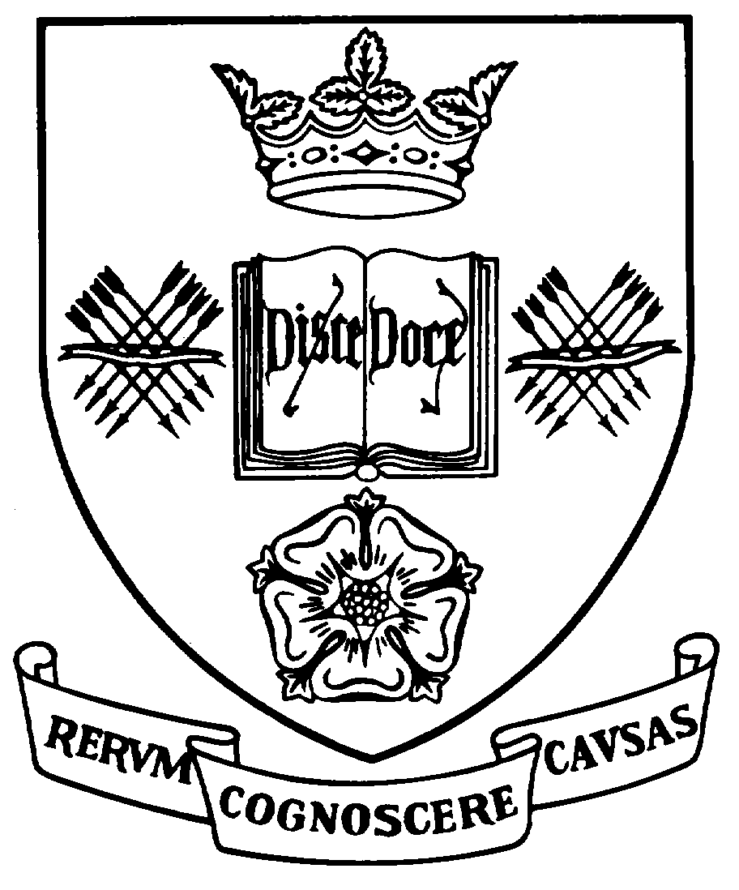

Programme Specification

A statement of the knowledge, understanding and skills that underpin a taught programme of study leading to an award from

The University of Sheffield
This programme specification covers the curriculum in Korean Studies for the following dual honours degree programmes and should be read in conjunction with the relevant programme specification for the second subject:
1. Programme Title |  | 2. Programme Code | 3. JACS Code
Korean Studies and Business Studies |  | EASU06 | T400
Korean Studies with Japanese |  | EASU14 | T400
Music and Korean Studies |  | MUSU06 | W300
4 | Level of Study | Undergraduate
5a | Final Qualification | Bachelor of Arts with Honours (BA Hons)
5b | QAA FHEQ Level | Honours
6 | Intermediate Qualification(s) | None
7 | Teaching Institution (if not Sheffield) | Sheffield University and Korea University, Sogang University, Sungkyunkwan University and Yonsei University, Seoul, Korea
8 | Faculty | Arts & Humanities
9 | Co-ordinating Department | East Asian Studies (EASU06/14), Music (MUSU06)
10 | Other Department(s) involved in teaching the programme | Management School, Music
11 | Mode(s) of Attendance | Full-time
12 | Duration of the Programme | 3 years plus one year at a leading university in Korea
13 | Accrediting Professional or Statutory Body | None
14 | Date of production/revision | March 2015

Dual Degrees
The University of Sheffield defines a dual degree as the independent study of two parallel subjects. Dual degrees offer students the flexibility to choose a programme of study that reflects their interests and gives the opportunity to develop detailed knowledge and key skills in two major subjects. Whilst the two subjects may be taught independently, they will complement, inform and illuminate one another. Where there are two programme specifications for dual degrees, one for each half of the programme, and students should refer to both documents for a full description of the whole programme. Where there are clear links between the two subjects, details will be included in Sections 15 and 20 of the programme specifications. However, there are some single programme specifications for dual degree combinations where there is a substantial degree of integration between the two subjects.
15. Background to the programme and subject area
The Korean Studies component of these dual BA degrees embraces the study of the language, history, society and culture of the Korean people, including the Korean diaspora in Manchuria, Japan, the United States and elsewhere. Native speakers of Korean now number around 70 million people within and without the Korean peninsula. Understanding Korea and the ability to use the Korean language to a high standard is becoming increasingly important because of the significantly increased commercial, industrial and diplomatic importance of the Republic of Korea (South Korea). Anyone wishing to study the development of historic and modern religions, the growth and spread of traditions of music, the geo-politics of the Cold War and Post-Cold War eras, rapid industrialisation and urbanisation, and the centrality of Northeast Asia in the peace and stability of the East Asian region, all need to know more about Korea. Korean is becoming increasingly important as a second language in commerce in East Asia.
The School of East Asian Studies, from its inception as the Centre for Japanese Studies in 1963, has earned an international reputation for the high spoken and written linguistic standards of its graduates, as well as for its innovations in teaching and research. The School was the first department of East Asian Studies in Britain (and one of the first anywhere in the world) to focus its study and research about East Asia on the modern period (post-1850) and to do so from a social scientific perspective, while not neglecting the humanities. It was the first department of East Asian Studies to offer dual honours degrees combining the study of the language and culture of a single East Asian nation with a specific social science subject. The School was also the first department of East Asian Studies to offer a programme of generic East Asian single and dual honours degrees which provided a fully integrated programme of study about the region. The School's award winning programmes in Distance Learning were the first and largest such programmes offered by a department of East Asian Studies anywhere.
Thus, a student doing a single honours degree programme in Korean Studies in the School of East Asian Studies can focus on Korea while also having the opportunity to study modules focussed on another national area or on East Asian generically. Subjects provided range from literature, religion, philosophy, and history, to economics, politics and business studies. No other department of East Asian Studies offers the rich range of subjects which are available in the School of East Asian Studies at the University of Sheffield. Its teaching, renowned nationally for its focus on contemporary East Asia, on the acquisition of practical language skills and on the use of social science methodologies, was rated 'excellent' in the most recent government-sponsored survey of teaching quality.
The growing significance of the Korean economy is creating an expanding need for graduates who possess the combination of analytical, cultural and linguistic skills which our single honours degree programme in Korean Studies offers. Because of both their high standard of linguistic attainment and knowledge of East Asia, the School's graduates have always been highly employable. Recent graduates are employed by major Korean or British companies, the Foreign and Commonwealth Office or have set up their own business with a Korean focus.
Further information is available on the School website: http://www.seas.ac.uk/
16. Programme aims
The Korean Studies component of these dual degree programmes has the following general aims which are consonant with the Mission Statement of the University of Sheffield:
- To provide high-quality teaching which is both informed by the research and scholarship of the School's staff and focused on student-centred forms of learning which develop both skills in analysis and communication;
- To foster the student's acquisition of high-level contemporary Korean language skills in conjunction with an awareness and understanding of the Korean cultural context;
- To sustain within the School a pedagogical and research culture which is able to promote the pursuit of knowledge, the impartial analysis of values, the acquisition of inter-cultural awareness and informed, professional attitudes towards Korea, its culture and society;
- To respond to the diversity of student interests by providing a range of modular options within Korean Studies which are appropriate to that programme;
- To widen access to Korean Studies to the extent permitted by the intellectual and linguistic aptitudes which the programmes demand;
- To enable students to maximise their potential in all aspects of their programme;
- To assess students over a range of knowledge, understanding and skills, and to identify and support academic excellence.
17. Programme learning outcomes
Having successfully completed the Korean Studies component of these Dual degree programmes, a student will have acquired:
Knowledge and understanding:
K1 | A sound knowledge and critical understanding of the structures and usage of modern Korean.
K2 | A sound knowledge and critical understanding of the culture and society of Korea.
K3 | A sound knowledge and critical understanding of the methodologies used to analyse language and culture.
K4 | A knowledge and critical understanding of the history, politics, business, economics, and culture of Korea (depending upon the options chosen).
K5 | Practical knowledge of contemporary life in Korea.

Skills and other attributes:
S1 | Advanced competence in writing and speaking modern Korean.
S2 | Advanced competence in understanding the written and spoken forms of modern Korean.
S3 | A developed level of inter-cultural awareness, derived from the study of the language and culture of Korea, leading to tolerant, professional and informed attitudes to Korea, its language, culture and society.
S4 | Basic skills in acquiring, using, and critically evaluating information about language and culture gained from a variety of sources, including teachers, native speakers, newspapers, broadcasts, books and works of reference, and electronic sources.
S5 | Some familiarity with primary and secondary source material, alongside a regard for the impartial analysis of the values expressed therein.
S6 | The ability to carry out individual study and research, and to participate in group activities such as seminars.
S7 | IT skills, especially the use of Korean for word processing, emailing, and on the internet.
S8 | Further transferable skills, valuable for employment, including information gathering, general IT skills (including familiarity with audio-visual technology and Powerpoint) the development of individual resourcefulness, analytical thinking, the ability to identify problems and ways of resolving them, the critical appreciation of source material, the ability to construct and sustain logical argument on the basis of such material, and the ability to present such argument clearly in both oral and written forms.
18. Teaching, learning and assessment
Development of the learning outcomes is promoted through the following teaching and learning methods:
- Induction procedures during Orientation Week at Level 1 include the First Year Orientation Session in which the degree programmes and requirements are described, study methods discussed, staff members introduced, personal tutors introduced, and the functioning and requirements of the department described. At the end of the session links to the School's Student Handbooks containing information on available modules, assessment procedures, School facilities etc are provided Immediately following this meeting, students meet with their personal tutor for a first orientation session with him or her. During Orientation Week, students also have Library Orientation including a separate meeting with the East Asian Studies Librarian as well as orientation in University IT skills. During this same week, students will meet separately with their Korean Studies degree tutor and attend the Level 1 'Skills Seminar' on essay writing and research.
- Formal Lectures are used frequently at Level 1, and infrequently thereafter, in order to impart essential knowledge (K1-K5 above). Modules with large numbers of students at Level 1 also include separate tutorial sessions.
- Seminars, which may be either staff-led or student-led, are used at Levels 2 and 3 throughout the programme for both language classes and modules devoted to culture, literature, history, politics, economics, business studies, linguistics, and philosophy. Their use is designed to reinforce information imparted through formal lecturing by allowing students to work through, analyse, understand and respond to that information. Seminars devoted to Korean language acquisition may take the form of classes devoted to reading or listening comprehension, written and spoken language production, translation both from and into Korean, or the teaching of formal grammar backed up by exercises and drills. In all cases, the aim is to expose students to as much authentic contemporary material in the Korean language as possible, both written and spoken. To this end, there is a dedicated satellite dish and video recorder to receive daily broadcasts from Korea. Language seminars may be conducted partly in Korean. Seminars thus contribute both to the achievement of knowledge and understanding (K1-K5) and to the development of key skills (S1, S2, S4, S5, S6, S8).
- Tutorials are smaller-group versions of the seminar, and they serve the same purposes and learning outcomes (designed to reinforce skills S3-S5). The word 'tutorial' is also used to describe meetings arranged between a tutor and an individual student in order to clarify a particular problem experienced by that student in the understanding of material or in the process of preparation for a seminar or an assessment.
- Independent study is essential to the successful completion of the programme. New students are introduced to study skills through information in the Student Handbook, through training in the Levels 1, 2 and 3 'Skills Seminars', and through the practical training components of 'studies' modules. The amount of independent study broadly expected for each module is clearly set out in the programme information, although it is recognised that this will vary from student to student. Independent study is generally geared towards the assimilation and further clarification of material gleaned from lectures, preparation for seminars, preparation for written assessments, and the broader development of the knowledge of the field of study. (S4-S8).
- The Year Abroad forms the second year of the degree programme and is spent at the language institute of one of SEAS’ four partner universities in Korea. Students typically receive four hours of daily tuition for five days a week, for a total of 600 contact hours during this period abroad. This is one of the most intensive programmes of Korean language tuition available and develops all aspects of language competence while the student is resident in the centre of the Korean capital. The Year Abroad's linguistic training is a core element in the student's learning experience, providing unparalleled opportunities for creative contact with Korean nationals, for the sustained exercise and development of both productive and receptive linguistic skills to a level appropriate to embark upon the final two years of study (S1, S2), for the development of practical inter-cultural awareness to set alongside the theoretical awareness derived from the study of Korean culture and society (S3), and for the development of personal resourcefulness and adaptability likely to enhance employability (S8).
Opportunities to demonstrate achievement of the learning outcomes are provided through the following assessment methods:
Regular formative assessment – As part of the tuition in Korean language, these assessments are usually in the form of periodic tests or weekly exercises designed to reinforce knowledge and skills in such areas as vocabulary acquisition, written and spoken language production, written and spoken language comprehension, and translation to and from the Korean language. By these means, the School is able at all levels to monitor carefully the student’s progress through the language component of the programme and to pick up and rectify areas of potential weakness in linguistic competence (K1, S1, S2).
Summative assessment of the student's knowledge of and skill in using the Korean language is achieved through several different methods. However, at all levels a student’s ability to demonstrate productive and receptive skills is assessed in both formal written examinations and face-to-face oral examinations. Part of the requirement to pass Level 3 Korean language is an extended presentation in Korean on an approved topic of contemporary interest. These assessment methods support S4.
Assessment of non-language ('studies') modules in subjects such as linguistics, literature, culture and society, history, politics, economics, and business studies (focussed on either the East Asian region as a whole or on one of the component nations) uses appropriate combinations of the following methods:
- written examinations designed to test subject knowledge (K2, K4);
- essay writing and project work designed to test subject knowledge, increasing autonomy in student learning, and the development of transferable skills (K2, K4, S3-8);
- seminar presentations designed to test research, organisational and communicative skills (S6, S8).
19. Reference points
The learning outcomes have been developed to reflect the following points of reference:
The research interests of departmental staff and the research strategy of the School of East Asian Studies;
Subject Benchmark Statements
http://www.qaa.ac.uk/AssuringStandardsAndQuality/subject-guidance/Pages/Subject-benchmark-statements.aspx
Framework for Higher Education Qualifications (2008)
http://www.qaa.ac.uk/Publications/InformationAndGuidance/Pages/The-framework-for-higher-education-qualifications-in-England-Wales-and-Northern-Ireland.aspx
University Strategic Plan
http://www.sheffield.ac.uk/strategicplan
Learning and Teaching Strategy (2011-16)
http://www.shef.ac.uk/lets/strategy/lts11_16
20. Programme structure and regulations
The Korean Studies component of the dual degree programmes provides a comprehensive pathway for the study of the language, culture and society of modern and contemporary Korea. The School of East Asian Studies does not presume that entering students will have competence in the Korean language, or indeed, that they will have studied any language prior to entering the University. The Korean language is taught from beginner's level, although (depending upon the standard of attainment), students with a sufficient prior knowledge of the Korean language may be given advance placement in the programme.
The Korean Studies component of these dual degrees emphasizes the study of the Korean language, combined where possible with the study of some aspect of Korean politics, history, society and business. Specifically, students take the following:
- at Level 1, two Korean language modules (40 credits), a core 'studies' module (20 credits) on Korean history, and modules on aspects of East Asia ranging from society to literature and economic development, depending on the specific dual degree;
- between Level 1 and Level 2, a year spent at one of SEAS’s four partner universities inSeoul, Korea studying the Korean language;
- at Level 2, two Korean language modules (40 credits), and (for some of the dual degrees) a core module (20 credits) on Korean society, and other modules on aspects of East Asia ranging from society to literature and economic development, depending on the specific dual degree;
- at Level 3, two Korean language modules (40 credits), and an optional module (20 credits) on Korean business (a core module for the dual degree with business management) and other modules on aspects of East Asia ranging from society to literature and economic development, depending on the specific dual degree;
The programme structure is designed to provide a context in which students can achieve all of the programme learning outcomes. Dual Honours students devote the same time to acquiring the Korean language as do Single Honours students hence ensuring that graduates of these degree programmes have a high linguistic knowledge as well as a sound disciplinary base.
Detailed information about the structure of programmes, regulations concerning assessment and progression and descriptions of individual modules are published in the University Calendar available on-line at http://www.sheffield.ac.uk/calendar/regs.
21. Student development over the course of study
At Level 1, the Korean Studies component of the programme provides:
(a) instruction in the Korean language from beginner's level, providing knowledge of basic grammar, spoken and written skills. At this level, the student is introduced to the Korean alphabet Han'gŭl.(b) studies modules on Korean Studies where specified, and
(c) modules in the dual discipline.
This pattern is designed to introduce students to the Korean language, an aspect of Korean society and culture, and the basic components of the dual subject.
Between Level 1 and Level 2, a year spent at one of SEAS’ partner universities in Seoul, Korea provides the student with intensive tuition in the Korean language in the context of Korean society.
At Level 2 the Korean Studies component of the programme provides:
(a) enhanced language training building upon the Year Abroad experience. At this point the student's language programme is based the study of recent newspapers, journals television broadcasts and other contemporary materials. At Level 2, students are introduced to the study of Chinese characters, developing the ability to read (but not write) Chinese characters, thus contributing both to the student's linguistic and cultural learning,
(b) advanced disciplinary study in aspects of contemporary Korea, and
(c) advanced study of the dual subject.
Seminars in disciplinary subjects develop both the student's research and presentational skills.
At Level 3, the Korean Studies component of the programme provides further enhancement of the linguistic and disciplinary subjects mentioned for Level 2 under items (a), (b), and (c).
This final year further refines the student's competence in oral, aural and written language skills, disciplinary knowledge of Korea and a specialised subject, and transferable work skills in formal presentation, research, and research writing.
22. Criteria for admission to the programme
Korean is taught from beginner's level; no prior knowledge of the language is required. However, entry to the programme requires good results at A-Level or in an equivalent examination.
Detailed information regarding admission to the programme is available at http://www.shef.ac.uk/prospective/
23. Additional information
This specification represents a concise statement about the main features of the programme and should be considered alongside other sources of information provided by the teaching departments and the University. In addition to programme specific information, further information about studying at the University of Sheffield can be accessed via our Student Services web site at http://www.shef.ac.uk/ssid.

