Introduction
This document is part of our “First Steps in R” resources. It is assumed that the reader has downloaded R and RStudio. No other pre-knowledge is required.

Most of the time we are used to interacting with a computer through a Graphical User Interface (GUI) (ie. with folders, files, windows etc). In R and RStudio, we type instructions (code) instead. The window the instructions are typed into is called the console. Of course, we must type our instructions in a way the computer will understand – this is why it’s called a programming language. This is the way computers were operated before the development of GUIs. R is a programming language which has been developed specifically for doing statistics. R and RStudio are pieces of software which allow the computer to read the code we type and execute it (ie. follow the instructions).

Opening R
If you open the R software you will get a window in which you can type code. This is the console. It is possible to use the R package to do statistics with R but RStudio is much more friendly to use. RStudio is called an Integrated Development Environment (IDE) for R. Note that for RStudio to work, it requires that R is also installed. Because of its ease of use, once you’ve used RStudio, you will probably find you never open R again! All of the materials in this series use RStudio for this reason.

First Opening RStudio
When you open RStudio for the first time there will be three windows. The one on the left is the console. You can type code directly in here and RStudio will follow your instructions as soon as you press return. One thing R can do is simple calculations like a calculator. You can experiment by typing calculations in the console. If you type “4+6” and press return, R will give you the answer 10.
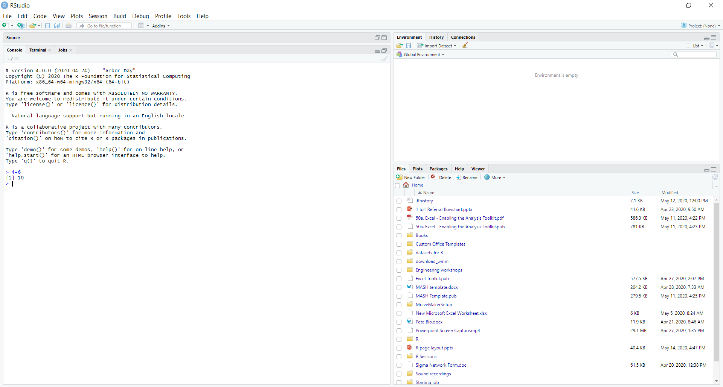
If you’d like to carry out other calculations, here are the ways you must enter them into RStudio for some simple operations.

Arithmetic Operations in R
Operation | R Code
4+6 | 4+6
6-4 | 6-4
4×6 | 4*6
4÷6 | 4/6
4⁶ | 4^6
e⁴ | exp(4)
Log(4) | log10(4)
Ln (4) | log(4)

Note that you cannot go back and delete text you have put in the console. If you’ve never done any coding at first this may seem strange but you’ll get used to it quickly.

Inputting code using a Script
A Script is the name for some code that has been written and which we want R to execute for us. You can write a script, edit it, save it then open it in RStudio and run it whenever you like. RStudio will let you let you edit your script until you’re happy with it and then run all or just some of it by highlighting and clicking run. If you choose “Save As…” in the file menu (as you would when saving, say, a Word document) the script is what gets saved. To create a Script file for the first time, in RStudio, click “File” then select “New File” and “R Script.”

A fourth window opens up on the top left in RStudio. Try typing a few calculation in here. You will see that RStudio will let you type without carrying out any of the calculations. See what happens if you highlight the text and click “Run.”

You should find that all the calculations are carried out at once in the console like so:
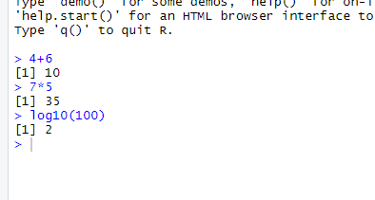

The Environment
As we write code, we will create “objects”. The word has a technical use in R programming which we will deal with in future worksheets. For now we will think of an object as being similar to a variable in algebra – ie. a letter to which we can assign a value.

We can tell R that we are creating a new object using the “assignment operator”:

<-
You can think of this as an arrow. The name of the new object should go on the left and the definition goes on the right. So the code

x <- 3
would create a new object called x which is defined to have the value 3. If we then type

x+4
We should find that R calculates 3+4 and returns the answer 7.

Type
x <- 3
in the console then look in the top right window. You should find that it looks like this.

(Note: You can use “=” as an assignment operator as well as “<-“. However, there is a technical difference in the way R reads “=”. In most situations, either “=” or “<-“ can be used interchangeably but it is a good practice to stick to <- when defining a new object)

When we are writing code we may want to define many new objects. These objects then exist in the R “Environment.” As we create new objects, the top right window keeps a record of them for us. This helps us keep track and can helps us ensure that we do not create two objects with the same name.

We can ask R to give us the same information by typing ls() in the console. ls is short for list – we are asking R to list all the objects in the environment.

You can remove an object from the environment by typing

rm()
With the name of the object in the brackets.

For example

rm(x)
Would remove our variable x from the environment.

You can delete all objects from the environment by clicking the broom icon in the top ribbon of the Environment window:

Alternatively, you can by typing the following command in the console:

rm(list=ls())
(Note: we don’t need to worry about the details of this command at the moment but in case you’re interested: “rm” tells R to remove the thing in the brackets. The rest of the code tells R that it is going to remove an object which is a “list“ and that list is called “ls()”. A “list” is a category of object in R. ls() is specifically the list of everything in the environment.)

The Bottom-Right Window
There are several tabs in the window in the bottom right. For the moment we will only worry about two of them. “Plots” and “Help”. If we ask RStudio to draw a graph or chart, it will appear in this window under this tab. If we ask RStudio for help – which we will often do when learning how to use a new piece of code – the answer will appear under the “help” tab.

Exercise:
- In the console, create an object called y and give it the value 15
- Create another object called z and give it the value 5
- Calculate y divided by z
- Clear the environment and repeat the above by writing a script to do all three stages and running it.
- Change the value of y in your script to 20 and run it again.

Suggested solutions to exercise

> y <- 15
> z <- 5
> y
[1] 15
> z
[1] 5
> y/z
[1] 3

Script:
y <- 20
z <- 5
y
z
y/z

And here it is run:
> y <- 20
> z <- 5
> y
[1] 20
> z
[1] 5
> y/z
[1] 4

