Introduction
This document is part of our “First Steps in R” resources. It follows on from similar documents about vectors and functions in R. It is assumed that the reader understands how to define numerical and character vectors and call a function in R. If you would like to recap these topics, the documents and videos are on the MASH website.

What is a matrix?
In mathematics, a vector can be thought of as a single line of numbers in order, usually written in a column like so:

$$\left(2 -1 0 7 4 \right)$$

A matrix is a grid of numbers arranged in rows and columns like so:
$$\left(2 -1 0 5 4 -2 3 9 0 8 8 1 \right)$$

Although there are differences between matrices in R and in mathematics, this grid arrangement is the key feature that they have in common.

Defining a numerical matrix in R

The following code is used to define a matrix in R. We will look at the elements of the code in turn:

new_matrix <- matrix(1:20, nrow=4, ncol=5)

In R, a matrix is an “object.” To define any new object we begin by giving it a name. Then we use the assignment operator “<-“ to tell R that the definition of the object is about to follow. We will call our matrix new_matrix:

new_matrix <-

So far, everything is the same as if we were defining a vector. Next we use the function “matrix” to tell R that the object we are defining will be a matrix.

Once we have stated which numbers we want to arrange in a matrix, we next specify how many rows and columns we want the matrix to have.

In the above example, we chose 4 rows and 5 columns.
The first argument of the “matrix” function must be a vector. In the above example we have used the vector “1:20” which is just the numbers 1,2,3,…20. Any vector can be used. The vector can be defined inside the matrix function like so:

new_matrix2 <- matrix(c(2,3,2,3,4,6,3,7,6), nrow=3, ncol=3)

In the above example the code tells R to concatenate (join together) the 9 numbers (2, 3, 2, 3, 4, 6, 3, 7, 6) into a matrix with 3 rows and 3 columns. Alternatively we can define the vector first and use the name of the vector as an argument like so:
eg_vector <- c(2,3,2,3,4,6,3,7,6)
new_matrix2 <- matrix(eg_vector, nrow=3, ncol=3)

If we define this matrix
new_matrix <- matrix(1:20, nrow=4, ncol=5)
in R and then ask R to show us the matrix (by typing new_matrix) we get the following output:
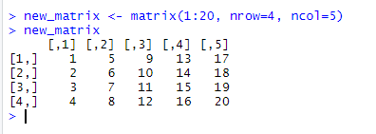
By default R arranges the data from our vector “1:20” by going down the first column, then the second column and so on. The matrix function has a fourth argument “byrow” which is set to FALSE by default. If we set change “byrow” to true, R starts by assigning data to the first row, then the second row and so on:
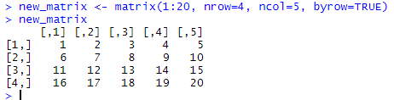

The preferred order for the arguments in the “matrix” function is as shown above. The vector containing the data must always be the first argument. However, we can put the other arguments in any order as long as the labels “nrow=”, “ncol=” and “byrow=” are used. Without labels, these arguments must be in the order shown above. Each of these three lines of code all define exactly the same matrix:

new_matrix <- matrix(1:20, nrow=4, ncol=5, byrow=TRUE)
new_matrix <- matrix(1:20, ncol=5, byrow=TRUE, nrow=4)
new_matrix <- matrix(1:20, 4, 5, TRUE)

Character Matrices
The previous examples discuss numerical matrices. If we define a character vector and ask R to arrange it into a matrix, the resulting matrix is called a character matrix.

For example:
char_vec = c("a", "b", "c", "d", "e", "f", "g", "h", "i")
char_matrix <- matrix(char_vec, nrow=3, ncol=3)
char_matrix
produces the following:
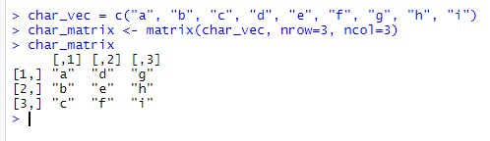
If we define char_matrix and new_matrix as above, we can see in the environment window (top right) that the first is stored as a character matrix and the second as a numeric matrix.
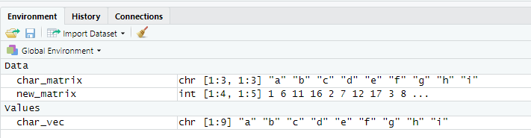

“chr” stands for character and “int” stands for integer (since all the numbers in our numeric matrix are integers.

Combining Vectors to make Matrices
It may be more convenient to define a vector for each row or column of a matrix and then ask R to put the vectors together into a matrix. This can be done with the “rbind” and “cbind” functions. “rbind” combines the vectors as rows and “cbind” as columns like so:
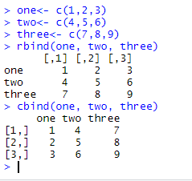
Combining numeric and character vectors
Numeric and character vectors can be combined to make a matrix using “rbind” or “cbind” like so:
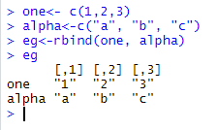

But if we check how R has stored this matrix, we will see that it is a character matrix:
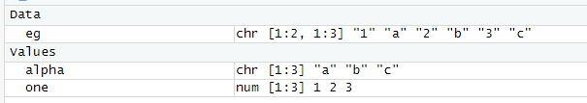

This means that R is now classifying the first row of the matrix as characters and not numbers. Matrices can only have one data type, and when we combine a character vector and a numeric vector, the numeric data is ‘coerced’ to become characters. If we want a row (or column) of numerical data and another with data stored as characters, we need to use a data frame. Data frames are dealt with in other documents in this series which can be found on the MASH website.

Exercise
In RStudio, define:
- A numerical matrix ordered by columns
- A numerical matrix ordered by rows
- A character matrix
- Three numerical vectors of length 5 called a, b and c
- A matrix which has vectors a, b and c as rows
- A matrix which has vectors a, b and c as columns

Solution to Exercise:

First let’s create a numerical vector of random integers using the sample() command. The following creates a vector of random integers between 0 and 9 of length 12
> num_vect1 <- sample(0:9, 12,replace=TRUE)
> num_vect1
[1] 1 6 1 1 7 5 3 2 7 5 9 0

Now create a matrix ordered by columns (remember the default is by columns)
> num_mat_col <- matrix(num_vect1,nrow=3, ncol=4)
> num_mat_col
[,1] [,2] [,3] [,4]
[1,] 1 1 3 5
[2,] 6 7 2 9
[3,] 1 5 7 0

Now create a matrix ordered by rows
> num_mat_row <- matrix(num_vect1,nrow=3, ncol=4, byrow=TRUE)
> num_mat_row
[,1] [,2] [,3] [,4]
[1,] 1 6 1 1
[2,] 7 5 3 2
[3,] 7 5 9 0

To create a sequential vector of letters, we can use either ‘letters’ or ‘LETTERS’ depending on whether you want lowercase or capitals. The following creates a character vector with the first 12 letters of the alphabet:
> char_vect <- letters[1:12]

Can also take a random sample of letters of the alphabet using the sample() function
> char_vect <- sample(letters[1:12],12, replace=TRUE)
> char_vect
[1] "d" "a" "g" "d" "b" "f" "d" "f" "f" "b" "f" "i"

The following uses the character vector that has been created to create a character matrix
> matrix_char <- matrix(char_vect,3,4)
> matrix_char
[,1] [,2] [,3] [,4]
[1,] "d" "d" "d" "b"
[2,] "a" "b" "f" "f"
[3,] "g" "f" "f" "i"

Alternatively, you can pick the character strings for your matrix by hand:

char_vect <- c(“first word”, “second word”, ...)

Now to create three vectors :
> a <- sample(0:9,5,replace=TRUE)
> b <- sample(0:9,5,replace=TRUE)
> c <- sample(0:9,5,replace=TRUE)
> a
[1] 3 7 8 9 7
> b
[1] 7 2 9 7 3
> c
[1] 3 8 9 4 8

(Again, these vectors have been produced by picking numbers between 0 and 9 at random. You don’t have to use the same method here, any numbers will do in your vectors.)

> row_matrix <- rbind(a,b,c)
> row_matrix
[,1] [,2] [,3] [,4] [,5]
a 3 7 8 9 7
b 7 2 9 7 3
c 3 8 9 4 8
> col_matrix <- cbind(a,b,c)
> col_matrix
a b c
[1,] 3 7 3
[2,] 7 2 8
[3,] 8 9 9
[4,] 9 7 4
[5,] 7 3 8

