Worksheet: One-way ANOVA in EXCEL
Example: Weight loss on one of three diets
Data need to be arranged in columns such that the observations for the groups are in separate columns:
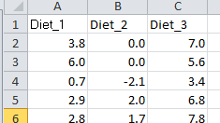

To check the assumptions that ANOVA is appropriate, construct histograms of the data separately for each group and calculate the standard deviations of the groups using the STDEV.S(A,B)
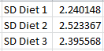

To do a one-way ANOVA you can use the data analysis toolpak:
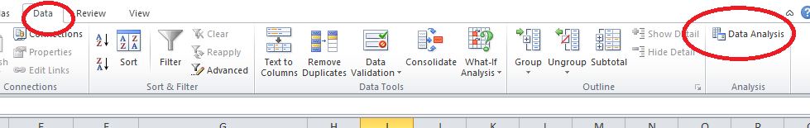

This will open up the Data Analysis dialogue box. Select Anova: Single Factor and click OK
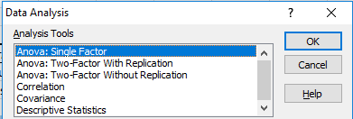

Then fill in the options:
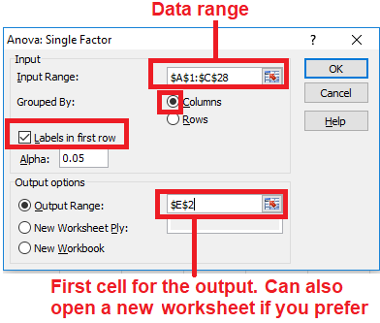

And here’s the output:
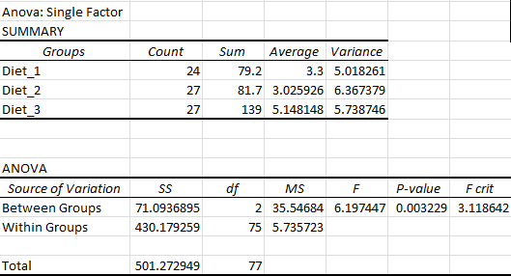

The first table (SUMMARY) shows you various summary statistics including the mean in each group and its variance. You can convert the variances into standard deviations by taking the square root. The second table includes the overall p-value for the ANOVA. If it is significant, this tells you that there are differences in the means between the groups, and you can then do post-hoc t-tests to see whether there are any significant differences between individual pairs of groups, using the methodology outlined in Worksheet 2. The P-value is 0.0032 indicating that there are significant differences in the amount of weight lost on each diet. Looking at the mean values in the summary table, the amount of weigh lost on diets 1 and 2 is similar at about 3 kgs but on diet 3 the amount lost is much greater (over 5kgs).

