LCT: Writing framework
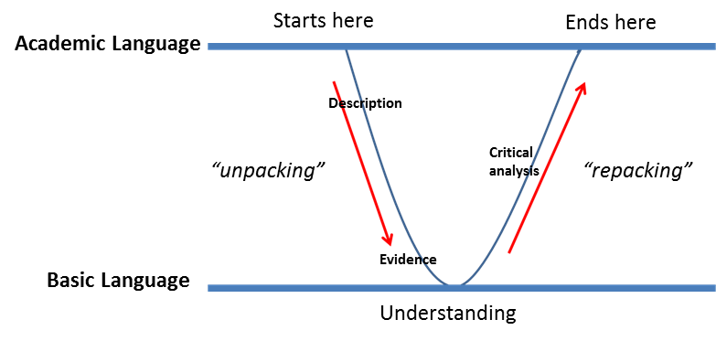
1
2
3
5

4

Below is a framework that applies LCT principles which can be used for your essay paragraphs:
Section of paragraph | Apply to your essay
- Concept
- Unpacking
- Evidence and examples
- Repacking
- Rounding off

