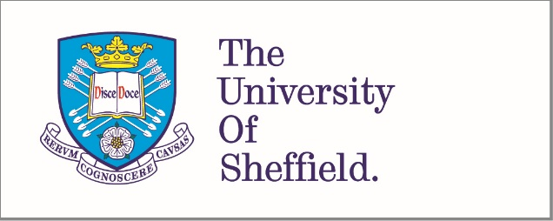
Telling stories and preserving memories –oral history in palliative care
Everyone has a story to tell and oral history enables people to tell it.
Oral history is the audio recording of memories, experiences and feelings; it preserves voices, participants are involved in producing their own life histories and it offers opportunities for participation across a range of abilities. An oral history interview is a chance for individuals to tell their story, to represent themselves in an account of their lives and have it professionally archived.
Our team at the University of Sheffield has developed a facility to deliver bespoke oral history services to your organisation.
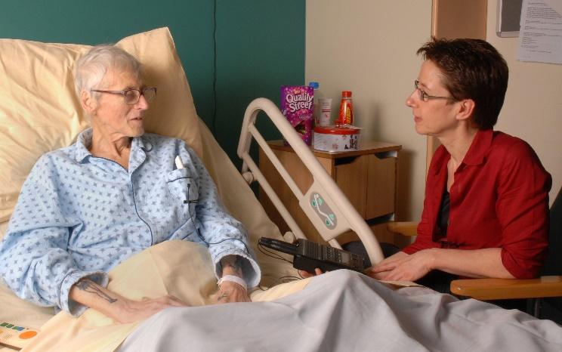
Oral history in palliative care creates high quality audio recordings using rigorous methods, techniques and archiving practices, to enhance the care provided to patients with a life-limiting illness, and for those they love. The first project began in 2007 in the Sheffield Macmillan Unit for Palliative Care, (Sheffield Teaching Hospitals NHS Foundation Trust), and has become an established service both in the unit and in people’s homes. The project is highly regarded by patients and families for its empathetic, meaningful and professional approach to preserving memories, voices and identities.
This pioneering initiative is now replicated in other areas of the country.
Benefits of oral history in palliative care
Oral history provides opportunities to reflect on whatever is important to the participant, with a sensitive and supportive interviewer. Oral history is person-centred and helps enhance identity, dignity and self-esteem at a time when lives may be changing rapidly.
A motivation for taking part in oral history can be to make a voice record for family as a lasting legacy.
Oral history is valued as an opportunity to:
- reflect on life, from the participant’s perspective, in their own voice, without having to write
- talk about themselves with no time limit or medical agenda
- talk with an empathetic and non-judgemental listener interviewer and is considered cathartic
- take part in a validating, dignified, satisfying and social activity whilst in hospital
- express identity, reveal the person behind the patient
- Health care professionals view oral history as complementing clinical care and enhancing relationships with patients

The oral history team here at the University of Sheffield works closely with healthcare professionals to ensure that patients’ interests are best served.

What we can do for you
We will facilitate the creation of individual audio records within your organisation to complement and enhance the experience of patients, family and friends whilst receiving care and services.

Oral histories are permanently archived and can provide you with resources for education and research. Where they have previously been used in teaching, students have said they find recordings insightful and a valuable route into discussion about patient experience, especially on issues that matter to people near the end of life.

How we work with participants
  - Participants are invited to create a recording in a friendly and informal session, free of charge
  - Oral history interviews are arranged at a time and place to suit the participant
  - During the session an oral historian skilfully prompts the participant through their life story
  - Afterwards, participants have opportunities to delete any sections of recording they feel uncomfortable about retaining on the record
  - Copies of the recording are given to the participant in a format of their choice, maybe a CD or via digital file sharing
  - Participants give signed consent (if they wish) for their recording to be securely stored and accessed in an archive

The participant is at the heart of oral history work, they decide when and where their interview session will take place, they are asked for permission to store audio materials created and they can stipulate how they may be used and accessed.

Our processes have been developed and evaluated over time and abide by ethical and legal guidelines.

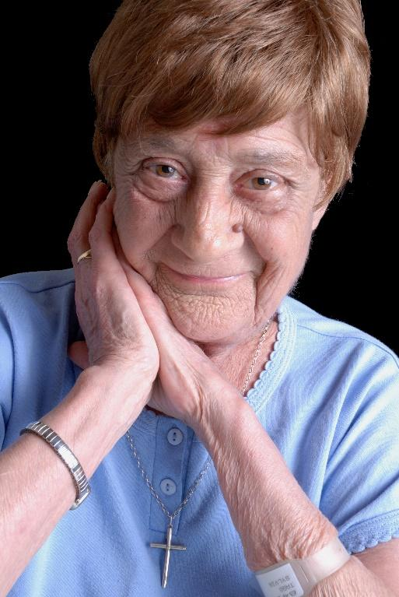

Our oral history project development offer
Typically we will work with you to deliver oral history, building capacity within your organisation to develop the necessary processes and skills to achieve a sustainable project.
If you would like to learn more about developing an oral history project from organisations who have worked with us, we would be pleased to put you in touch.

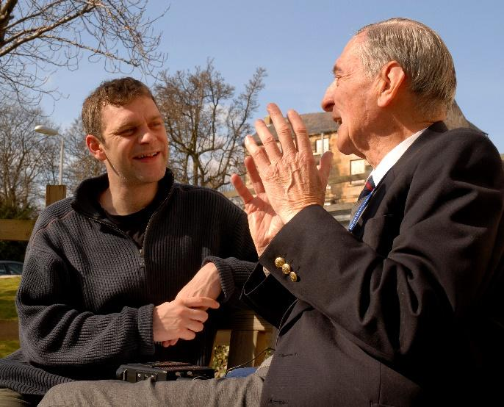

What’s required of the service user?
We will need you to:
- Meet and liaise with us so that you understand what oral history is, what it does and doesn’t do and how to promote it with patients
- Facilitate access to potential participants and support recruitment.
- Appoint a strategic "champion" who can lead on objectives, provide safety/quality governance criteria and meet sign off on requirements, recruit volunteers (where appropriate) and be the main point of contact
- Provide interview space, office space, storage and use of computer, printer etc
- Maintain regular contact with the University of Sheffield project team
We are sure you’ll find the whole process a valuable and rewarding experience.

Feedback from users
“He was very pleased and enjoyed it very much. He thought it was lovely and all the time he was listening to it he had a big smile on his face. And he kept telling me he loved me.” Participant’s wife, reflecting on listening to the recording with her husband.

“I found that it got better as it went on and less intimidating. It was great to bring back some of the memories. All three interviewers were well up to the job and set me at ease. It was a unique experience and I enjoyed doing it.” Participant.

“I never knew I would be able to leave a lovely and unique legacy to my two children when I pass away... I can’t put into words what this has truly meant to me, and hopefully my family.” Participant.

“It brought back memories for us both, being his brother, it brought back past memories to us all.” Above participant’s brother.

“I’ve enjoyed it tons and I wish I was well enough to do more.” Participant.

“I’m really glad I did it. I had a good laugh with my sisters talking about doing it and reminiscing.” Participant.

