England Nursing Associate
Practice Assessment Document

Guide to using the PAD

England NAPAD, Standards of proficiency for nursing associates, (NMC 2018)

Completing the Practice Assessment Document

Contents | Page number
Introduction | 3-4
Criteria for assessment in practice | 5
Criteria for assessment in practice – overall framework Years 1 & 2 | 6
Student responsibilities | 7
Practice Supervisor responsibilities | 8
Protected learning time – NMC guidance and AEI specific guidance | 9
Practice Assessor responsibilities | 10
Academic Assessor responsibilities | 11
Document signatories and checklist for assessed documents | 12
Orientation | 13
Initial, mid-point and final interview | 14
Professional values | 15
Patient/Service User/Carer Feedback Form | 16
Record of working with and learning from others/inter-professional working | 17
Record of communication and additional feedback | 18
Record of peer feedback – Year 2 only | 19
Proficiencies | 20
Episode of care | 21
Medicines Management | 22
Action plan | 23
Record of practice hours | 24
Ongoing achievement record (OAR) – Part A | 25
Ongoing achievement record (OAR) – Part B | 26

Introduction

The purpose of this guide is to provide guidance for the completion of the England Nursing Associate Practice Assessment Document. General guidelines are provided for each element within the PAD. This guidance should be read alongside specific instructions that may apply to individual Universities.

The England NA PAD has been developed to ensure that student nursing associates are prepared to successfully meet the Standards of proficiency for nursing associates (NMC 2018) together with the Apprenticeship Standards for Nursing Associates (IATE, 2019) at the point of registration The NMC standards specify the knowledge and skills that Nursing Associates must demonstrate when caring for people of all ages and across all care settings and comprise six platforms and two annexes. The role of the Nursing Associate in the 21st century is to provide care for people who have complex mental, physical, cognitive and behavioural care needs across a range of settings including people’s own homes, in the community or hospital or any health care setting.

The platforms are:
- Being an accountable professional
- Promoting health and preventing ill health
- Provide and monitor care
- Working in teams
- Improving safety and quality of care
- Contributing to integrated care
Annexe A: Communication and relationship management skills
Annexe B: Procedures to be undertaken by the nursing associate

[N.B. This Guide has been adapted from the Guide to Using the Pan London Practice Assessment Document 2.0, 2018 with kind permission from the PLPLG]

Practice Supervisors, Practice Assessors and Academic Assessors have an important role in supporting and guiding the student through their learning experience. This includes facilitating any reasonable adjustments the student may require to achieve the maximum benefit from the placement. Descriptions of these roles can be found within this guide.

As well as undertaking the required assessments, the role of the Practice Supervisor and Practice Assessor also includes identifying relevant learning opportunities and creating learning and development plans with the student.

The document has been designed around the following Components of Assessment and Feedback:

- Initial, Mid-Point and Final Interviews per placement
- Professional Values
- Proficiencies
- Episode(s) of Care
- Medicines Management
- Patient/Service User/Carer Feedback Form
- Record of working with and learning from others/interprofessional working
- Record of communication/additional feedback
- Record of peer feedback – PAD 2
- Ongoing Achievement Record

[N.B. The screen shots currently include the Mapping Codes from the Standards of proficiency for nursing associates (NMC 2018)
Following validation the mapping codes are removed from the documents. The screen shots in this Guide will be
updated following validation.]

Criteria for Assessment in Practice

Within the PAD three key statements have been developed to reflect the level of performance that the student is required to demonstrate at the
end of each Year, as well as the level of assistance that may be required at each stage where the student by the end of the Year is practising
independently, competently and confidently. The following three levels of performance are to be met by the end of each Year: refer to table 1

By the end of Year 1 | Guided participation in care and performing with increasing knowledge, skills and confidence
By the end of Year 2 | Practising independently with minimal supervision, provides and monitors care, demonstrating increasing knowledge, skills and confidence.

Table 1

In addition to achieving the required level of performance at the end of each year the student is assessed against a specified set of criteria related to knowledge, skills, attitudes and values for each component of assessment within the PAD. These criteria are used to assess the student on different placements across the year as they work towards the overall performance level to be achieved by the end of the Year. For details of the criteria in each year refer to Table 2.

If the student’s performance gives cause for concern at the mid-point interview or at any point during the experience feedback must be given and an action plan written to enable the student to address this prior to the final interview. The Practice Assessor must communicate with and involve the Academic Assessor in this process.

Within the PAD there are guidelines relating to how the assessment is managed within each University, and the student should ensure that they have read and understood these.

Criteria for Assessment in Practice - Overall Framework Years 1 & 2

Guided participation in care and performing with increasing knowledge, skills and confidence.  Year 2  Year 1  Practising independently with minimal supervision, provides and monitors care, demonstrating increasing knowledge skills and confidence. | Year 2  Practising independently with minimal supervision, provides and monitors care, demonstrating increasing knowledge, skills and confidence.  Guided participation in care and performing with increasing knowledge, skills and confidence.  Year 1
PAD 1: Guided participation in Care  ‘Achieved’ must be obtained in all three criteria by the student by the end of the year.  Achieved Knowledge Skills Attitude and values  YES Is able to identify the appropriate knowledge base required to deliver safe, person centred care under some guidance. In commonly encountered situations is able to utilise appropriate skills in the delivery of person centred care with some guidance. Is able to demonstrate a professional attitude in delivering person centred care. Demonstrates positive engagement with own learning.  NO Is not able to demonstrate an adequate knowledge base and has significant gaps in understanding, leading to poor practice. Under direct supervision is not able to demonstrate safe practice in delivering care despite repeated guidance and prompting in familiar tasks. Inconsistent professional attitude towards others and lacks self-awareness. Is not asking questions nor engaging with own learning needs. | PAD 2: Provides and monitors care with minimal guidance and increasing confidence.  ‘Achieved’ must be obtained in all three criteria by the student by the end of the year  Achieved Knowledge Skills Attitude and Values  YES Has a sound knowledge base to support safe and effective practice and provide the rationale to support decision making. Utilises a range of skills to provide and monitor safe, person centred and evidence based care with increased confidence and in a range of contexts. Demonstrates an understanding of professional roles and responsibilities within the multidisciplinary team. Maximises opportunities to extend own knowledge.  NO Has a superficial knowledge base and is unable to provide a rationale for care, demonstrating unsafe practice With supervision is not able to provide safe care and is unable to perform the activity and/or follow instructions despite repeated guidance Demonstrates lack of self-awareness and understanding of professional role and responsibilities. Is not asking appropriate questions nor engaged with their own learning.

Table 2

Student Responsibilities
You should take responsibility for your own learning and know how to access support and;
- Engage positively with all learning opportunities
- Understand the assessment requirements
- Work with and receive written feedback from a range of staff (including identified Practice Supervisors) and Service-Users
- Reflect on your own learning
- Provide feedback on learning experience
FAQs
For many of your placements you will be in your employer placement. You will be allocated spoke placements to enable you to obtain a range of experiences.
Q: When should I contact my allocated placement?
A: It is advisable to contact your allocated placement in advance of starting your placement to obtain the information you need to enable you to prepare.

Q: Will I have a named contact on placement?
A: You will have a nominated person to support you and address any concerns. This could be a Placement Manager, Ward Manager, Team Leader, Service Manager or other.

Q: Who will supervise me on placement?
A: You will be supported by a number of Practice Supervisors who will support your learning and can contribute to assessment. (refer to page 8)

Q: Who will assess me on placement?
A: You will have a nominated Practice Assessor for your placement, who is responsible for assessing and confirming proficiency and achievement. The Practice Assessor will liaise with the Practice Supervisor and Academic Assessor to obtain feedback on your progress. (refer to page 9)

Q: Will there be support from the University when on placement?
A: You will have a named Academic Assessor for each Year of the programme. The Academic Assessor will liaise with your Practice Assessor. If you have any concerns on placement you should raise these with the university as soon as possible. (refer to page 10 and university guidelines)
Practice Supervisor Responsibilities
Practice Supervisors (PS) are registered nurses, registered nursing associates, midwives or registered health or social care professionals. They have current knowledge and experience and are appropriately prepared for the role;  - Ensures learning opportunities are facilitated  - Contributes to assessment and records regular feedback  - Seeks feedback from other supervisors  FAQs  Q: What is my role in supporting the student?  A: You have responsibilities for overseeing the student’s progress during the placement. You will undertake the initial interview in the placement with the student which includes supporting the student to identify their learning opportunities and completion of the learning plan.  Q: What is my role in assessing the student?  A: The Practice Assessor has responsibility for student assessment. Practice Supervisors have an important role in contributing to assessment and giving regular feedback and the following can be undertaken by the Practice Supervisor to contribute to the student’s assessment;  - Initial interview on placement  - Professional Values at midpoint interview  - Proficiencies as appropriate and relevant to your scope of practice and professional role  Q: What is my relationship with other identified roles?  A: You will record feedback on the student’s progress and liaise with other Practice Supervisors and the Practice Assessor to give feedback to inform the Practice Assessor’s decisions.  Q: What if I am not a registered nurse and supervising the student?  A: A range of registered health or social care professionals can support and supervise student learning and contribute to the student’s assessment within their scope of practice. | 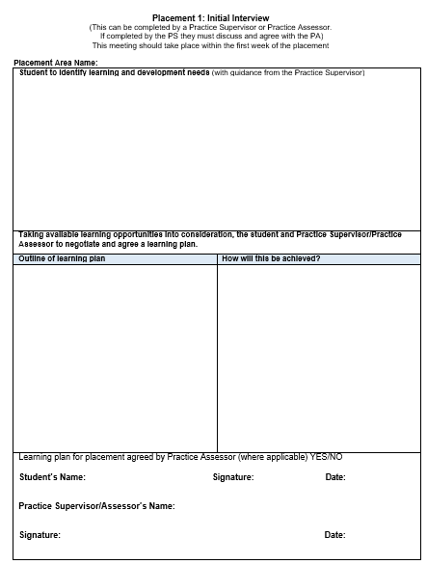
Protected learning time – NMC guidance |  | Guidance on protected learning time in your AEI
Organisations must ensure that nursing associate students have protected learning time in line with one of these two options (NMC 2018)
Option A: nursing associate students are supernumerary when they are learning in practice
Option B: nursing associate students who are on work-placed learning routes:
- are released for at least 20 percent of the programme for academic study
- are released for at least 20 percent of the programme time, which is assured protected learning time in external practice placements, enabling them to develop the breadth of experience required for a generic role, and
- protected learning time must be assured for the remainder of the required programme hours

- The NMC does not require nursing associate students to be supernumerary while learning in practice, but the student must have protected learning time. The decision about how this is provided is for AEIs and their practice placement partners.

- All students must be supervised when they are learning in practice. The level of supervision will depend on level of risk associated with particular tasks or interventions, and the competence and confidence of the student.

Practice Assessor Responsibilities
Practice Assessors (PA) are registered Nurses or registered nursing associates with current knowledge and expertise and are appropriately prepared for the role;  - Conducts assessments, informed by feedback from Practice Supervisors  - Makes and records objective decisions, drawing on records, observations, student reflection and other resources  - Periodically observes the student  - Gathers and coordinates feedback from Practice Supervisors and other relevant people  - Schedules communication with Academic Assessors at relevant points  FAQs  Q: What is my role in assessing the student?  A: You have responsibility for student assessment and will liaise with the Practice Supervisors to obtain feedback and Academic Assessors to discuss student achievement and progression. You will review assessment documentation in the PAD that has been completed by a range of other health or social care professionals who have contributed to aspects of assessment.  Q: What specific elements do I need to assess and document?  A: The Practice Assessor assesses;  On each placement:  - Initial interview (can be undertaken by Practice Assessor or Practice Supervisor; if PS undertakes, must be agreed by PA)  - Midpoint interview  - Professional Values at final interview  - Final interview  - Confirmation of proficiencies  During the year:  - Episodes of Care and Medicines Management  Q: What is my responsibility when a student’s performance causes concern?  A: If a student requires an Action Plan, you should liaise with the Academic Assessor. Depending on the AEI and the local practice placement policy you may have to inform the nominated person. | 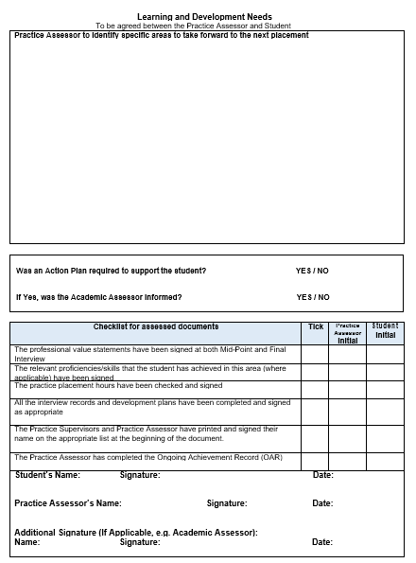  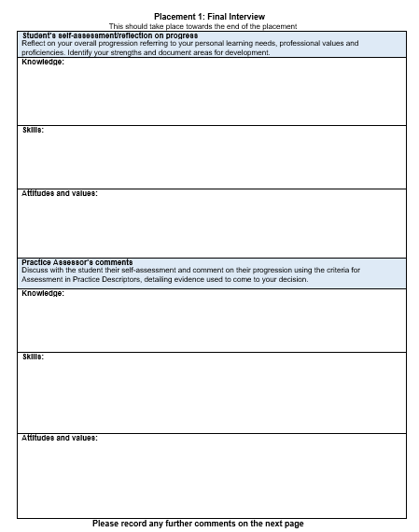
Academic Assessor Responsibilities
Academic Assessors are registered Nurses and are nominated for each Year of the programme and are appropriately prepared for the role;  - Works in partnership with the Practice Assessor to evaluate and recommend the student for progression for each year of the programme  - Has understanding of the student’s learning and achievement in practice  - Enables scheduled communication and collaboration between Academic and Practice Assessors  FAQs  Q: What is my role in relation to student assessment?  A: The student has an Academic Assessor for each Year of the programme and will provide continuity and have an overview of student achievement to inform progression. If there is cause for concern in relation to the student’s performance you should be involved in agreeing an Action Plan.  Q: Who will I liaise with?  A: You will communicate and collaborate with the Practice Assessor at relevant scheduled points during the Year. This may be in person, via email or telephone as appropriate.  Q: What is my responsibility in relation to the student’s progression towards registration?  A: In Year 3 to ensure the student is able to provide care, lead and co-ordinate care confidently they will meet with their Practice Assessor or Practice Supervisor weekly to discuss and summarise achievement. The Academic Assessor will review and confirm the overall achievement in the PAD and recommend progression to registration in the OAR. | 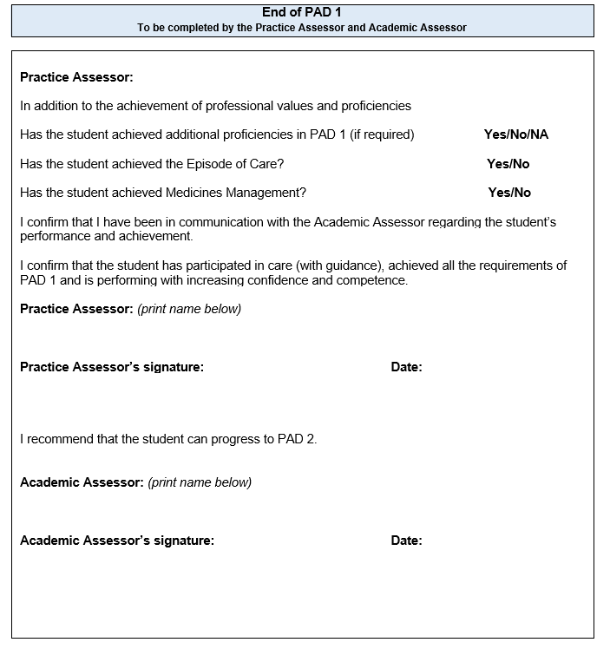
Document Signatories and Checklist for assessed documents
There are separate pages for Practice Supervisors, Practice Assessors and Academic Assessors to record information. It is your responsibility to complete these details.  Any registered professional who writes in the PAD must complete the appropriate signatories page. This includes the record of orientation, record of communication and/or record of practice hours.  This is required by the University to cross reference and prevent falsification of records.  Please ensure that you insert your name, signature and date as required throughout the document.  Checklist for assessed documents:  At the end of each placement in the final interview, the Practice Assessor completes the checklist to confirm all components have been assessed and records signed. | 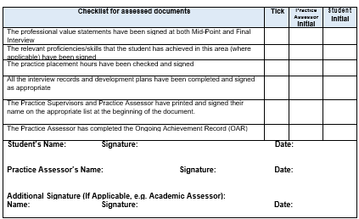
Orientation
There are some elements of orientation that must be completed on the first day on placement. Refer to orientation page in the Practice Assessment Document.  FAQs  Q: Who can orientate the student and complete this page?  A: An appropriate member of staff familiar with the area, as identified by the nominated person/local manager can complete the student orientation and sign the appropriate section of the PAD.  Complete the appropriate signatory page. | 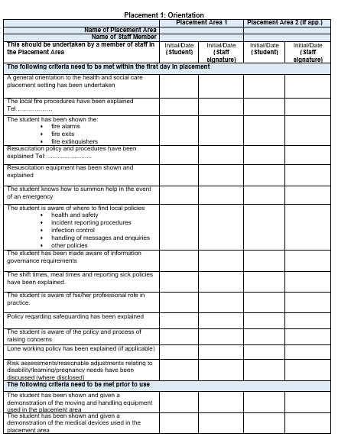

Initial, Mid-point and Final Interview
The interviews provide a formal record of student learning, reflections and achievement. Students are encouraged to take responsibility for their own learning and record reflections.  Initial interview:  This is completed by the student with support from the Practice Supervisor or Practice Assessor who will identify the learning opportunities available during the placement and will reflect on their achievements. If the Practice Supervisor completes the initial interview with the student this needs to be confirmed by the Practice Assessor.  Mid-point interview:  This is completed by the student and the Practice Assessor who will review progress and if there are causes for concern the Practice Assessor will liaise with the Academic Assessor and complete an action plan.  Final interview:  This is completed by the student and the Practice Assessor who will review progress and confirm achievement. At the end of the interview the Practice Assessor must complete the checklist for assessed documents. | 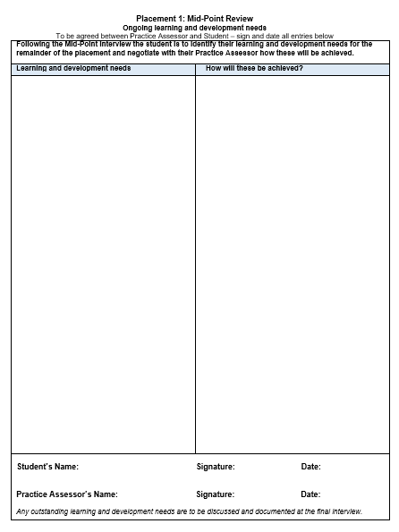  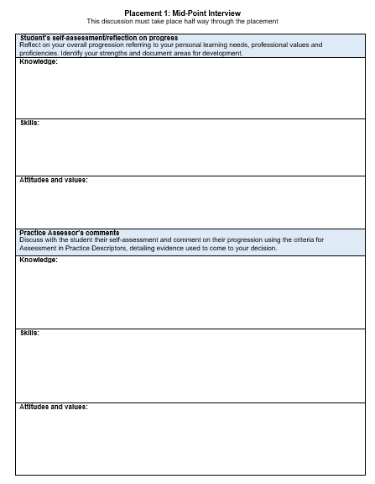
Professional Values
Students are required to demonstrate high standards of professional conduct at all times during their placements. Students should work within ethical and legal frameworks, and be able to articulate the underpinning values of The Code (NMC, 2015). The Professional Values reflect a number of proficiency statements and are captured under the four sections of The Code.

Student reflection on meeting Professional Values:
The student selects one example from practice on each placement to demonstrate how they practise within The Code. Confidentiality in relation to people receiving care and service providers should be maintained. For each placement a different area of The Code should be selected to reflect on.

Student achievement:
Where other components have been assessed and achieved e.g. a proficiency assessed at the beginning of the Year, the student needs to demonstrate continued competence and confidence in the proficiency. Professional Value statement 8 enables the assessor to ensure and record that the student is meeting this requirement.

FAQs
Q: Who assesses the professional values?
A: The Practice Supervisor or Practice Assessor can assess the mid-point professional values. If the Practice Supervisor assesses the mid-point this will be reviewed and agreed by the Practice Assessor. The final Professional Values on each placement are assessed by the Practice Assessor who will discuss and review with the student their reflection. If there are any concerns raised these should be discussed with the Academic Assessor.

Patient/Service User/Carer Feedback Form
Within each placement there is a page for the student to receive feedback directly from someone they have cared for and/or carers. Practice Supervisors or Practice Assessors are asked to support students by facilitating this and asking people or their families to complete the form and they should sign this on completion. It may not be possible to have this completed in every placement.  FAQs:  Q: Who asks the person receiving care or carer to complete the form?  A: The Practice Supervisor/Practice Assessor should obtain consent from patients/service users/carers who should feel able to decline to participate.  Q: Does the person receiving care or carer have to sign the form?  A: No.  Q: How is the feedback used in the assessment process by the Practice Supervisor and Practice Assessor?  A: The student will reflect on the feedback provided by the patient/service user/carer and discuss the outcomes, including any changes to practice that need to be made which can be included in the interviews or in an Action plan. | 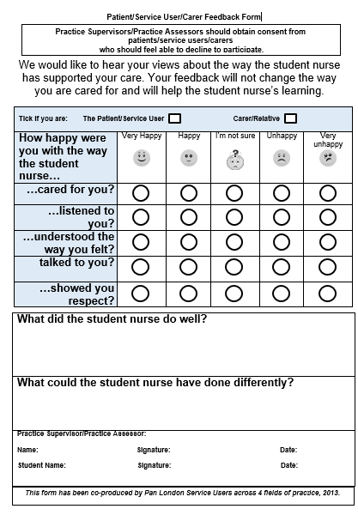
Record of Working with and Learning from Others/Inter-professional working
Students will have opportunities across all Years to work with other professions across a range of teams and agencies and will be able to gain an understanding of the different roles and responsibilities and importance of teamwork in providing person centred care.  Student reflection:  Students should reflect on their learning when working with members of the multi-disciplinary team and document this. The Practice Supervisor will discuss the student’s reflection and comment on their experience.  FAQs  Q: How are the reflections used in the assessment process by the Practice Supervisor and Practice Assessor?  A: The Practice Supervisor will discuss the student’s reflection on their learning from others and provide relevant feedback to the Practice Assessor as appropriate. The Practice Assessor will review documented records where the student has worked with other health and social care professionals and incorporate into assessment where appropriate. | 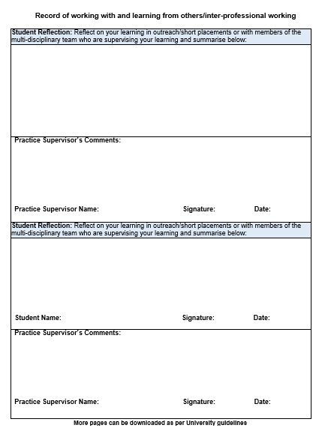

Record of Communication and Additional Feedback
These records can be completed by Practice Supervisors, Practice Assessors, Academic Assessors or any other members of the team involved in the supervision and assessment of the student.  Complete the relevant signatory page.  This is for additional feedback that has not previously been documented in the PAD.  FAQs  Q: Should other members of the team be registered professionals?  A: No. It may be appropriate for an experienced health care assistant to give feedback on working with the student. However they would not be contributing to assessment decisions.  Q: What type of information should be recorded?  A: Any relevant information that can be used in the assessment process, or that records the student’s progression. | 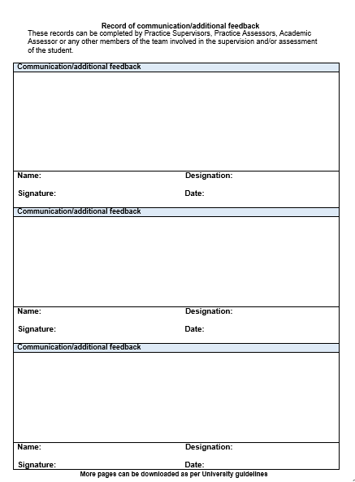

Record of peer feedback – Year 2
These records can be completed by the student’s peers i.e. other students who have worked alongside you or have had the opportunity to discuss your learning needs with you. If you have facilitated a teaching session on placement you can use this form below to obtain feedback.  FAQs  Q: Which students can complete peer feedback?  A: Any student in practice that you have worked with regularly. This could be Nursing, Midwifery, Allied Health, Medical and/or Social Work students.  Q: How is peer feedback used in the assessment process by the Practice Supervisor and Practice Assessor?  A: The Practice Supervisor will discuss with the student the feedback they have received from peers in relation to how they support other student’s learning in practice and facilitate teaching. The Practice Assessor will review documented peer feedback where the student has received feedback from other students and incorporate into assessment where appropriate. | 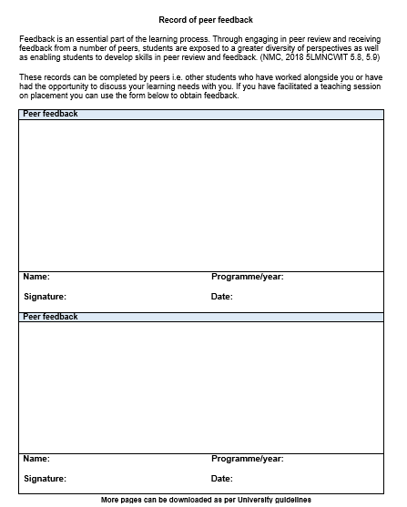
Proficiencies
Assessment of proficiencies are undertaken across the Year. These can be assessed in a range of placements. If a proficiency is assessed as achieved early in the Year it is expected that the student maintains that level of competence and could be re-assessed in subsequent placements during the year. This is underpinned by Professional Value 8.

In exceptional circumstances if a student does not have access to specific learning opportunities to enable assessment of all the proficiencies in year 1/ PAD 1 they may be permitted to meet these in PAD 2 as per their local university guidelines – see the university specific pages for details. Where required these proficiencies must be agreed by the practice assessor who must ensure she/he has liaised with the academic assessor. The student must then present PAD 1 at the beginning of year 2 to their practice assessor to ensure completion of the identified proficiencies in PAD 2.

On occasions students may also have the opportunity to meet additional proficiencies in Year 1/ PAD 1 as per local university guidelines. These can be recorded on the ‘Additional proficiencies’ page in this PAD by the Practice Assessor. Achievement of these must then be explored as part of the initial interview in PAD 2, as further experience to consolidate these proficiencies may be required

FAQs
Q: Who assesses the Proficiencies?
A: Practice Supervisors and other Registered health or social care professionals can contribute to the assessment of proficiencies, within their scope of practice. Practice Assessors will also assess proficiencies and have responsibility for confirming that proficiencies have been met at the final interview.

Episode of Care
Episodes of Care are holistic assessments which enable the student to demonstrate progression across a number of platforms and must be achieved by the end of the Year. Effective communication and relationship management skills underpin all aspects of care. This assessment must be completed by a Practice Assessor.  Year 1:  Formative - episode of direct care meeting the needs of a person receiving care.  Summative - episode of direct care meeting the needs of a person receiving care.  Year 2:  Episode 1 - Supervising and teaching a junior learner in practice, based on the delivery of direct person-centred care.  Episode 2 - group of people receiving care with increasingly complex health and social care needs.  The student and the Practice Assessor should identify the appropriate placement and episode of care to complete this assessment. As there is only one opportunity for assessment the planning should take this into consideration to maximise the learning for the student.  Student reflection:  An integral component of this assessment is the student reflection on the delivery of person centred care and the student reflection forms an integral year of the end point assessment at the end of Year 2. | 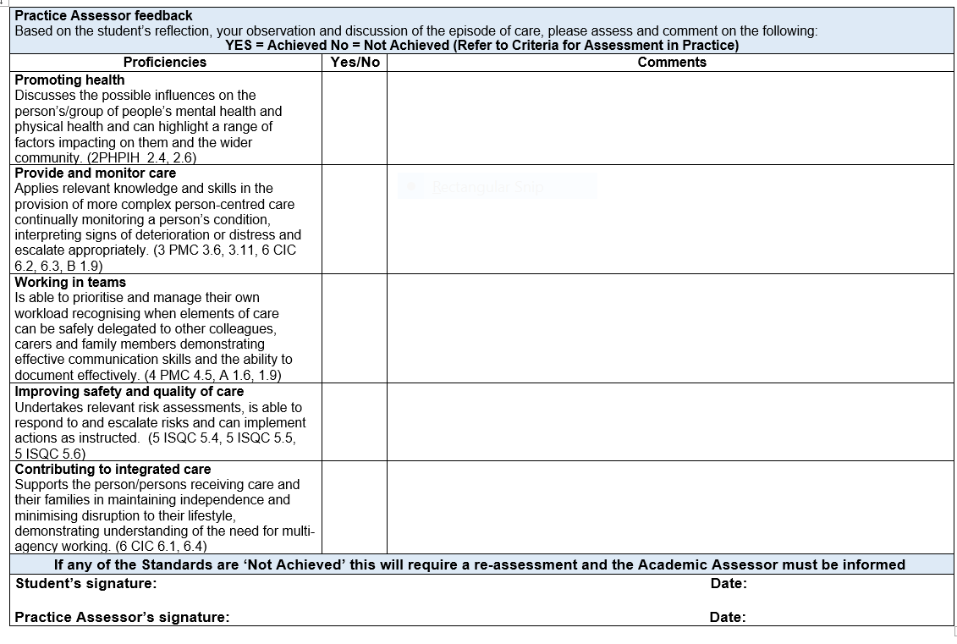
Medicines Management
The students is required to undertake a Medicines Management assessment during each Year. This assessment must be completed by a Practice Assessor.  The student and the Practice Assessor should identify the appropriate placement to complete this assessment. As there is only one opportunity for assessment the planning should take this into consideration to maximise the learning for the student. The student should be allowed a number of practice opportunities to administer medicines under supervision prior to this assessment.  By the end of Year 2 the student should be consolidating their knowledge, skills and competence in relation to the safe administration of medicines within the required regulatory frameworks relating to Standards of proficiency for nursing associates (NMC 2018), The Code, (NMC 2015) and A Competency Framework for all Prescribers (The Royal Pharmaceutical Society 2016). | 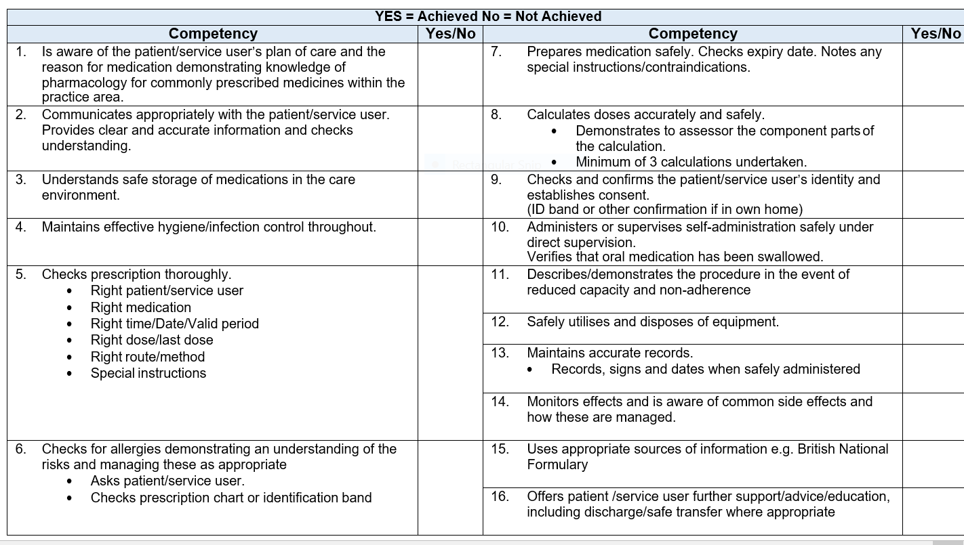
Action Plan
There are Action Plans available within each Year. An Action Plan should be completed if there is cause for concern in relation to the student’s performance. For example, failure to achieve components of assessment such as Professional Values.  If a student requires an Action Plan, the Practice Assessor should liaise with the Academic Assessor and is responsible for reviewing progress and ensuring support and learning is available. Depending on the AEI and the practice placement’s policy, the Practice Assessor may have to inform the nominated person on placement.  FAQs  Q: What timescale should be used for the student to achieve the Action Plan?  A: This will depend on the area of concern and the frequency of learning opportunities available within the length of the placement. The student has to be able to attend and engage in learning in order to achieve the action plan.  Q: How much support and learning should be provided?  A: This will depend on the Year that the student is undertaking and the complexity of the area of concern. The student has to be able to demonstrate competence or professionalism relevant to the stage of the programme.  Q: What happens if the student does not achieve the objectives within the Action Plan by the stated review date?  A: The Practice Assessor will need to document their decision regarding whether the student has failed the placement and communicate the outcome with the Academic Assessor. | 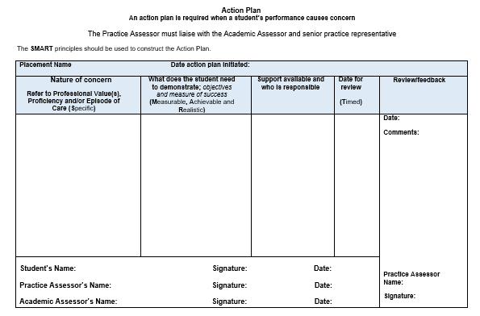

Record of Practice Hours
Students are required to provide evidence of having completed the required number of practice hours for NMC Registration.  Members of staff on placement must verify the student’s hours at the end of each shift/week on this form. Staff verifying practice hours must complete the relevant signatory page towards the front of the PAD.  Students will have specific information from their university regarding how this is reported and recorded.  FAQs  Q: Is the staff member responsible for verifying all the hours recorded?  A: No, the staff member is only calculating those hours documented on the practice hours page once the six weeks are complete. | 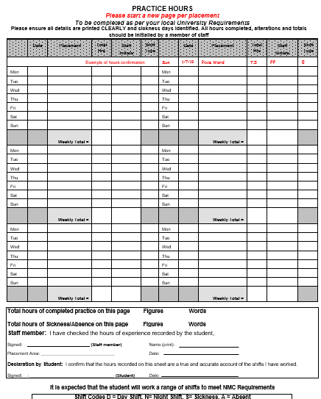
Ongoing Achievement Record (OAR) – Part A
The Ongoing Achievement Record (OAR) summarises the student’s achievements in each placement and with the Practice Assessment Document (PAD) provides a comprehensive record of professional development and performance in practice.  The Practice Assessor completes the summary page at the end of each placement and at the end of each Year completes the progression statement.  The Academic Assessor confirms the completion of each placement, adds comments and at the end of each Year completes the progression statement.  FAQs  Q: Should the Academic Assessor be present when the OAR is completed?  A: The Academic Assessor liaises with the Practice Assessor to confirm progression at the end of each Year in the PAD and OAR. Communication must be scheduled for this to occur and may be face to face or though other communication methods. If the student has not achieved assessment in order to progress, the Practice Assessor and the Academic Assessor will liaise and complete an Action Plan. | 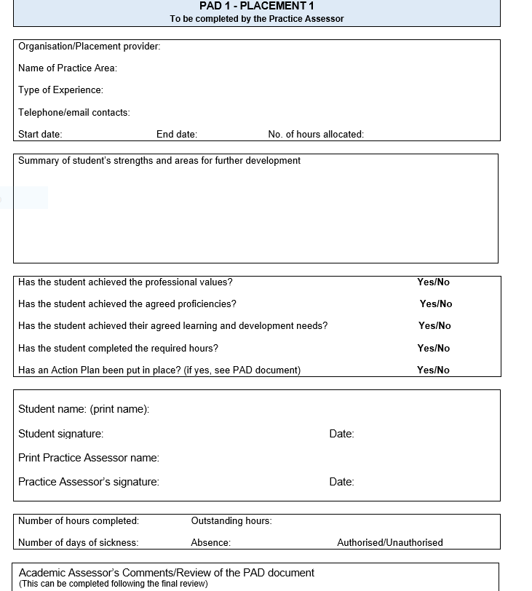
Ongoing Achievement Record (OAR) - Part B
HEI’s to add their own specific guidance here as there will be variations

