# Evaluating Information and Critical Thinking

## Contents

Contents 1

What is critical thinking and why is it important? 2

Introduction 2

Questioning the item. 2

Questioning the author/creator. 4

Questioning the content. 5

Questioning the currency. 6

Summary 8

Full URLs 8

## What is critical thinking and why is it important?

Watch the video to find out: [What is critical thinking?](https://digitalmedia.sheffield.ac.uk/media/1_pud5vjyv" \o "What is critical thinking? (video))

## Introduction

Are all sources of information equal? Can you believe everything you read on Wikipedia? Are there cases where Twitter would tell you more than a textbook?

There's lots of information out there, and not all of it is reliable, or appropriate for academic work. This tutorial is designed to help you evaluate the information you find and judge which sources are appropriate for a particular piece of work.

Evaluating information is an important part of research skills and critical thinking at university. Your work will benefit from using the best evidence and information available.

This tutorial suggests things you might like to consider, although not all will be relevant to all types of information, and you need to take into account the particular needs of your assignment/discipline.

Back to Contents

## Questioning the item.

Firstly, is the information relevant? If it is a journal article, it might be worth reading the abstract, introduction and conclusion to make sure that the content is pertinent and suitable for your research needs. Or, if it is a book, go through the contents page to check chapters and sections titles. In a website or blog, you can read the “About” section or similar to get an idea of its scope.

There are many types of information sources available. In most cases at University, you are expected to use academic information sources such as journal articles, conference papers and books. Many of these have been through a process of peer-review. Peer-review means that the work has been evaluated by experts within the relevant academic field, who check if it meets the standard necessary for publication.

Web pages and other non-academic sources don't go through such a rigorous process, and are less likely to include references.

It is also important to consider...

* Is it **primary** (presenting original research) or **secondary** research (literature review or opinion/analysis/discussion based on previous research)? Which are you interested in?
* The **level** - could it be too technical, or too basic?
* The **type** - is it an overview, an opinion, the results of one piece of research, or a literature review?
* The **purpose** of a piece of information - why has it been created?
* The **intended audience** - is it an appropriate piece of information for you?

Think about the type of information you need - you can then decide on the best place to find that information. We've given some examples of different information sources below:

* **Peer-reviewed journal article**: other experts have checked this piece of research before publication. If it is describing the results of a piece of research it is important to consider the research methodology and the conclusions drawn from the results.
* **Commercial web page**: this website is designed for a commercial purpose and this may affect how the information is presented.
* **A textbook** gives an overview of a topic at the time of publication, and a research monograph is a detailed book focused on one topic.
* **Facebook post or other social media**: Generally social media posts are someone’s opinion, not backed up by evidence or checked by anyone.
* **Wikipedia**: although a Wikipedia entry can be a useful place to start your research, it’s not considered an academic information source.
* **University web page**: the URL ac.uk tells you this page is from an HE education. You can check other URLs such as gov.uk, org.uk, .edu etc.
* **Newspaper article**: Newspapers often have a particular bias.
* **Dataset:** you can draw your own conclusions from the data, but you must check the details about the sample and methods etc.

Below are three scenarios and some examples of information sources which you might use in each case.

### Scenario 1: You have been asked to write an essay on a topic you’re not familiar with and need an introduction or overview to get you started.

#### Useful information sources

* **Google**: Google searches may help you to get an idea of the key terms and concepts.
* **Wikipedia**: Wikipedia may help you get an idea of key terms and concepts.
* **Academic textbooks**: Academic textbooks will give you a reliable overview of the topic and ideas of how to find more detailed information if you need it.

### Scenario 2: You are doing some in-depth research for your dissertation and need to find out about the latest academic research on your topic

#### Useful information source

* **Academic journals**: In most academic fields, current research is published in academic journals. You will be expected to search for academic journal articles when performing a literature review for a dissertation or research project.

### Scenario 3: You are researching climate change and are interested about how this issue is represented in the media.

#### Useful information sources

* **Social media**: Non-academic sources such as social media are often prone to bias, but can provide useful information on popular opinion, people's reactions to and representations of events and controversial topics. It is key that you check who the owner is of the social media account as some academics and scientists do use social media to disseminate current research.
* **Newspaper articles:** Whilst often open to bias, non-academic sources such as newspaper articles can provide useful representations of events.

Back to Contents

## Questioning the author/creator.

Think about the last time you purchased a piece of technology, such as a mobile phone and consider the following questions:

* Were you drawn to a brand/name you were familiar with?
* Did you know other people with a phone made by that company, or did they have a good reputation?
* Would you consider buying a phone from a company you hadn't heard of?
* Would you do some research into the company first – e.g. by looking at online reviews?
* Would you only buy your phone through a reputable company/website?
* Would you consider what other products the company makes?

**Questions like these are thinking critically, you probably do it more than you realise.**

When evaluating information in an academic context, you may wish to consider the following points:

* Is it clear who created it? (This may be harder with websites.)
* Are they experts in their field? (Citations can give an indication of the influence or reputation of an author. A citation is when an author’s work is mentioned in someone else’s work.)
* Why have they created it? (Knowing the author's motivation can help you determine whether there is any bias to the information.)
* What else have they produced?
* Does the creator work for a particular organisation?
* Who is it published by?
* Who is it funded by?

Back to Contents

## Questioning the content.

When you're shopping for food, how do you decide what's healthy and what isn't? Many foods claim to be good for you, but the information they give can be misleading. If a yogurt claims to be 'low fat', does it give figures? 'Low' compared to what? How does the amount of fat compare with other yogurts? Does it mention the sugar levels?

In the image below, looking at the nutritional information for Yeo Valley Natural Yogurt and its 0% fat counterpart, you can see that the 0% version contains 2 grams more sugar. This is not clear from the ‘low fat’ description.

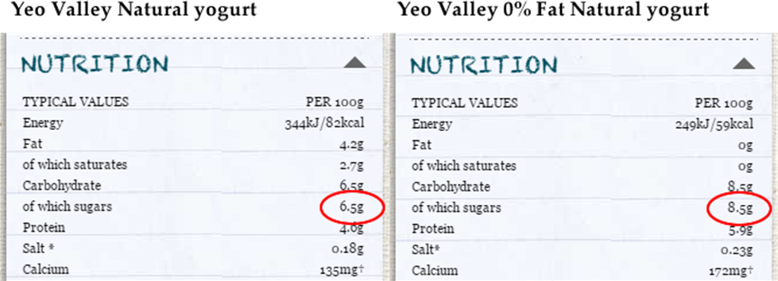

Source: Yeo Valley [website](https://www.yeovalley.co.uk/things-we-make/yeogurt/natural), 2015.

A study of the ingredients list will often show that products billed as 'low fat' will include a variety of ingredients which are not present in the regular version of the product, and again not clear from the 'low fat' description.

In the image below, comparing the ingredients list for Activia Strawberry Yogurt and Activia 0% Strawberry Yogurt, you can see that the 0% fat version contains Fructose, acesulfame K. and sucralose. These are artificial sweeteners that are not present in the full fat version.

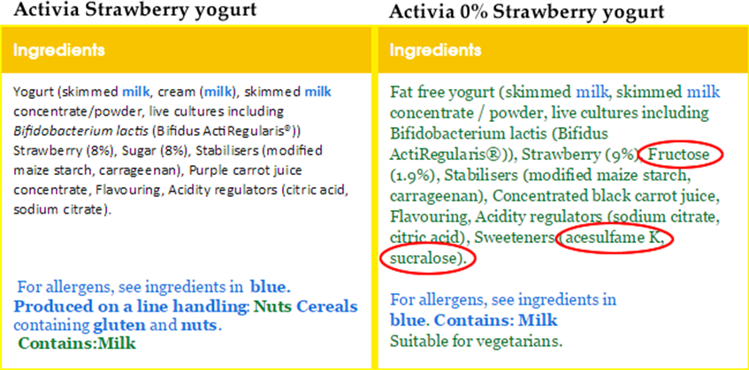

Source: Danone Activia [website](https://www.danoneactivia.co.uk/products/everyday-fruit-classics/4-packs/strawberry/strawberry), 2015.

Similarly, not all the information you find when you're researching will be reliable or appropriate for your needs. Here are some questions you may want to consider:

* How does it fit with your reasoning?
* Is it supporting your argument or providing an alternative viewpoint?
* Will it be useful for exploring a particular aspect of your theory or for more general background investigation?
* Are the points made backed up by research?
* Are the conclusions in line with other research on the topic? If not, why not?
* Is there a piece of research that you feel is missing and it has not been mentioned? Why?
* Are the research methods used valid and reliable? Are they delineated so you can understand them?
* Are the references used appropriate? Are they current if this is relevant to your topic?

Back to Contents

## Questioning the currency.

How current is the information? The importance of this will vary depending on what you need the information for.

Imagine a guidebook to Berlin that was published in 1992. If you were visiting Berlin for the first time, would you choose this guidebook?

Is the information still likely to be accurate (e.g. will the bars, restaurants it mentions still be open?) If not, what would you use instead?

You may want to consider the following points when evaluating an information source:

* Can you tell when it was published? If not, does this affect the reliability of the source?
* How current is it? Check the publication date, or the 'last updated' date on a web page.
* Has the information been superseded? Is there a later edition of a book, or more recent research? Have more recent articles cited this one?
* Why has this information appeared at this point in time?
* How does it relate to other literature on the same topic published before, or since?

[Back to Contents](#_Contents" \o "Back to Contents)

## Summary

You have reached the end of this resource. This information has been adapted from the [Evaluating Information and Critical Thinking tutorial](https://vle.shef.ac.uk/bbcswebdav/xid-48061695_1).

Why not look at some of our other Research Skills and Critical Thinking resources? [Book onto a Workshop or take an Online Tutorial](https://www.sheffield.ac.uk/library/study/research-skills).

Remember to reflect on and record your skills development using [mySkills](https://www.sheffield.ac.uk/skills/myskills).

Visit our FAQs: [Library FAQs](http://libraryhelp.shef.ac.uk/)

Get in touch: [library@sheffield.ac.uk](mailto:library@sheffield.ac.uk)

[Back to Contents](#_Contents" \o "Back to Contents)

## Full URLs

“What is critical thinking?” video: <https://digitalmedia.sheffield.ac.uk/media/1_pud5vjyv>

Yeo Valley website: <https://www.yeovalley.co.uk/things-we-make/yeogurt/natural>

Danone Activia website: <https://www.danoneactivia.co.uk/products/everyday-fruit-classics/4-packs/strawberry/strawberry>

Evaluating Information and Critical Thinking tutorial: <https://vle.shef.ac.uk/bbcswebdav/xid-48061695_1>

Research Skills and Critical Thinking Workshops and Tutorials: <https://www.sheffield.ac.uk/library/study/research-skills>

mySkills: <https://www.sheffield.ac.uk/skills/myskills>

Library FAQs: <https://libraryhelp.shef.ac.uk/>

Back to Contents

Last reviewed: September 2024



Except otherwise noted, this work by The University of Sheffield Library is licensed under the Creative Commons Attribution-NonCommercialShareAlike 4.0 International License. To view a copy of this license, visit http://creativecommons.org/licenses/by-nc-sa/4.0/.