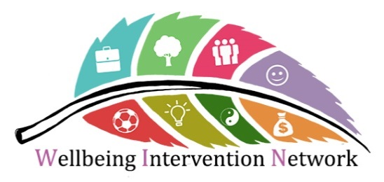

October 2018- Issue 1
Good afternoon
Welcome to the first email bulletin from the Wellbeing Intervention Network (WIN). We hope you had a good summer, and that the sunshine helped boost everyone’s wellbeing. As you may have noticed WIN now has a logo. Thank you to Veronica Fibisan from ScHARR for designing it.
This bulletin will be fairly short, but hopefully will get the ball rolling in terms of WIN, given both interest and work on wellbeing is increasing all the time. If you have anything you would like to contribute for next month’s bulletin, be it promoting an event or letting people know about a paper, presentation or project, it would be great to hear from you.

Wellbeing community attachments-
Within ScHARR (School of Health and Related Research), we have been running a number of placements for Masters in Public Health students at local community organisations who are delivering wellbeing activities. This has been an innovative but successful development. The students develop their understanding of wellbeing interventions and the work which is done outside of statutory health and social care services. The community organisations are also finding it beneficial because the students undertake pieces of research that helps inform their practice, builds capacity and develops relationships between the university and wider Sheffield Community. For example one student worked with a community organisation to design them an outcome measure, which the organisation is now using to capture the impact of their work. The project has been successful and is expanding, with more students and community organisations taking part each year.

Improving Wellbeing through Urban Nature (IWUN) Cafe
The Improving Wellbeing through Urban Nature (IWUN) group run Café IWUN, which provides an opportunity to come and chat with others about IWUN and your own research, projects and ideas. Let them know you are coming then drop in with questions about IWUN’s work, discuss links between their work and yours or just extend your Sheffield connections.

IWUN team members will be there, drinks and snacks are provided. IWUN Cafe will take place on the following dates:
Date: Tuesday 16th October 2018
Time: 4:00pm – 6:00pm
Location: Krebs café, Firth Court
Map: http://ssid.sheffield.ac.uk/campus-map/?location=firth-court
Date: Tuesday 6th November 2018
Time: 4:00pm – 6:00pm
Location: Krebs café, Firth Court
Map: http://ssid.sheffield.ac.uk/campus-map/?location=firth-court
Book your place at Café IWUN: HERE (Click open hyperlink or go to: https://docs.google.com/forms/d/e/1FAIpQLScGxKPfAAXuk73EfPgV-YKgt6DAjG0PTgCF0pH_C_1BV6dgrw/viewform)

Have you undertaken health/community research in Sheffield or know of any recent research?

As part of the Sheffield Person Centred City initiative, Janet Harris (researcher in ScHARR) is compiling a list of research studies and evaluations that have been done on health promotion, prevention, community services, health and social care services in Sheffield over the past 10 years. If you have undertaken any research in this field or are aware of anything please can you send the information to Janet: janet.harris@sheffield.ac.uk
Thank you for reading and please do send in anything for the next bulletin (November time).

